Chapter 2: Genetic Basis of Autism
Analysis of current studies on the genetic underpinnings of autism suggests that ethnic variation in autism-association alleles could play a role in the genetic model of autism. After studying evidence for a genetic basis of autism, this chapter explores the multilocus epistatic model of inheritance hypothesized for autism. Examining the current techniques for studying autism’s genetic underpinnings is used to later critically evaluate the current findings regarding autism-associated genes. Finally studies that test for autism-associated genes in different populations are evaluated to determine if the hypothesis that ethnic variation in the genetic underpinnings of autism may play a significant role.
Evidence for a Genetic Basis of Autism
Genetic evidence and studies in non-autistic relatives of individuals with autism confirm the heritability of autism. The heritable, genetic basis of autism is supported by the identification of multiple genes whose mutations are associated with increased risk of autism (2, 20). Additionally, both siblings and non-autistic relatives of those with autism show an increased risk for developing the disorder (245). Studies have found that the risk of autism for siblings of autistic patients is much higher than the risk of autism for the general population with values varying between 2 and 8% (2, 38, 46, 116, 163). Combined data from series of studies looking at the risk of autism in second and third degree relatives have found that second degree relatives have a 0.18% risk for autism while third degree relatives have a 0.12% risk for autism (66, 116, 194, 246, 247). Not only are relatives of autistic individuals more likely to have autistic disorders, but they are also more likely to exhibit milder autistic behaviors (2). Shared behaviors between autistic individuals and their siblings, parents, and other relatives include obsessive-compulsive behaviors, social phobias, communication deficits, stereotyped behaviors, (21, 23, 100, 195, 235). This combination of genetic evidence and the lesser autistic phenotype found in non-autistic relatives suggest a strong heritability of autism.
Twin studies most robustly indicate autism’s heritability by systematically accounting for both the genetic and environmental causes of autism. Twin studies seek to determine whether genetic causes play a role in disease etiology by comparing the disorder concordance rates for genetically identical monozygotic twins and dizygotic twins who share about half of their genetic material; using both types of twins theoretically controls for similar environmental factors and allows the genetic underpinnings of a disease to be exposed (247). A series of such studies have been performed for autism spectrum disorders (12, 77, 130, 209, 240, 247). While the first study reported a lower MZ concordance rate of 36% than later studies, later studies report concordance rates between 60 to 95% for MZ twins (12, 77, 130, 209, 240). Concordance rates vary from 0% to 23% in DZ twins, with higher rates most likely due to non-systematic sampling and reevaluation of subjects using broader autism phenotype criteria (12, 77, 130, 163, 209, 240). Using the difference between MZ and DZ concordance rates, the heritability of autism has been estimated to be about 90%. These studies suggest that genetic factors play a large role in autism’s etiology, in autism’s etiology; however, because MZ concordance is not 100%, environmental factors must also be significant and may explain differences in phenotype between MZ twins (163, 247). Ultimately, the established heritability of autism confirmed by genetic and family studies has lead to multiple hypothesized theories of the genetic inheritance of autism.
Genetic Inheritance Models of ASD
While many genetic inheritance models of idiopathic autism have been proposed, a multilocus model with epistasis what is epistasis? What is multilocus? that explains the role of inherited and de novo mutations as well as accounts for autism’s gender bias is the best proposed model. The genetic mechanisms for many types of autism associated diseases such as Rett Syndrome and Fragile X syndrome have been elucidated; however, models explaining the genetic causes of idiopathic autism, or autism of unknown cause, are still being explored (5, 78, 156). A successful genetic model of idiopathic autism must explains autism’s gender bias, clinical heterogeneity, variable penetrance how does the concept of penetrance apply to a polygenic disorder? Does everyone know what penetrance is? of autism-associated genes, and non-Mendelian inheritance patterns. Ultimately, a multilocus model with epistasis that accounts for the role of both inherited and de novo mutations accomplishes this task. While the precise mechanism causing autism’s gender bias is still undergoing debate, variable penetrance and imprinting are two valid models. Additional alternate theories complement this multilocus epistatic theory, but cannot explain autism’s inheritance alone. Ultimately, the multilocus epistatic model offers a potential explanation for how ethnicity and race could influence autism’s heredity.
All genetic models of autism must account the disease’s significant characteristics including its gender bias, clinical heterogeneity, variable penetrance of autism-associated genes, and non-Mendelian inheritance patterns (175). While all pervasive developmental disorders (PDDs) have male to female ratios of 3 or 4 to 1, severe autism is equally likely to be found in both males and females (79, 139, 255). A successful genetic model of autism should explain these gender inequalities in prevalence while also accounting for the similarities in severity (175). Additionally, a genetic model of autism must account for its clinical heterogeneity, or the variation in cognitive, communicative, behavioral, and social phenotype between patients (175, 245). The previously discussed twin studies suggest a non-Mendelian mode of inheritance (78, 247). The MZ and DZ concordance rates do not show a difference by a factor of 2 or by a factor of 4 as expected for autosomal dominant or autosomal recessive inheritance respectively with complete penetrance (247). Regardless of penetrance, disease risk should fall by about a half as one expands in the family circle from twins to first, second, and third degree relatives in disease caused by one major gene (206, 247). Previous discussions of the risk of autism for second and third degree relatives demonstrate that this pattern is not observed and suggest that autism is caused by many genes that do not follow Mendelian inheritance patterns (66, 116, 194, 246, 247). Finally, many autism-associated gene variants show incomplete penetrance (18, 120, 175). The primary multilocus model with epistasis satisfies these criteria for a genetic model of autism.
A multilocus model with epistasis accounts for autism’s clinical heterogeneity, the variable penetrance of autism-associated genes, and its non-Mendelian inheritance patterns. In a multilocus model with epistasis, multiple genes are responsible for the genetic basis of a disorder with interacting (epistatic) loci (78). A study by Pickles et al. found that such a multilocus epistatic model with two to ten loci with three interacting loci was most likely to explain their family history data (194). An additional study by Risch et al. proposed a multilocus model with 15 or more loci (207). Additional support for this multilocus model includes findings that social and communication deficits as well as repetitive behaviors rarely have shared heritability (2, 211). Similarly, different loci have been linked to characteristics associated with social, communication, and stereotyped behavior domains separately (2, 3, 40, 218). Two alternate models include the single locus model, in which one gene is primarily responsible for the autistic phenotype, and the heterogeneity model, in which multiple genetic origins give rise to the same condition in different individuals (78, 194, 270). Although Pickles et al. rejected both of these models in favor of a multilocus model with epistasis, additional studies do not preclude the heterogeneity model, suggesting that mutations in different combinations of specific genes may still lead to a similar autistic phenotype (194, 207). The multilocus epistatic model also explains autism’s clinical heterogeneity, the variable penetrance of autism-associated genes, and its non-Mendelian inheritance patterns. Because mutations in many genes are responsible for the autistic phenotype, specific combinations of these mutations may lead to different phenotypes that from the disorder spectrum and explains its clinical heterogeneity. This model also accounts for the incomplete penetrance of many autism-associated mutations by requiring many mutations for a full autistic phenotype. Finally as previously mentioned, this oligogenetic pattern of inheritance is non-Mendelian (66, 116, 194, 246, 247). As the multilocus epistatic model explains many of the key genetic characteristics of autism, it is extremely likely.
A genetic model of autism incorporating the different roles of inherited and de novo mutations in sporadic and familial autism explains autism’s gender bias, variable penetrance of autism-associated genes, and non-Mendelian inheritance. While sporadic autism has been defined as that which exists in a simplex family, inherited or familial autism is that which occurs in multiplex families (287). Zhao et al. and Sebat et al. propose a model where sporadic autism is caused by spontaneous de novo mutations that have high penetrance in males and low penetrance in females (220, 287). These mutations can persist in females without causing an extreme phenotype; this allows the mutation pass on to offspring with a bias towards males who are more likely to express the phenotype due to high male penetrance (283). This model thus accounts for the observed gender bias in autism through the concept of gender-variable penetrance. Families prone to inherited or familial autism are thus created from low-risk families that acquire many asymptomatic de novo mutations (283). The increase prevalence of de novo mutations in sporadic cases of autism has been shown, supporting this hypothesis (220). This model of genetic inheritance explains the high MZ concordance rate through shared inherited and de novo mutations while claiming the lower DZ concordance rates results from sharing of only some of each type of mutation (287). Although Zhao proposes this model as an alternative to the multilocus model with epistasis, models combining oligogenetic inheritance with both inherited and de novo mutations have been proposed, suggesting that these models are not exclusive and together give a more complex view of the inheritance of autism (115, 283). The role of de novo mutations in this model causes it to move past a simple Mendelian inheritance model into a more complex inheritance pattern typically seen in autism. This model also explains how “common variants” inherited from one’s family and “rare variants” arising from spontaneous mutation can both play crucial roles in autism’s genetics (2, 179).
Incomplete penetrance in females and X-linked imprinting are two plausible models to explain autism’s gender bias. Although the conventional explanation for biased gender ratios seen in autism is sex linkage, there has been inconsistent data regarding genes associated with autism found on the X-chromosome (137, 163, 226, 232). Evidence supporting autism transmission between males in multiplex families rules out the possibility of sex linkage in these circumstances (93, 164, 208). Zhao et al. also rules out the possibility of sex linkage because material from the maternal X chromosome containing an autism-associated mutation is not found in both siblings that have autism (283). Instead, Zhao et al. and Sebat et al. propose a model in which incomplete penetrance of inherited mutations from one parent chromosome creates carriers of autism-associated mutations (220, 283). He argues that differences in penetrance between males and females occur because of previously observed sexual dimorphisms in cognition, social ability, and other associated autistic characteristics (16, 233, 283). Another model proposed to explain autism’s gender bias is X-linked imprinting, where X chromosome genes are marked and differentially expressed based on their maternal or paternal origin (181, 232). An X-chromosome autism-protective gene is silenced when maternally transmitted and expressed when paternally transmitted (232). As the paternally transmitted gene can only be passed onto daughters but the maternally transmitted gene can be passed to both sons and daughters, women will be more likely to have this protective locus, require more mutations for the autistic phenotype, and have a lower prevalence of autism (232). While other models including differential exposure to sex hormones such as androgens have been proposed to explain autism’s gender bias, little evidence has been found to support this hypothesis (232). Although the proposed models are valid explanations for autism’s gender bias, further experimentation needs to be conducted to confirm their validity.
Alternative models including mitochondrial transmission, environmental factors, and epigenetic inheritance have been proposed to complement the multilocus epistatic model. The maternal transmission of mitochondrial DNA may play a role in autism as it is a non-Mendelian inheritance pattern and as abnormalities in mitochondrial DNA have been associated with autism (175, 182, 197, 267). It is unclear however, how mitochondrial transmission of mutations could lead to the observed gender bias in autism, and appears that mitochondrial gene mutations are only significant in a subset of cases of autism (182, 267). Some suggest that additional environmental or immunogenic factors are needed to complement autism-predisposing genetic factors because the concordance rates for MZ is not 100% (78). Proposed environmental causes for autism include maternal or congenital hypothyroidism, maternal thalidomide, valproic acid, or alcohol use, congenital cytomegalovirus or rubella infection, and MMR vaccination; however little conclusive evidence supporting these hypotheses have been found (9, 43, 45, 78, 92, 159, 213, 249). Epigenetic modifications of genes, including DNA methylation and histone modification, alter gene expression in response to environmental cues and parental origins, suggesting that this may be the mechanism by which environmental or other cues influence the autistic phenotype (217). Evidence of the role of epigenetic modification of chromosomes 15Q and 7Q strongly support this hypothesis (115, 217). While these alternate models may play a role in autism’s etiology, the strong evidence supporting the multilocus epistatic models suggests that these methods are not the primary means by which autism is inherited.
Through the inherited mutation component of this multilocus epistatic model, ethnicity and race could influence the heritability of autism. De novo mutations occur at random and thus should be equally likely to occur in all ethnic and racial populations. If ethnic and racial populations do not interbreed, these random de novo mutations will remain in that population and become inherited mutations unique to the ethnic or racial group. Although it is possible that the random nature of de novo mutations will spontaneously cause the same autism-associated mutation in different ethnic populations, it is also likely that ethnic or racial specific mutations exist. Assuming that each ethnic or racial group has unique inherited mutations, the combined genetic mutations causing autism is likely to differ more between individuals in different ethnic or racial groups than it is to differ between individuals in the same ethnic or racial group. Significant variations in single nucleotide polymorphisms and copy number variants have been reported between individually in ethnically distinct populations, supporting this conclusion (8). While such a model does not necessarily support claims that a particular ethnic or racial group is more susceptible to autism, if one ethnic or racial group contained significantly more autism-associated inherited mutations in their gene pool, this would be a possibility. Further analysis of whether differences in the prevalence of autism-associated mutations differ by ethnicity and race will shed light on the viability of this hypothesis.
Genetic Techniques for Studying Autism
To critically evaluate the current findings regarding the genetic underpinnings of autism, the primary techniques employed to study the genetics of autism must be understood and evaluated. Chromosomal analysis, linkage studies, association studies, candidate gene resequencing studies, and array-based studies have been used to study autism’s genetics. While chromosomal analysis can identify large rare genetic abnormalities, linkage and association studies are better to identify specific disease related loci. Linkage and association studies also suffer from shortcomings including difficulty identifying rare variants, difficulty establishing significance levels, problems in establishing inheritance mode, creating a large enough sample, and finding appropriately matched controls. Candidate gene resequencing studies can confirm the results of chromosomal, linkage, and association studies, but are rarely useful alone. Ultimately, DNA microarray based copy number variant studies are the most effective way detect autism-associated genetic variants as these methods can detected small variations as well as their inherited or de novo origin. By understanding the genetic techniques for studying autism as well as how differences in ethnicity in subjects can influence the results of these studies, the current findings regarding the genetic underpinnings of autism can be critically analyzed.
Although chromosomal analysis identifies rare genetic abnormalities and large, broad regions associated with autism, it is often a useful starting point for studying the genetics of autism. The primary forms of cytogenetic analysis include G-banding and fluorescent in situ hybridization (FISH) (126). G-banding, which uses trypsin and Gimesa stain to create a karyotype with stereotypically stained chromosomes, is an older technique with low resolution of only about 5 to 10 million base pairs, a region that can contain as many as 50 to 100 different genes (1, 144). FISH, a more recent technique in which fluorescently labeled DNA probes hybridize to chromosomes that are visualized by fluorescence microscopy, can identify smaller chromosomal abnormalities of about 50 to 100 kilobases (17, 144). Array Comparative Hybridization, a new molecular cytogenetic technique, can identify even smaller chromosomal abnormalities and will be discussed in depth in the Array-Based Methods section (144). While such chromosomal analyses are useful for identifying duplications, deletions, translocations, breakpoints, and large portions of DNA that may be associated with autism, chromosomal abnormalities have been found in less than 10% of individuals with autism (126, 163, 256, 275). Ultimately, studying chromosomal abnormalities through the described cytogenetic methods is a useful place to begin the investigation of the genetic underpinnings of autism.
While linkage studies aid in finding specific loci located near autism-associated genes, the disease’s heterogeneity and unknown mode of inheritance limit the applicability of this method. Linkage occurs when certain genetic loci and alleles are likely to be inherited together; this often occurs when genetic loci are physically near each other (142). In non-parametric linkage studies, data from multiplex families are analyzed to see if affected members share linked genetic markers, which are likely to be near disease loci and are absent from unaffected family members at a rate greater than chance (142, 179). Such genetic markers include such as restriction-fragment length polymorphisms (Fraps) or single nucleotide polymorphisms (SNPs) (142). The reported logarithm of the odds (LOD) score is the likelihood of obtaining the data of shared markers in affected family members compared to the likelihood of obtaining it by chance (179). While a score above 2.2 is considered suggestive, a score above 3.6 is considered significant (128, 179). Most studies use an affected sibling pair design in multiplex families (179). Parametric linkage studies test to see if genetic markers follow a hypothesized mode of inheritance and work best on disorders caused by few genes; however they are non frequently employed in autism research as autism has an unknown mode of inheritance and an oligogenetic origin (179). A strength of linkage studies is their consistency with the multilocus epistatic model of autism inheritance (126). While linkage studies are able to identify multiple alleles associated with autism at limited loci, they are less effective at identifying multiple loci associated with autism (179). To address the problem of achieving significant linkage due to autism’s genetic heterogeneity, quantitative trait loci (QTL) linkage studies use populations with specific deficits associated with autism but found in the entire populations to identify loci for those specific deficits (126). Searching for a specific QTL in a narrowed population is to increase these studies’ ability to achieve significant linkage (126). Linkage studies should be complemented with other methods that better facilitate finding multiple autism-associated mutations at many loci.
While candidate gene resequencing offers a means of narrowing the broad results reported from cytogenetic, association, and linkage studies, it is often difficult to know which sections to resequence. In candidate gene resequencing studies, a particular gene is resequenced in both patients and controls to identify variants that exist in the patient population (13). This method is useful to identify and confirm rare variants that contribute to autism; however, it is often difficult to select candidate genes as a third of all human genes are expressed in the brain (126, 256). Using identified loci from cytogenetic, association, and linkage studies can aid in this process of gene selection (2, 126).
Despite their ability to demonstrate relationships between specific loci and disease phenotypes, association studies are limited by replication difficulties, large sample sizes, significance level determination, and subject ethnicity matching. Association studies test if a given allele’s frequency differs between cases and controls (142). Genetic markers, such as SNPs, are often in linkage disequilibrium, a statistical association between two or more linked loci, with disease variants (25). While many-case control association studies analyze such genetic markers in unrelated healthy and diseased subjects, family-based association studies analyze genetic markers with unaffected parents as controls (25, 126, 179). Family-based association methods like transmission disequilibrium tests (TDT) are preferable because they limit false positives due to ethnic variation in populations (25, 126). Association studies also examine haplotypes, or alleles at multiple loci on the same chromosome inherited from one parent. Despite their positives, association studies can be difficult to replicate, require a large sample size, and ignore the important role of rare variants (25, 179). Specific association methods to identify rare variants are expensive, require larger sample sizes, and may be ineffective due to variant’s extreme rarity (179). These shortcomings can be overcome by demonstrating variant functionality, showing variant segregation within a family, examining the total population rare variants, using proper statistical thresholds, and internally replicating findings (179). Ultimately, association studies confirm the relevance of a particular loci following linkage and cytogenetic evidence (179).
DNA microarrays to detect copy number variants are the best method to identify the genetic underpinnings of autism because they can detect extremely small genetic abnormalities and can determine whether these variants are inherited or de novo. DNA microarrays are now able to identify previous undetectable small deletions, insertions, duplications, and other chromosomal abnormalities including copy number variants, or DNA segment in which differences in copy number of a particular segment exist in an individual compared to a reference genome (CNVs) (76). Most individuals are thought to have somewhere between 15 and 20 CNVs, although much larger values have been reported (76, 104, 221). A microarray is created using small probes that represent specific known areas of the genome (154). Dye-labeled genomic DNA from an autistic and control are then competitively hybridized to the microarray, with specific portions of the microarray only labeled with control DNA when an abnormality has occurred (154). A variety of specific methods exist including array comparative genomic hybridization (aCGH) using a bacterial artificial chromosome (BAC), representational oligonucleotide microarray analysis (ROMA), and Affymetric 500K SNP microarrays (126). While aCGH-based BAC microarrays have allowed for detection of chromosomal abnormalities as small as 150 kilobases, the oligonucleotide-based ROMA assay and SNP assay have higher resolution as well as measures to reduce background noise (76, 126). Using matched non-related controls allows one to identify autism-associated CNVs; however, using non-affected parents as controls also allows one to determine if identified CNVs are de novo (44, 220). These array based methods are extremely valuable as they test whole genome, have high resolution, search for rare variation, and allow for the study of all autistic patients, not just those with large chromosomal abnormalities (179). While it can be difficult to determine which CNVs are pathogenic as these mutations are common in normal individuals, focusing on rare, de novo, and large CNVs that are homozygous can help resolve this problem (179). Ultimately, array based methods offer the best future for studying autism.
Identified ethnic variation in genetic markers used in linkage, association, and microarray based methods of studying autism’s genetics suggests that control subjects must be carefully matched to ensure that identified genetic variants are associated with autism and are not an artifact of natural ethnic variation. Variation in the frequency of genetic markers such as SNPs and of CNVs has been reported in populations that differ substantially based on ethnicity (8, 53, 110). As genetic markers are commonly used in linkage and association studies, the controls selected for these studies must be matched carefully by ethnicity to ensure that genetic variants are caused by the association with autism and not differences in ethnicity. The family-based methods of linkage studies are more likely to control for these factors as ethnicity is less likely to vary by family; however, association studies using non-related controls must take special precautions (126). As identified variants can be so rare that results are difficult to reproduce in other populations, the inability to reproduce results in an ethnically distinct population for association-based studies or other studies may suggest ethnic variation in the genetic underpinnings of autism (179). Understanding how ethnicity can influence the various genetic techniques associated with autism will allow a critically analysis of the genetic underpinnings of autism in different ethnic populations.
Current Findings in the Genetic Underpinnings of Autism and the Role of Ethnicity
Understanding the experimental techniques used to study autism’s genetics allows for a better assessment of the current findings on autism’s genetic underpinnings as well as of the potential ethnic variation in those underpinnings. The current genetic autism findings will be discussed in context of experimental techniques to determine which genes are most likely to be associated with the disorder. Following this discussion, the studies of genes that had been studied in multiple ethnic groups will be critically analyzed to determine whether different ethnic groups are likely to have substantially different genetic underpinnings of autism. Ultimately, such analyses suggest that while ethnic variation in autism’s genetic underpinnings is likely, additional large studies are needed to determine the significant and implications of such differences.
Current Genetic Findings
Studies identifying chromosomal abnormalities in autism, such as 2q37, 7q11, 15q11-q13, 17p11.2, 17q11, and 22q11, locate regions of interest that can be more specifically studied by more specific experimental methods. While the 2q37 deletion is associated with gene CENTG2, 7q11 is related to autism-associated disorder Williams syndrome (126, 263). The 15q11-q13 region, associates with the UBE3A, ATP10A, GABRB3, GABRG3, and GABRA5 genes, is one of the most frequent autism-associated chromosomal abnormalities (55, 176, 177). While the 17p11.2 duplication is also found in those with Potocki-Lupski syndrome, the 17q11 deletion contains the NF1 gene, which encodes a Ras protein regulator (149). The 22q11 deletion is associated with the ADORA2 gene, an adenosine receptor mutated in Velocardiofacial syndrome (81, 126). Additional loci have been identified through karyotype (126, 129, 239). While chromosomal studies have identified important autism-associated areas of the genome, linkage, hypothesis driven, functional, mutational, and disorder-related studies further specify autism-associated candidate genes.
Like chromosomal studies, linkage studies identify large autism-associated regions, including 7q and 17q11-q21, for further study. Linkage to 7q has been repeatedly replicated; identification of the importance of this region have implicated genes such as RELN, NRCAM, MET, FOXP2, WNT2, EN2, CNTNAP2, and others with autism (2, 7, 33, 47, 63, 88, 91, 103, 146, 169, 189, 191, 223, 253, 257, 262). Similarly, consistent linkage results at the 17q11-q21 locus have lead to the identification of SLC6A4, NF1, NOS2A, ITGB3, and HOXB1 (83, 121, 266). Although loci on chromosomes 1, 2, 3, 5, 6, 7, 11, 13, 17, 19, and X have been identified as autism-associated through linkage studies, difficulty obtaining significant LOD scores has prevented these findings from being conclusive (2, 25). Additional association studies are frequently needed to confirm the relevance of loci identified in this manner.
The material above relates to statistically significant genomic variation identified by some kind of broad search criteria. Now comes a different type of evidence. Add some explanation as to the different rationale – a bit jarring. In general your review is admirable in its thoroughness but needs more synthesis and guideposting to tutor the reader better.
Studies examining functional variants, patient-specific mutations, and genes of related disorders are also useful to identify candidate genes for later association studies. Examining the tissues of autistic individuals and controls has led to the identification of several genes including DAB1, MAP2, GRPR and other identified by Hu et al. (61, 74, 101, 102, 107, 157, 165)(Table 1). Mutations identified in individual autistic patients are also useful for identifying variants. Genes involved in the synapse (RIMS3, EIF4E), ion exchange (SCN1A, SCN2A, SLC9A9, CACNA1H) neuronal receptors (PCHD10, JMJD1C), transcriptional repression (MBD3, MBD4), transcription factors (ARX), various enzymes (DMPK, ADSL), and other (NTNG1, RPL10, SLC6A8, REEP3) have all been identified in this manner (26, 35, 61, 73, 86, 99, 124, 127, 162, 172, 198, 230, 238, 265, 285). Genes implicated in related disorders including Joubert syndrome, Tuberous sclerosis, Smith-Lemli-Opitz syndrome, Duchene Muscular Dystrophy, Rett Syndrome, Fragile X syndrome, Timothy syndrome, have been tested for associations with autism (4, 118, 126, 170, 188, 228, 229, 234, 237, 271). Chromosomal and linkage studies generally provide more reliable evidence of a candidate gene due to their study design; however, additional association testing can strengthen these studies’ original findings.
The next graf is qualitatively different in terms of rigor and type of evidence. New heading and some acknowledgement please
Hypothesis-selected candidate genes provide a stronger biological explanation of autism pathogenesis; however, these studies must be validated by additional experiments that’s an understatement. Speculations regarding the involvement of the neurexin-neuroligin pathway in autism led to later mutational studies including genes NLGN4, NLGN3, SHANK3, and NRXN1 (71, 75, 112). High platelet serotonin levels in autistic patients led to the investigation of serotonin receptors and enzymes including SLC6A4, HTR3A, HTR1B, HTR3C, TPH2, and MAOA (6, 48, 56, 57, 164, 183, 204). The DRD3 dopamine receptor was studied due to the effectiveness of dopamine blockers as an autism treatment (60, 64, 164). Implications of the glutamatergic system in autism have lead to the investigation of glutamate receptor genes GRIK2 and GRM8, GABA receptors genes GABRA4 and GABRB1, which modify glutamate activity, and GABA biosynthesis enzymes GRIN2A and ABAT (14, 49, 111, 140, 164, 224). The role of oxytocin in social behavior lead to the investigation of the OXTR gene with autism (126, 163, 273). Immune system abnormalities in autistic individuals has lead to the investigation of MHC-I gene HLA-A, MHC-II gene HLA-DRB1, and complement system gene C4B (180, 252, 260). Despite the biological plausibility of such findings, further studies are needed to confirm their validity. It would be more accurate to call attention to how speculative these possibilities are!
While association studies can confirm chromosomal, linkage, functional, mutational, and disorder-associated findings, genome wide association studies (GWAS) can also lead to the discovery of specific autism-associated loci. Association studies of SLC25A12, STK39, ITGA4, genes in 7q31, and others have been performed to confirm original chromosomal and linkage findings (126, 200, 202). Chakrabarti et al. uses association to confirm findings in candidate genes involving sex steroids, neural growth, and socio-emotional behavior, such as NTNG1, ESR1, ARNT2 and others (37, 167)(Table 1). Many other genes, first implicated in autism by previously described methods, have been confirmed by association studies, including MTF1, DISC1, PRKCB1, and others (11, 27, 31, 42, 51, 96, 105, 117, 119, 138, 150, 160, 168, 174, 192, 193, 216, 222, 223, 242, 274, 280, 288)(Table 1). Genome wide association studies (GWAS) offer significant promise for identifying new autism-associated variants, and one such study by Wang et al. has identified several autism associated genes including FEZF2, CDH9, CDH10, and others (87, 98, 113, 161, 187, 225, 251, 258) (Table 1). Through both candidate specific and GWAS, association studies are crucial for confirming autism-associated genes.
As CNV studies can screen the whole genome to identify both small inherited and new mutations associated with autism, these methods offer the best means to identify autism-associated genes. Crucial CNV studies including Sebat et al., Marshall et al., Bucan et al., and Glessner et al. have lead to the identification of many genes (29, 89, 143, 220). These genes serve as receptors, catalysts, cell adhesion molecules, and many other functions; they include CA6, DYPD, RFWD2, and others (15, 39, 41, 70, 94, 114, 123, 171, 184, 219, 241, 250, 282, 284)(Table 1). Additional CNV studies have identified genes such as CNTN4, MCPH1, AVPR1A, and NBEA (36, 185, 212, 278). The ability of this technique to efficiently identify small de novo and inherited mutations makes it extremely powerful for identifying autism-associated loci.
The Role of Ethnicity in the Genetics of Autism
Genetic findings suggest that ethnic populations may unique frequencies of autism-associated alleles, suggesting that ethnic variation may play a role in autism’s genetic underpinnings. After describing the criteria for inclusion of studies in the analysis, the potential causes for ethnic variation in findings are outlined. Multiple studies of the same gene conducted in different ethnic populations are first analyzed to determine whether there are differences in findings based on ethnicity. Next, individual studies with multiple ethnic populations are examined to control for study design’s effect on outcomes. Ultimately, the findings are discussed to determine whether ethnicity has a potential role in the genetic model of autism.
Genetic studies included in this analysis were identified from the Simons Foundation Autism Research Initiative (SFARI) Gene database, which reports the genetic loci currently implicated with ASD identified from published literature (80). Included genes were studied either by multiple separate studies conducted in different ethnic populations or by one study with multiple, defined ethnic groups. Only studies with relevant ethnic information reported were included in the analysis. Studies supported by purely functional data were excluded. Out of the 207 loci included in the previous review, only 26 met the criteria to be included in the analysis. Discussion of the potential causes for ethnic variation will provide a framework for examining individual studies with multiple ethnic populations and multiple studies of the same gene conducted in different ethnic populations. Ultimately, such analyses will provide a better insight into the role of ethnicity on autism’s genetic underpinnings.
Differences in autism-associated genes in distinct ethnic populations can be due to differences in study design, in background population characteristics, and in causative mutation. When comparing studies of the same gene conducted in different ethnic populations that use different experimental techniques, observed differences in association may be due to differences in genetic markers used, significance levels employed, or other aspects of study design. While these comparisons can give a good idea about whether a gene is likely to have ethnic variation, further study using consistent experimental techniques is required to confirm such claims. According to Collins et al., population differences in allele frequency, linkage disequilibrium, and haplotypic background can also lead to reported ethnic variation (49). Less allele variation or fewer alleles in a particular ethnic population could lead to low power, making statistical significant difficult to obtain (49). Different genetic markers may be in linkage disequilibrium with the disease variant in each ethnic populations, making results difficult to replicate. If same mutation arose in different haplotypic backgrounds in each ethnic community, different genetic markers will be associated with the disease variant, leading to differences in reported association (49). Finally, different causative mutations in each ethnic population could explain the differences in association. While analyzing multiple studies of the same gene will provide suggestions of genes that show ethnic variation, individual studies that study multiple ethnic groups will provide the most conclusive evidence regarding ethnic variation of the genetic underpinnings of autism.
The differences in autism-associated genes and genetic markers identified in ethnic populations tested in separate studies may be due to differences in study design, population background, or causative mutation. European and Chinese Han significant associations of GRIK2 were not replicated in Indian populations (72, 111, 227). SHANK3 gene association was reported in a French population but not mixed and Chinese populations (71, 199, 244). Similarly, the NGLN3, NGLN4X, GRPR, NF1, and SLC6A4 genes did not report consistent association in various ethnic populations (22, 37, 56, 59, 69, 85, 95, 106, 112, 122, 148, 149, 151, 153, 166, 186, 196, 203, 243, 254, 269, 272, 279). Inconsistent association of the ADA gene in two distinct Caucasian populations suggests either subtle population differences or substantial study design influence (27, 97, 190). In addition to distinct associations between ethnic populations, distinct genetic markers associated with autism were reported in different ethnic populations for GRIK2, RELN, GRM8, FOXP2, WNT2, EN2, GABRB3, and PKRB1 (24, 50, 67, 68, 72, 83, 84, 90, 105, 125, 132, 135, 145, 146, 173, 189, 210, 224, 227, 231, 248, 261) (10, 19, 28, 30, 54, 62, 65, 88, 133, 134, 141, 147, 148, 152, 155, 158, 178, 192, 215, 259, 264, 276, 277, 286). While a HOXA1 A218G base substitution reported only by Ingram et al., a GGC triplet repeat in RELN’s 5’ untranslated region (UTR) in Italian and Caucasian populations (24, 50, 67, 68, 83, 105, 125, 135, 189, 210, 231, 248). While genetic markers associated with GRM8 and EN2 were not replicated in Chinese Han populations, genetic markers associated with FOXP2 were uniquely reported in the Chinese population (19, 28, 84, 88, 90, 132, 145, 146, 173, 224, 259, 261, 277, 286). While the study design’s role in this findings cannot be ruled out, the role of population background is unclear. Several studies reported ethnic variation of the allele in question, suggesting that low prevalence of the may lead to difficulty establishing significance in an association study (105, 133, 148). Wassink et al. argued however that their findings regarding a WNT2 mutation could not be replicated despite enough power to detect the association (134, 147, 155, 264). Controlling for study design by examining ethnic populations studied in the same study will give a better idea of whether ethnic variation in autism’s genetic underpinnings is likely.
While consistent findings involving HOXB1, GLO1, ITGA4, and OXTR have been found in all ethnic populations tested in separate studies, different genetic markers have been identified in each population. The GLO1 gene was not found to be associated with autism in either Italian, Caucasian American or Finnish populations using case-control based and family based association methods (205, 214). Similarly, all populations did not find HOXB1 to be autism-associated (82, 105, 136, 210, 248). The absence of positive findings confirmed across all studies suggest that differences in study design may make it difficult to confirm results across multiple studies in different populations. While ITGA4 was found to be autism-associated in Caucasian, Irish, and Portugese populations, different haplotypes were found in three sample populations tested in Conroy et al. and SNPs were not consistently identified in Correia et al. and Conroy et al. (52, 58, 200, 201). Although the oxytocin receptor (OXTR) has been found significantly associated with autism in 5 separate population, the specific SNPs associated with autism differed between studies (109, 131, 268, 273, 281). For example, although both Wu et al., Jacob et al., and Lerer et al. found significant association at the rs2254298 SNP, Wermter et al. could not replicate these findings although an association between OXTR and autism was found (109, 131, 268, 273). Similarly, the MET allele rs1858830 C has been associated with ASD in mixed American, Caucasian and African American cohort; however, in Italian cohorts no association has been seen (32-34, 108, 236). Some mixed cohorts have found association with the rs38845 allele instead however (236). These examples suggest that although similar associations can be found within the same gene in different populations, ethnic variations in identified genetic markers are still likely to exist.
The ethnic variation in autism-associated NRXN1, GABRA3, GLO1, and PON1 genes in individual studies with multiple populations may suggest ethnic differences in autism’s genetic underpinnings; however, these differences could be residual study design effects. A NRXN1 mutational study found two structural variants in Caucasian autistic individuals but none in African Americans (75). Similar mutation tests found that Caucasians and African Americans tended to have different GLO1 C419A SNPs (117). Further support for genetic differences between ethnicities include higher frequencies of a NRXN1 deletion in case and control African Americans than in case and control Caucasians (75). An association study by D’Amelio et al. found differences in autism-association of the PON1 gene in Caucasian Americans and Italians (63). Examining multiple ethnic populations in the one mutational or association study should control for many study design as the same experimental methods should be performed on each ethnic group. These observed ethnic differences must be due to either differences in population characteristics or in causative mutation.
While individual studies have found a gene to be autism-associated in multiple ethnic groups, few studies have identified the same SNPs in each population to confirm the association. A study by Coon et al. of the TPH2 gene found significant association between the gene and autism even when excluding the Italian population from their white and Italian study cohort; such findings suggest that the genetic variation between the two populations was not large enough to substantially alter the study’s results (57). Although a study by Collins et al. reported significant association the GABRA4 gene in both Caucasians and African Americans, the associated SNPs for Caucasians consisted of rs17599165, rs1912960, and rs17599416, while those for African Americans consisted of rs2280073 and rs16859788 (49). A study in Caucasians replicated the findings at the SNP rs1912960, strengthening the hypothesis that the observed differences were due to ethnicity (140). Additionally, Collins et al. reported an interaction between GABRA4 and GABRB1 in the Caucasian population alone (49). Such findings support a hypothesis that while the general genetic underpinnings of autism are shared across ethnic groups, different variations in the same genes may be responsible for disorders such as autism.
While additional need to be conducted to confirm ethnic variation’s role in the genetics of autism, current findings suggest that ethnic variation in population background or in causative mutation may play a role in autism’s genetic underpinnings. Both multiple studies in distinct ethnic populations and individual studies with multiple ethnic populations show more ethnic variation than similarities. Such findings suggest that while study design differences may cause inconsistent findings regarding autism-associated genes, differences in population background or causative mutation still play a substantial role in the observed differences. Differences in population background may lead to different associations of genetic markers without actual ethnic differences in disease loci. Alternatively, ethnic differences in autism-associated allele frequency may make autistic individuals of a particular ethnicity more likely to possess certain inherited autism-associated mutations. Different frequencies of alleles associated with autism in different ethnic populations supports the hypothesis that there is ethnic variation in the genetic underpinnings of autism. Further studies using identical experimental techniques in multiple ethnic populations and attempting to quantify the presence of certain autism-associated alleles in distinct ethnic populations are needed to confirm this hypothesis.

Is Table 1 a list of all known genetic findings that you could identify? Can you find a way to estimate what fraction of cases involve variants of one or more of these genes? I am wondering how far along this approach is getting. If it’s far enough along then it reduces wiggle room for finding future ethnic variation.

Table 1 – Overview of Genetic Findings regarding Autism
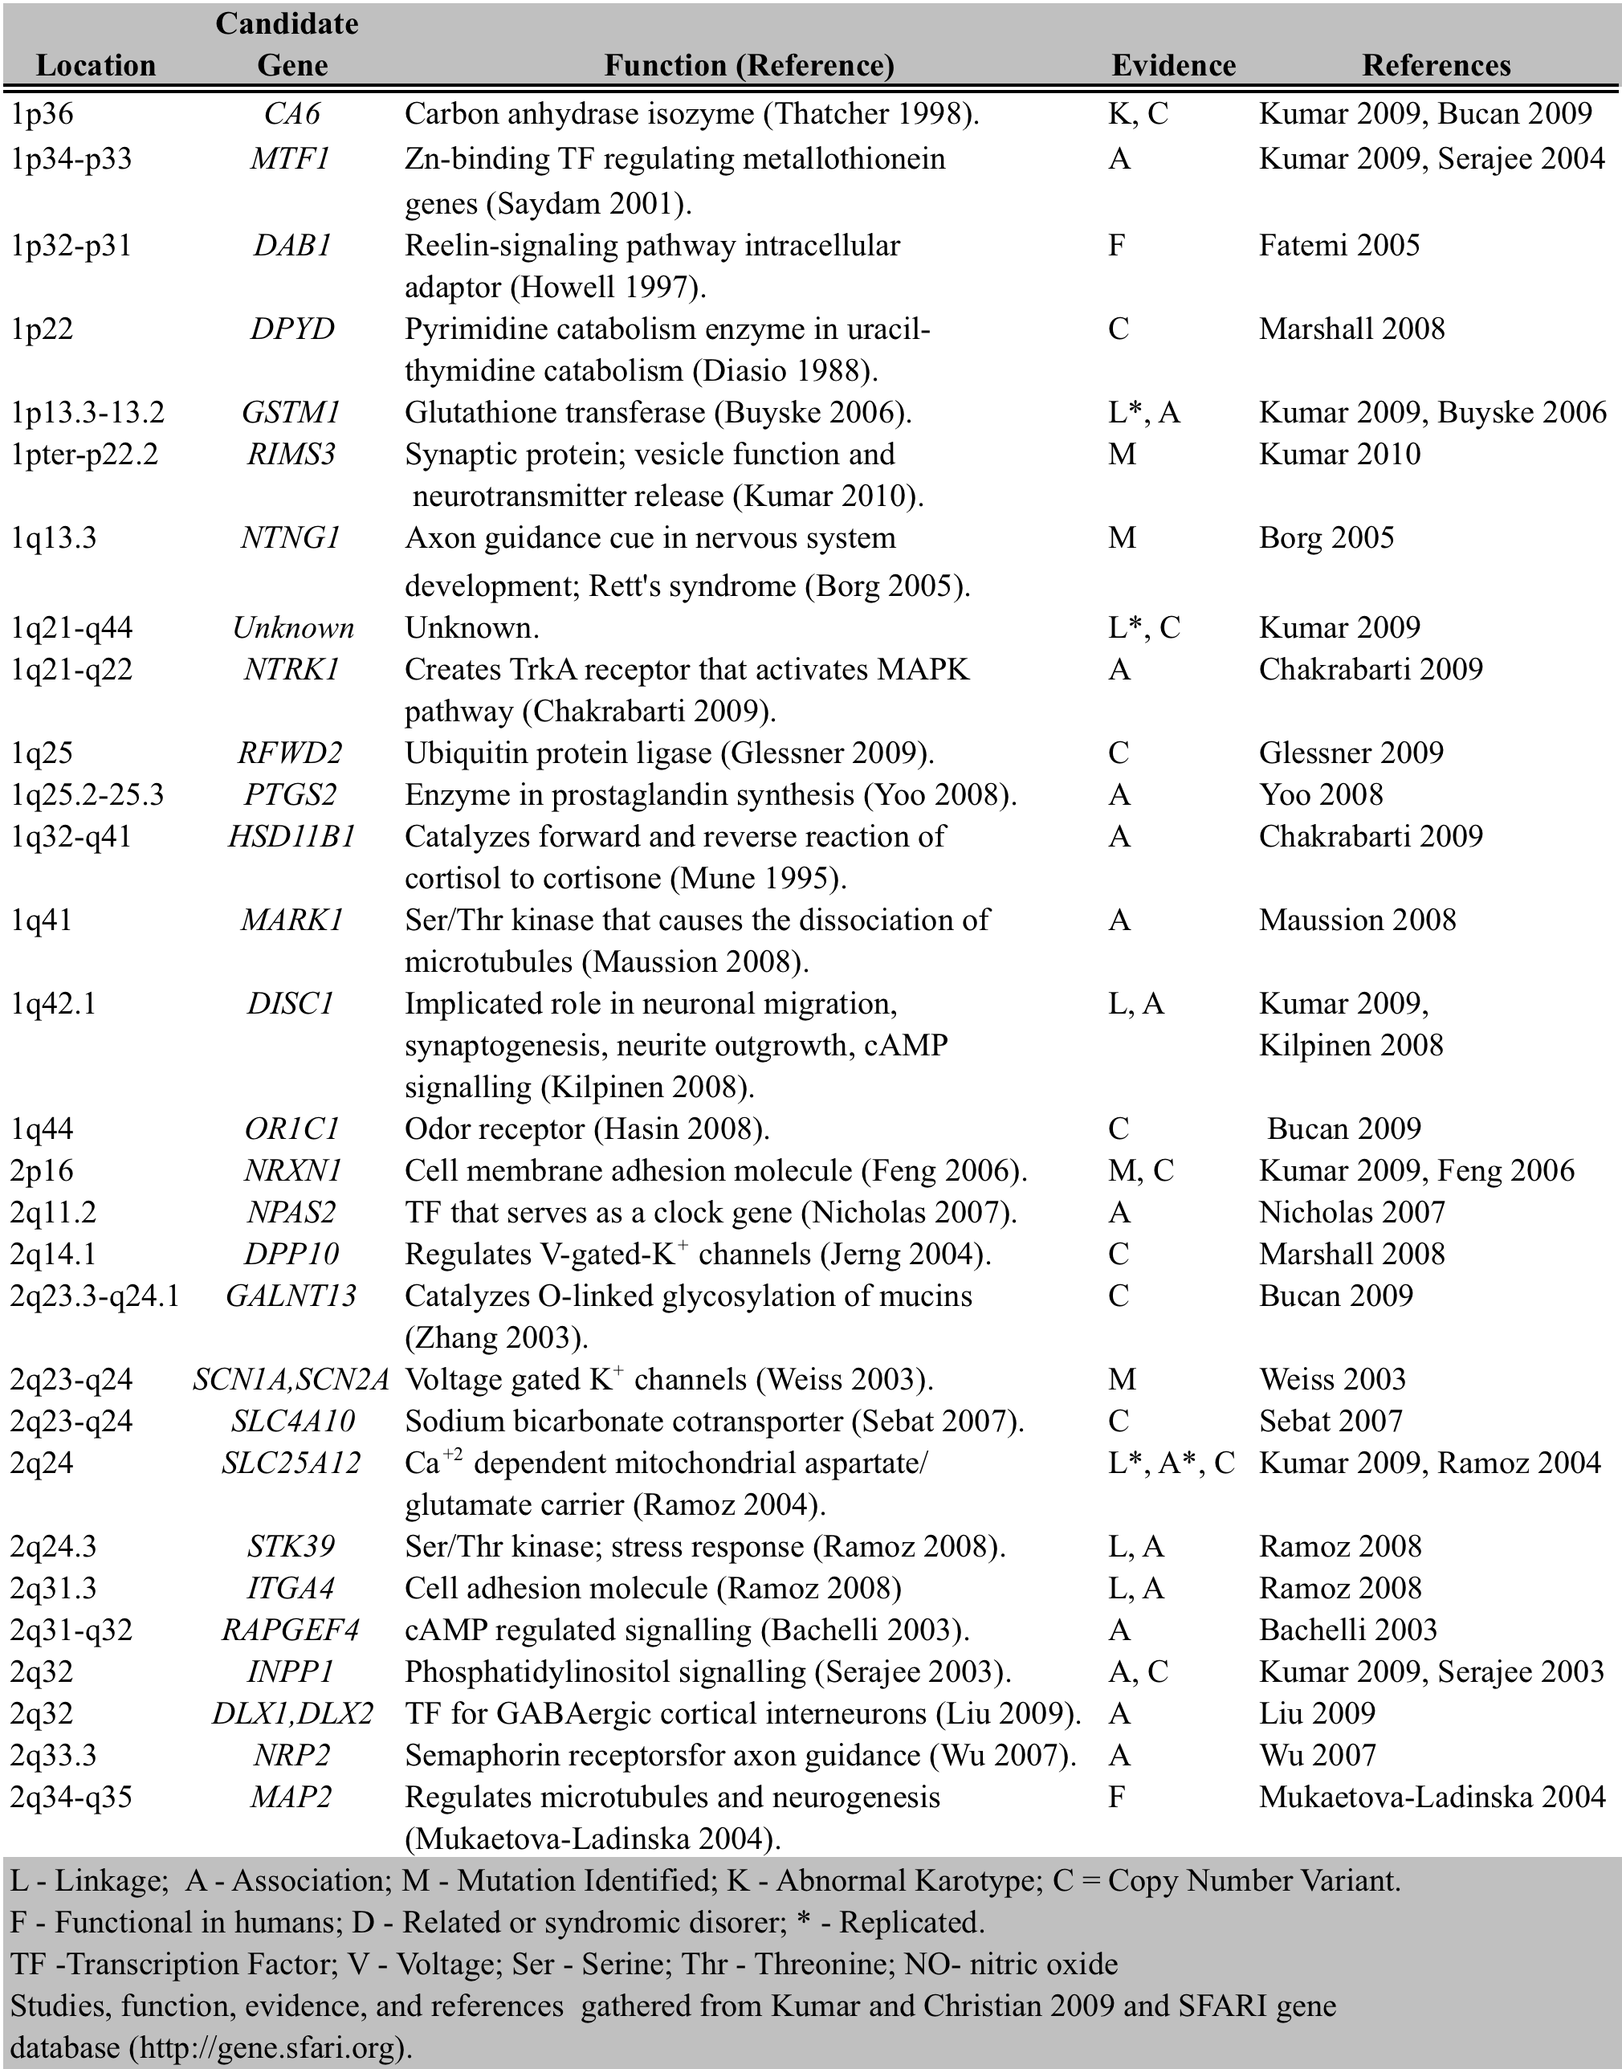

Table 1 – Overview of Genetic Findings regarding Autism
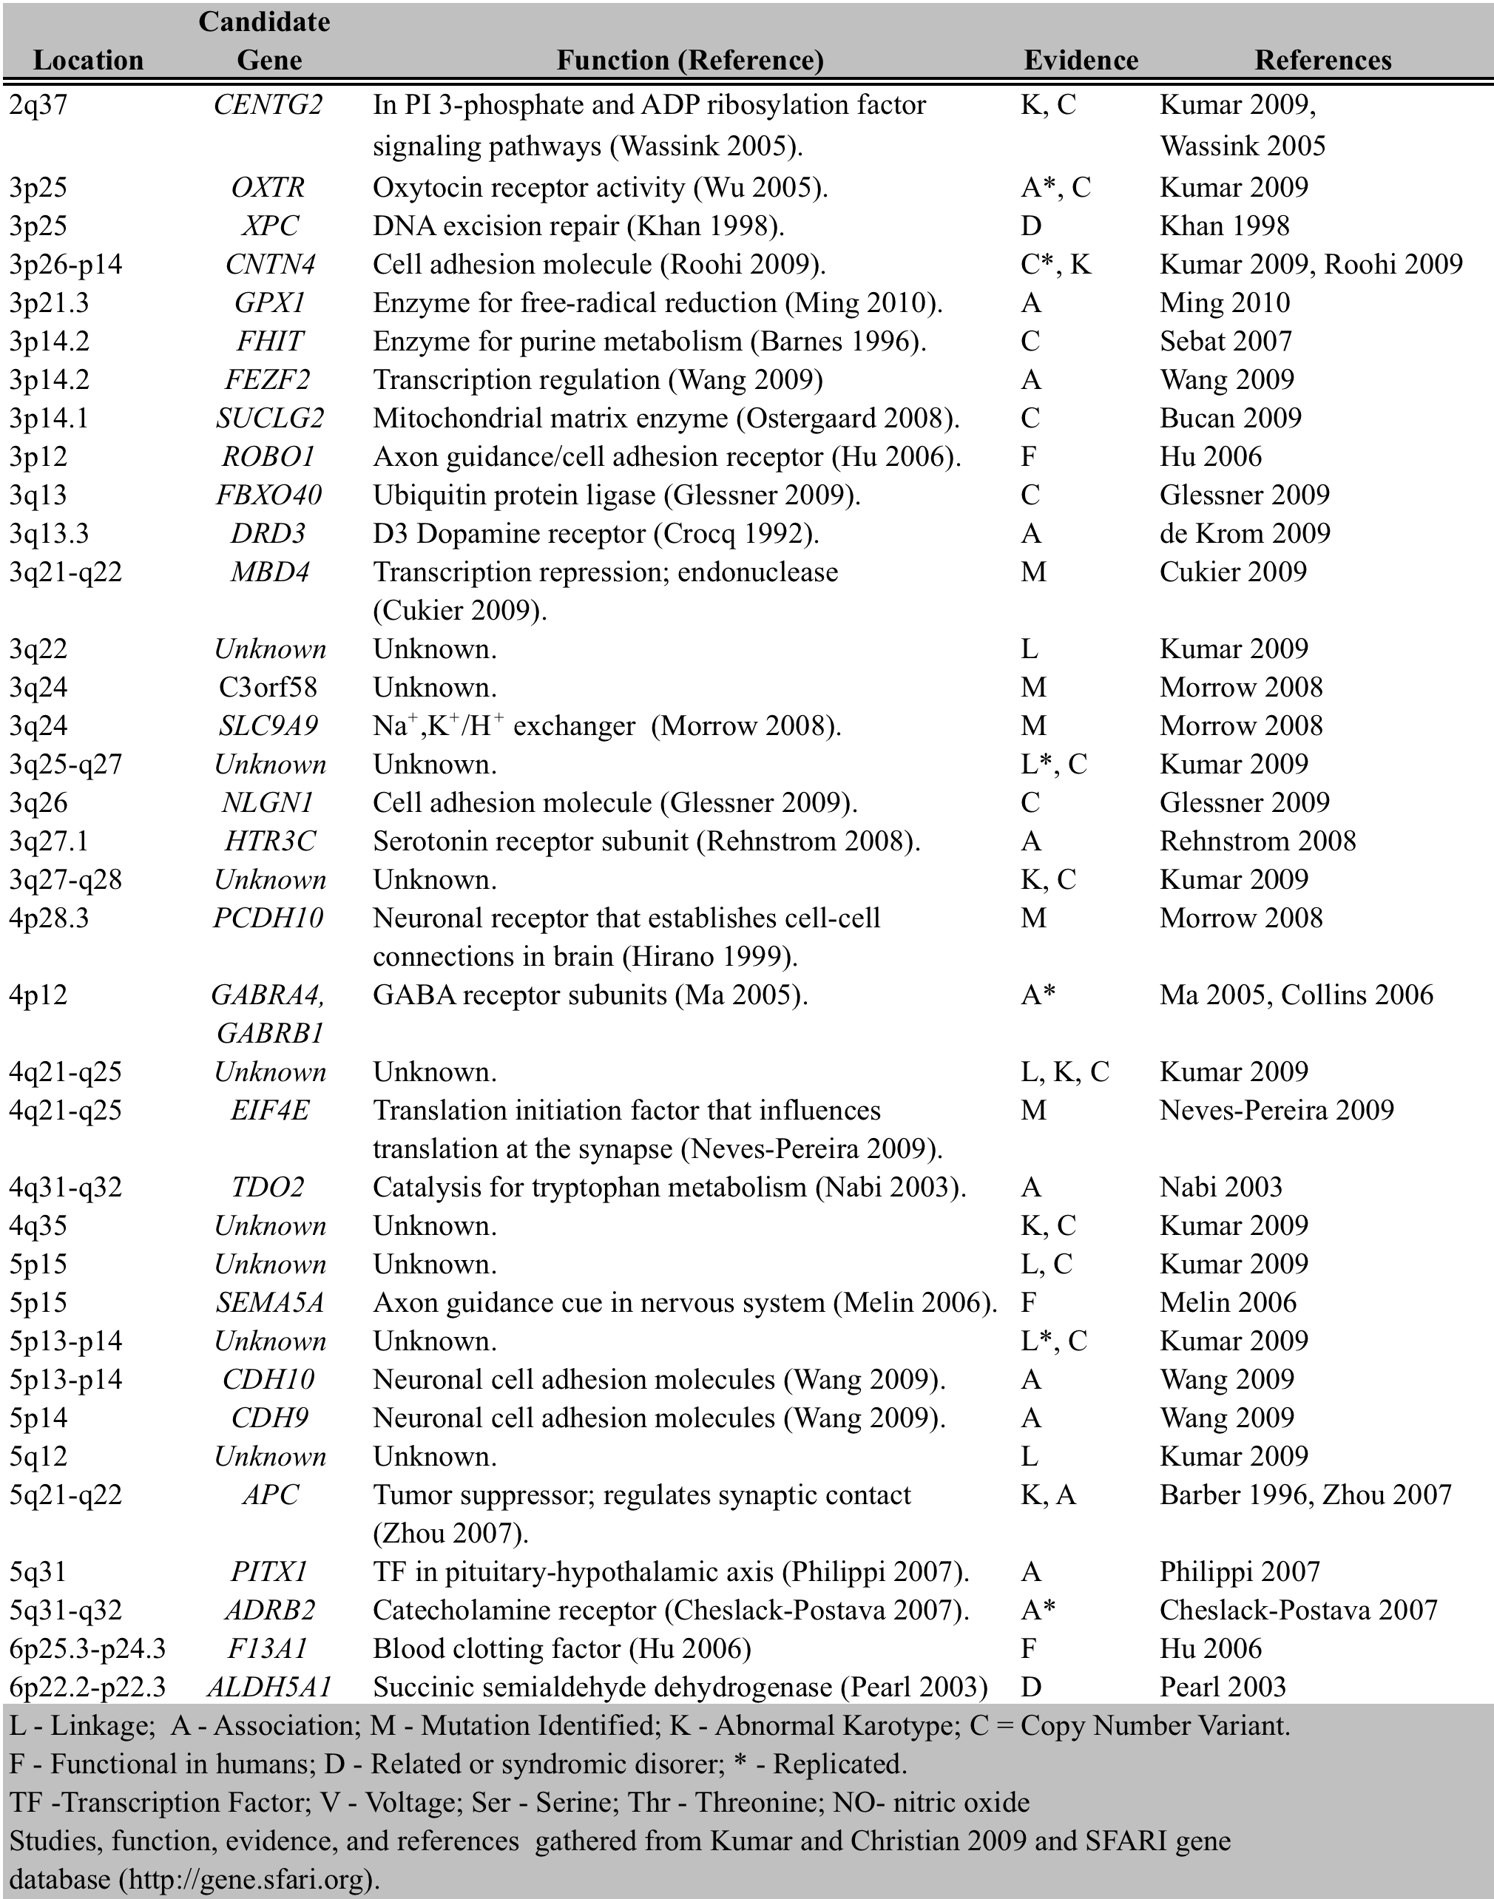

Spellcheck table: “seratonin”. Also make uniform, for instance spell out “serine/threonine kinase”

Table 1 – Overview of Genetic Findings regarding Autism
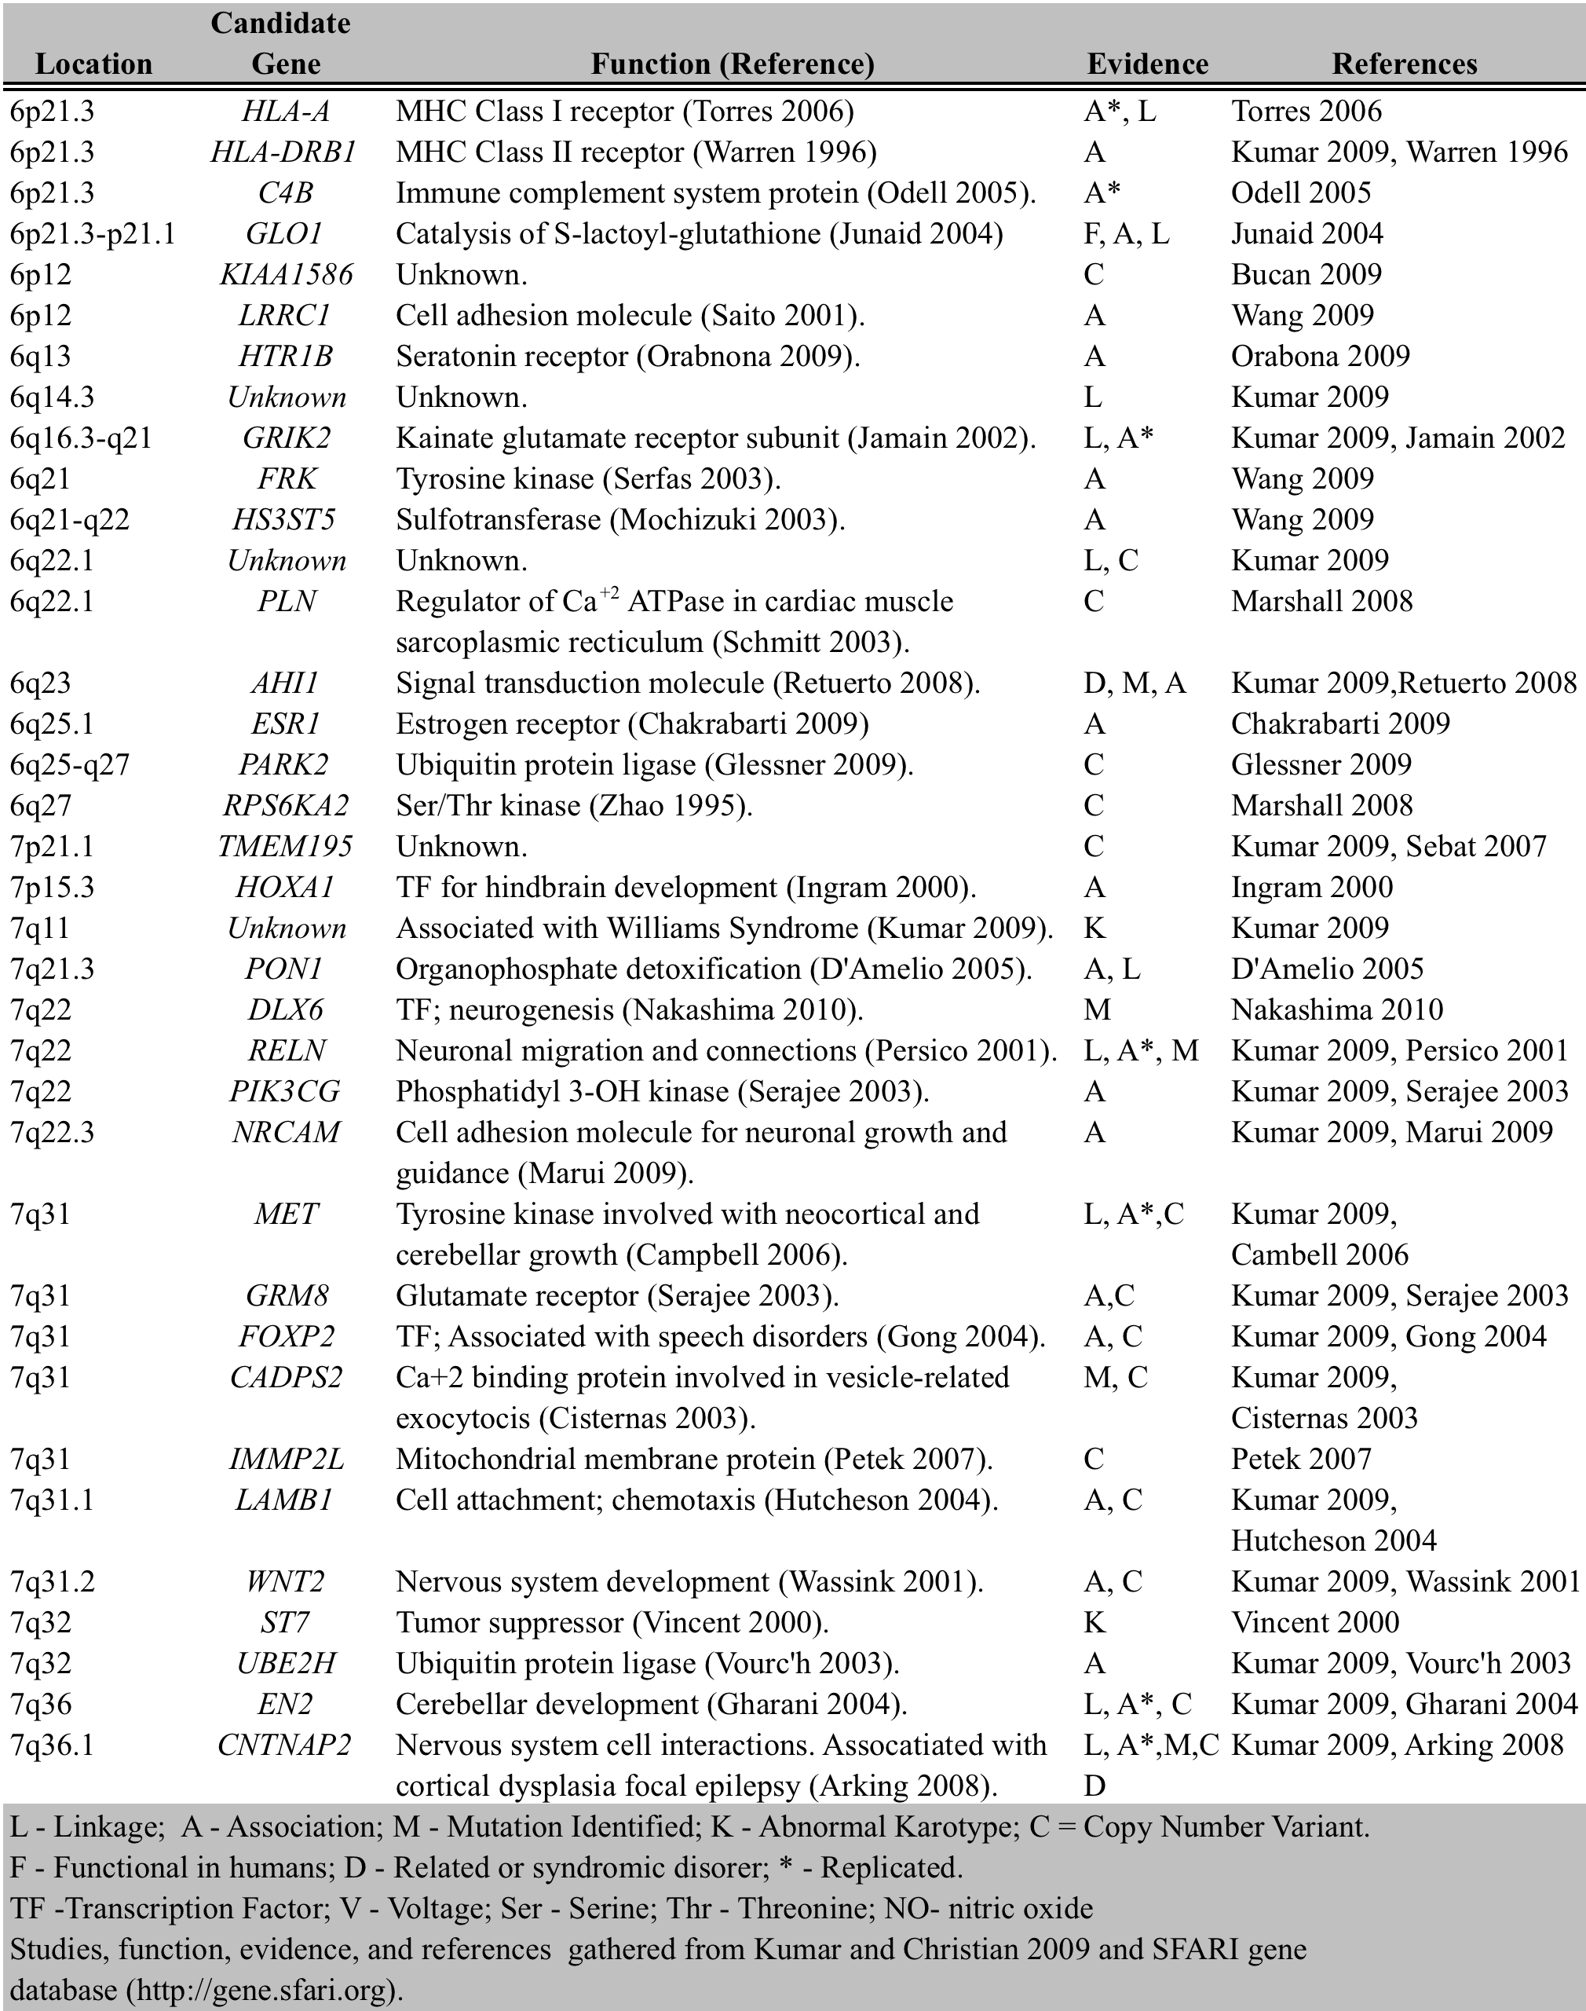

Table 1 – Overview of Genetic Findings regarding Autism
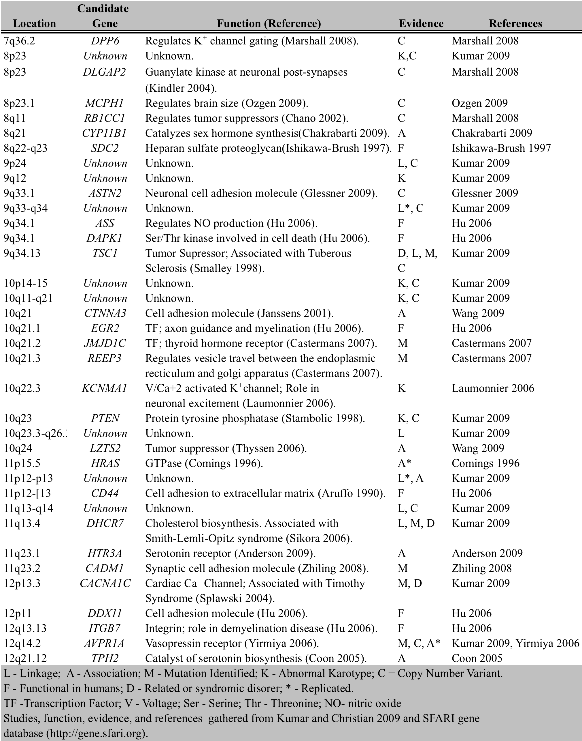

Table 1 – Overview of Genetic Findings regarding Autism
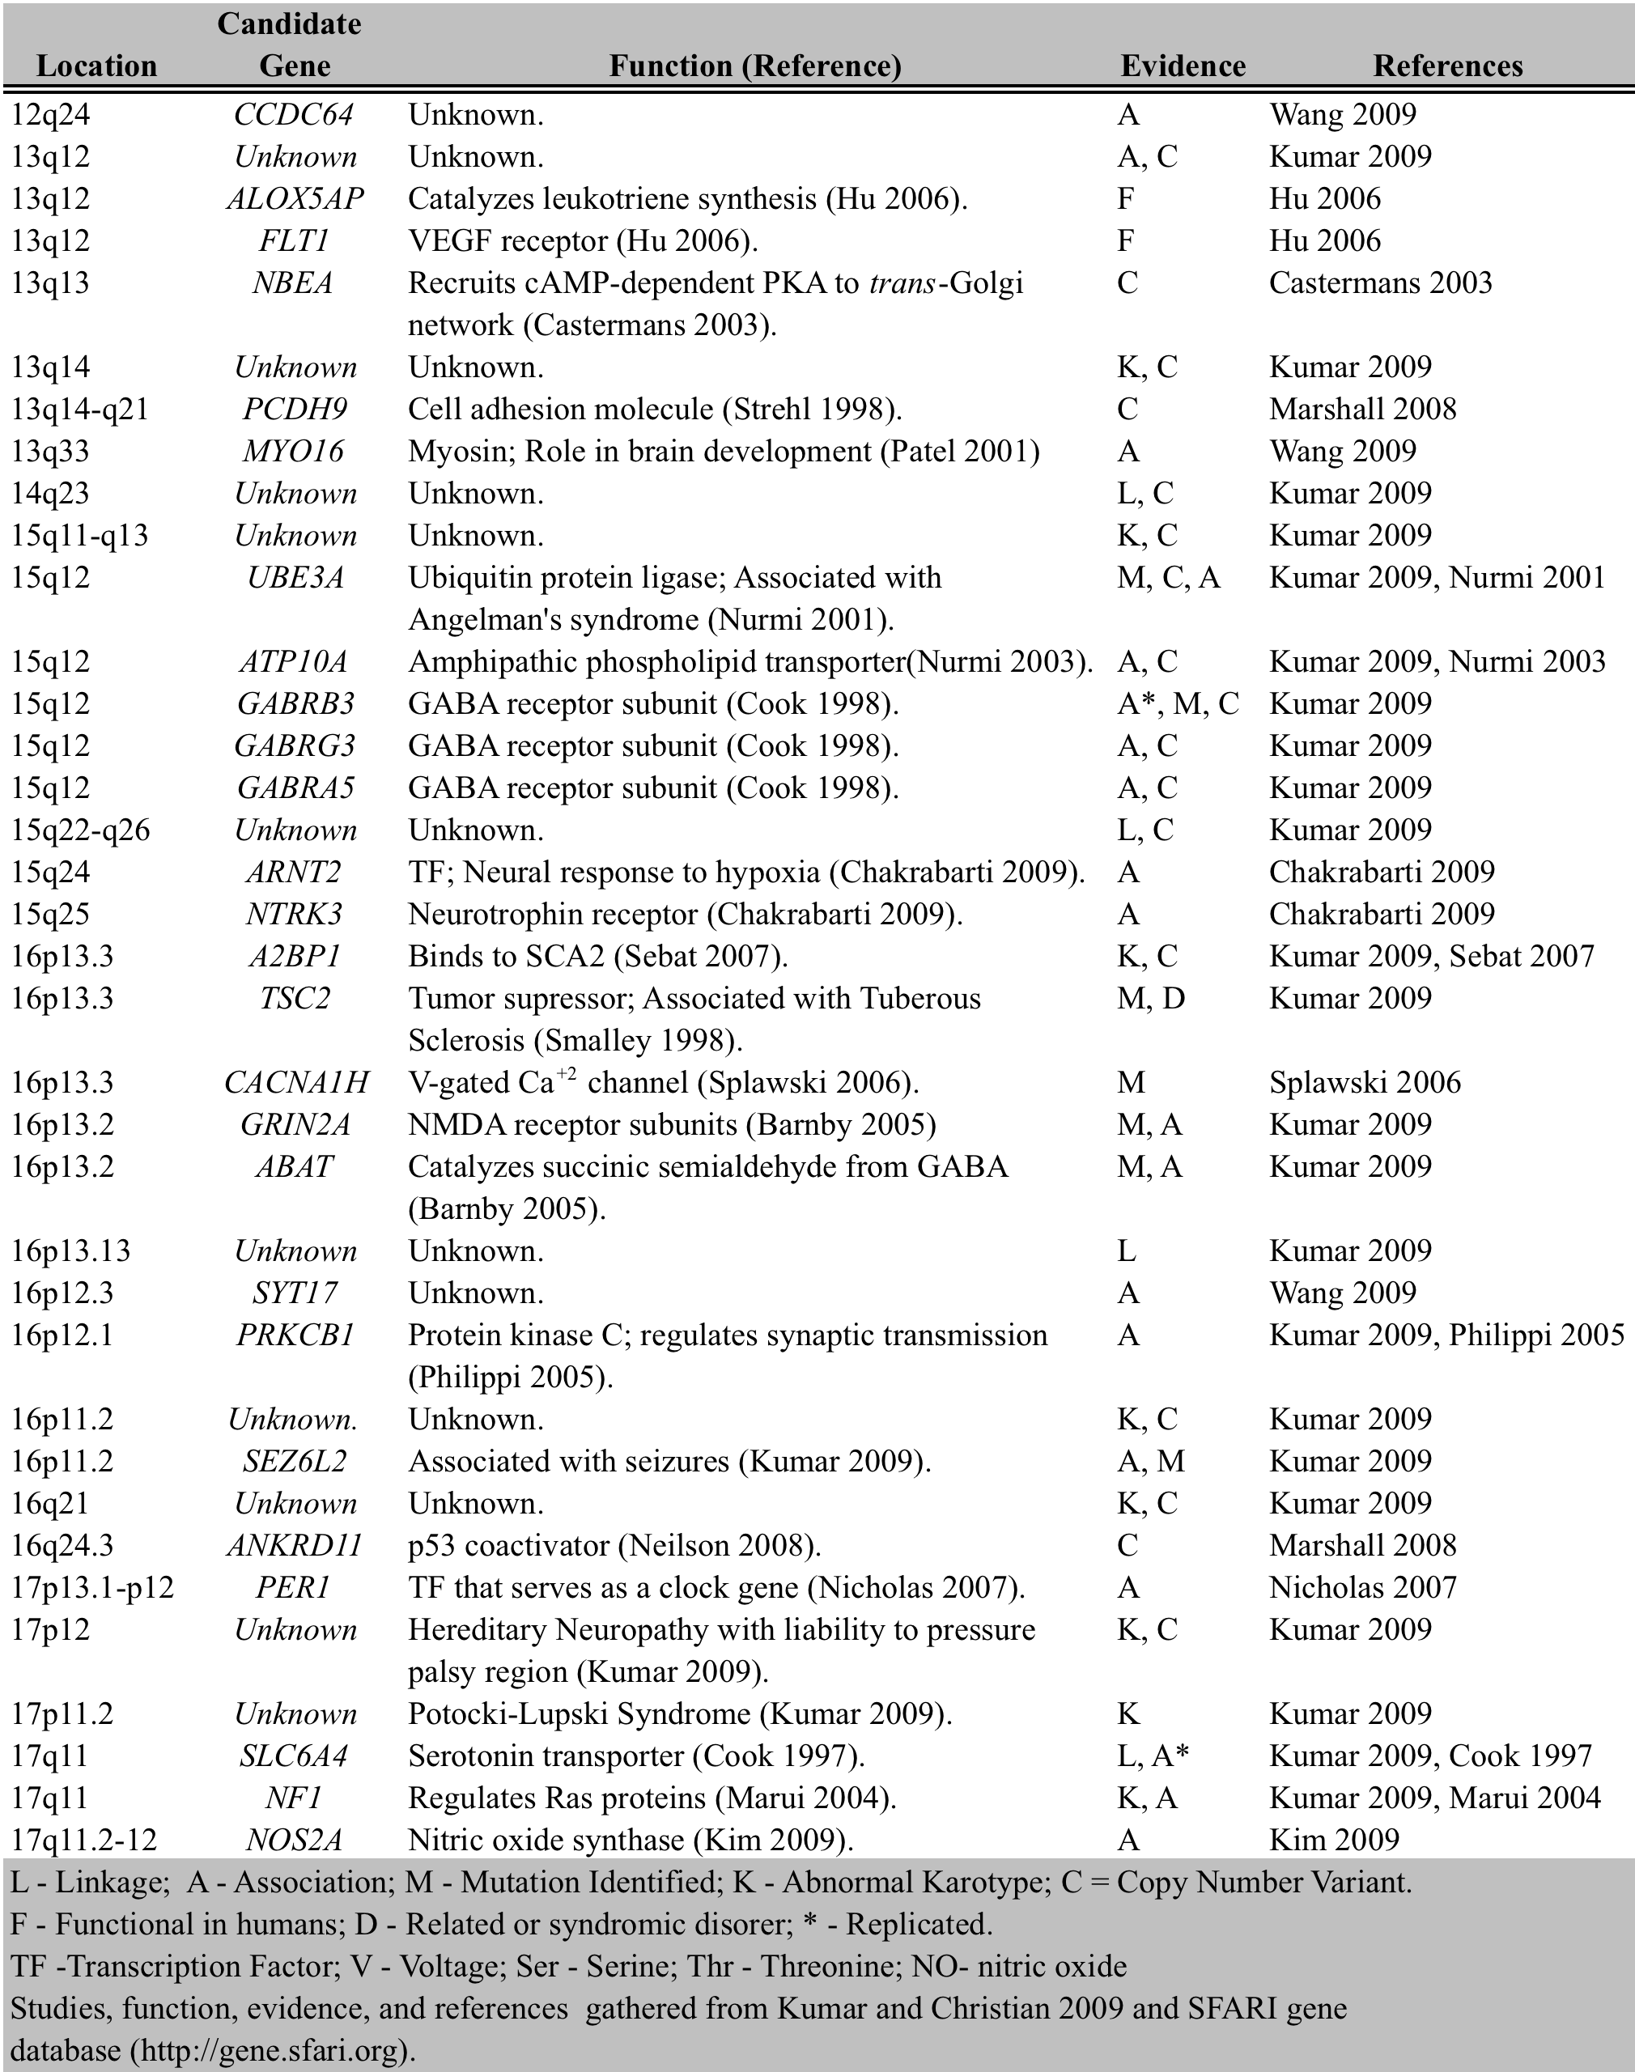

Table 1 – Overview of Genetic Findings regarding Autism
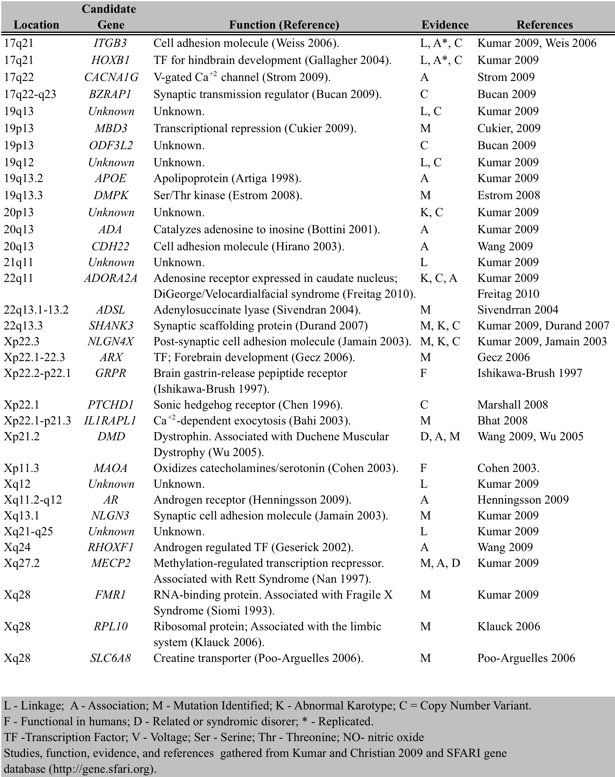

One thing is confusing me about Table 1. It lists only 1-2 studies per gene. Yet for many genes, Table 2 lists many studies. Is there a way to get this across better in Table 1, for instance by listing multiple studies per gene? It might require rotating the format 90 degrees

Page breaks are occurring in wrong places. Use Ctrl-Enter to force a page break
Can the names of these proteins please be given again?
I wonder if this table would be clearer if it were sorted into (a) cases where variation occurs for the same ethnic group resampled in different studies (b) variation where the ethnic group varies too, therefore indicating an actual ethnically-orrelated difference. Also, can you include studies where a locus was studied in multiple ethnic groups and significance was found in all groups studied?

If you find a better abbreviation in the right-hand column, perhaps longer information could be given under Pop. Ethnicity, which is the really interesting column of the table
Table 2 – Ethnic Variation in Autism Findings
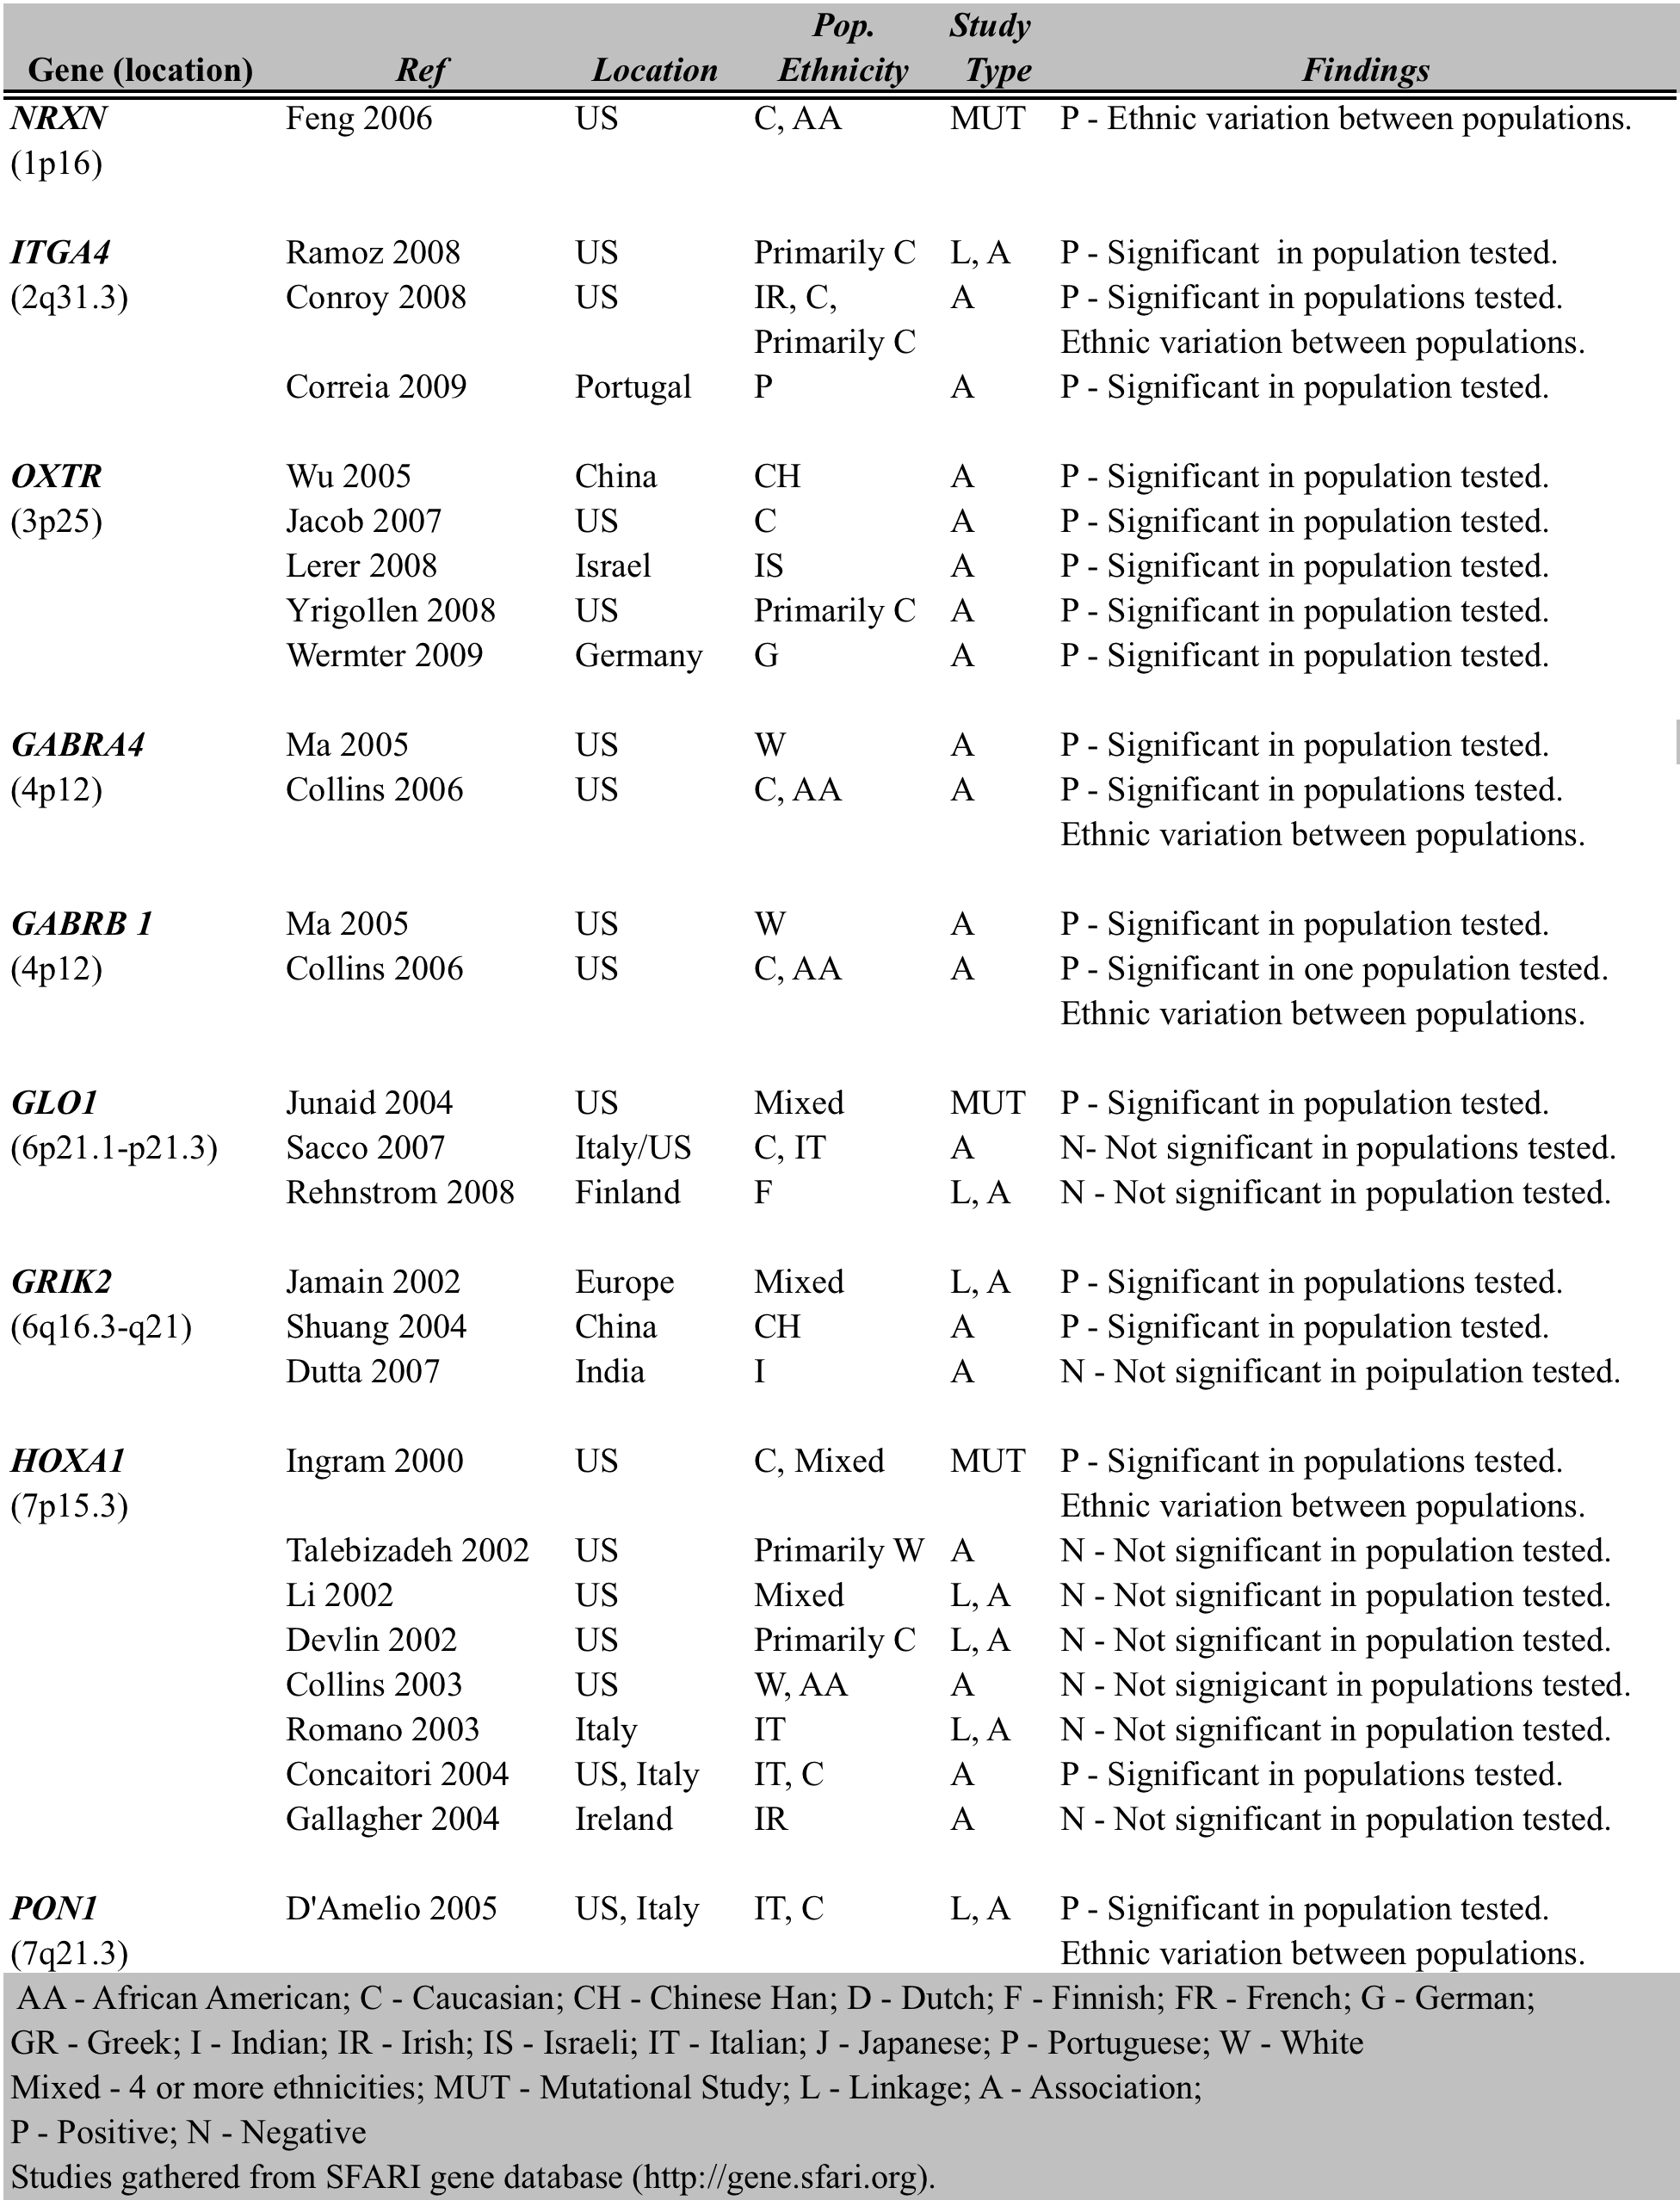

7 lines up “signigicant”??? other similar typos throughout

Table 2 – Ethnic Variation in Autism Findings
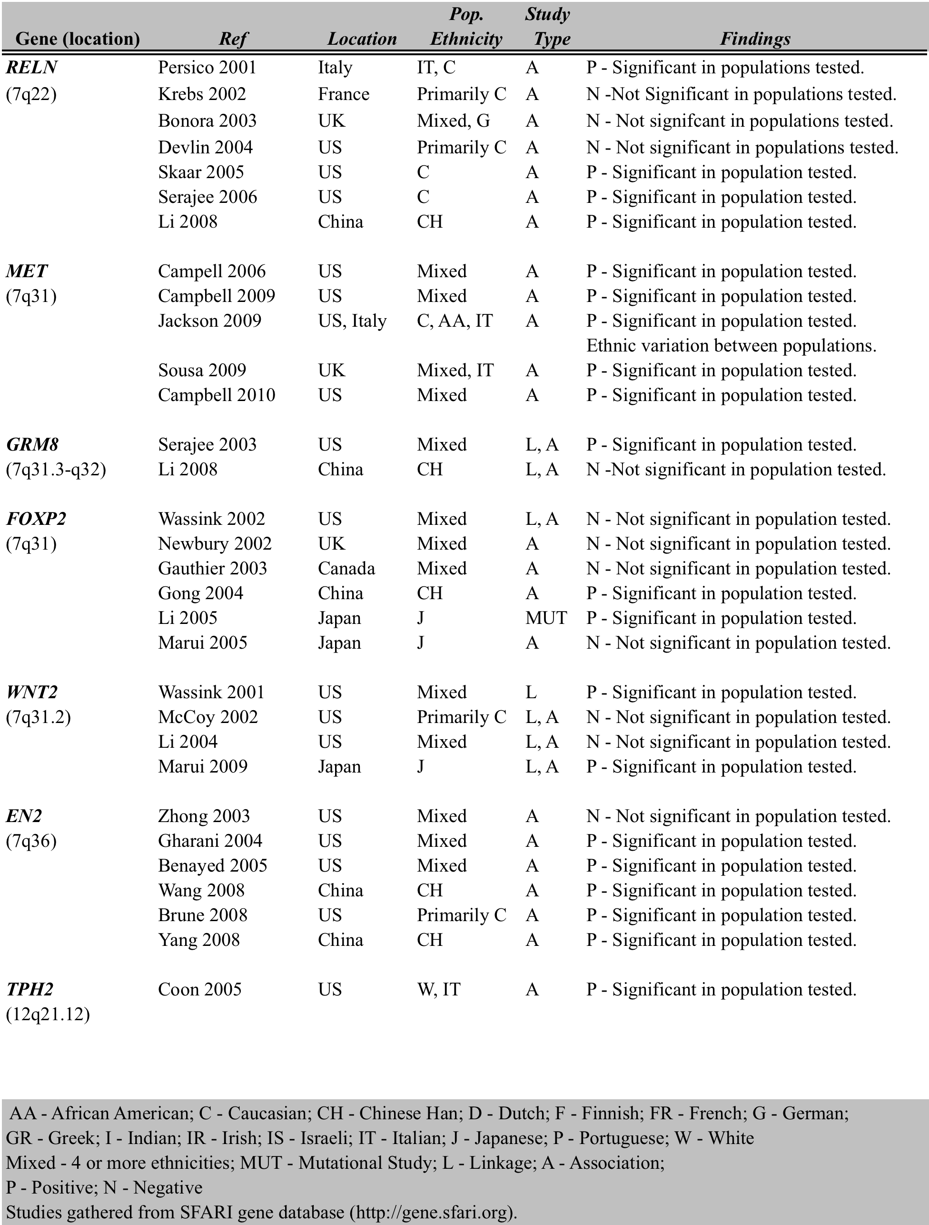

Table 2 – Ethnic Variation in Autism Findings
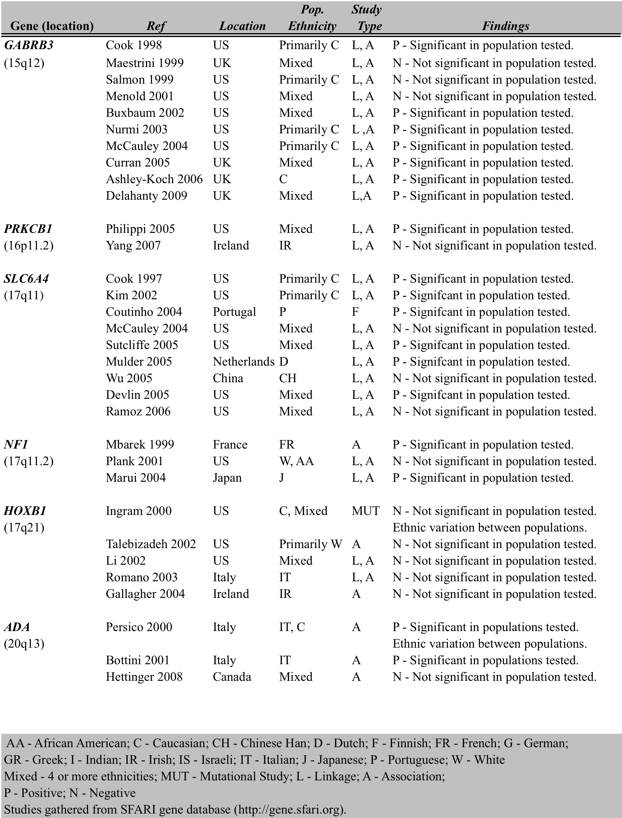

Table 2 – Ethnic Variation in Autism Findings
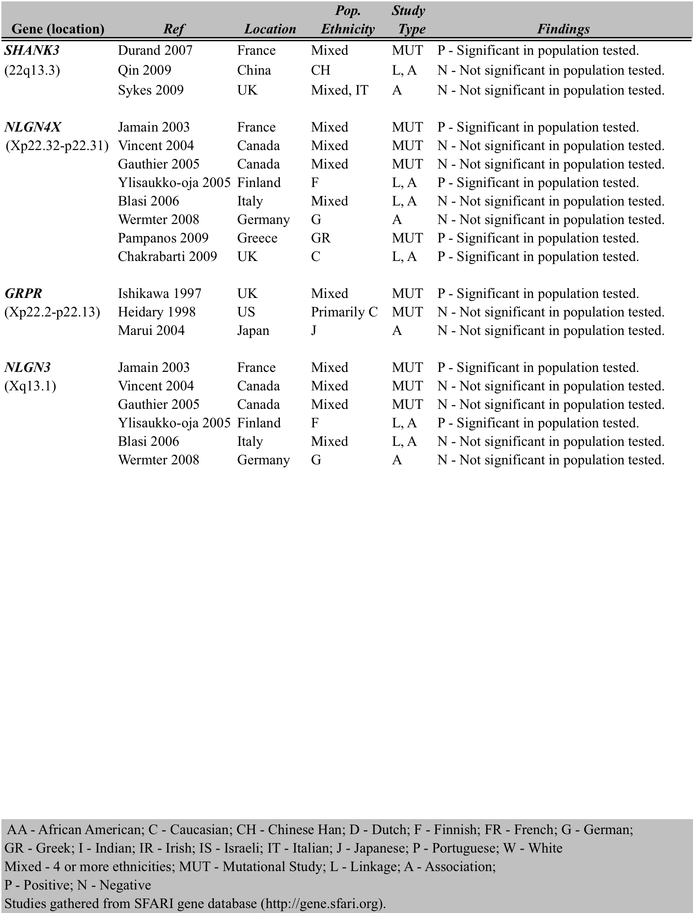

In addition to the above very interesting table, it might be worthwhile to have a table that gives

- number of genes for which an ethnic group has been studied more than once – then give how many of those cases have an apparent variation (i.e. at least one study fails to find an association)

- number of genes for which multiple ethnic groups have been studied – then given how many of those cases have an apparent variation (i.e. at least one ethnic group is reported not to show an association)

The reason is to get some kind of handle on the reliability of a reported association, and whether reported ethnic variation is likely to reflect variation beyond what happens when a population is re-sampled repeatedly.

>>>>>

I am interested in the fact that the genes with most consistent cross-ethnic group associations are OXTR, MET, and EN2. You say that MET is involved in neocortical and cerebellar development. EN2 is involved in cerebellar development. And cerebellum is a commonly altered structure in autism. Oxytocin receptors might not fit into this unification, though there may be something about them that I don’t know about in regard to cerebellum.

It is emerging pretty clearly that you are heading toward a discussion of these exceptional cases. What could account for the variations? I wonder if you will end up discussing variation in methods that might lead to false positives and negatives. For this purpose it might be good to pay attention to the studies that appear to be exceptional, in the sense of accounting for a minority of the findings. Perhaps a count or table indicating what methods were used in these cases, and whether they led to positive or negative results.

It appears to me that mutational studies that go against the group tend to find positive results, and that linkage and association studies tend to find negative results. The only exceptions are NLGN3 and NLGN4X (unless I have misread something, entirely possible). To me this suggests that much of the apparent ethnic variation may simply arise from biases in these approaches. Which leads to some discussion of where those biases come from!

Reference 1 below is mis-ordered.

Works Cited

1. 2003. Introduction to the Analysis of the Human G-Banded Karyotype, p. 259-269. In J. Swansbury (ed.), Cancer Cytogenetics: Methods and Protocols, vol. 220. Humana Press, Totowa.
2. Abrahams, B. S., and D. H. Geschwind. 2008. Advances in Autism Genetics: On the Threshold of a New Neurobiology. Nature Review Genetics 9:341-355.
3. Alarcon, M., R. M. Cantor, J. Liu, T. C. Gilliam, and D. H. Geschwind. 2002. Evidence for a language quantitative trait locus on chromsome 7q in multiplex autism families. American Journal of Human Genetics 70:60-71.
4. Alvarez-Retuerto, A. L., R. M. Cantor, and J. G. Gleeson. 2008. Association of common variants in the Joubert syndrome gene (AHI1) with autism. Human Molecular Genetics 17:3887-3896.
5. Amir, R. E., I. B. Van den Veyver, M. Wan, C. Q. Tran, U. Francke, and H. Y. Zoghbi. 1999. Rett syndrome is caused by mutations in X-linked MECP2, encoding methyl-CpG-binding protein 2. Nature Genetics 23:185-188.
6. Anderson, B. M., N. C. Schnetz-Boutaud, J. Bartlett, and e. al. 2009. Examination of association of genes in the serotonin system to autism. Neurogenetics 10:209-216.
7. Arking, D. E., D. J. Cutler, C. W. Brune, and e. al. 2008. A common genetic variant in the neurexin superfamily member CNTNAP2 increases familial risk of autism. The American Journal Of Human Genetics 82:160-164.
8. Armengol, L., and e. al. 2009. Identification of Copy Number Variants Defining Genomic Differences among Major Human Groups. Public Library of Science ONE 6:e7230.
9. Aronson, M., B. Hagberg, and C. Gilberg. 1997. Attnetion deficits and autism spectrum probelms in children exposed to alcohol during gestation: a follow up study. Developmenal Medicine and Child Neurology 39:583-587.
10. Ashley-Koch, A., H. Mei, J. Jaworski, and e. al. 2006. An analysis paradigm for investigating multi-locus effects in complex disease: examination of three GABA receptor subunit genes on 15q11-q13 as risk factors for autistic disorder. Annals of Human Genetics 70:281-92.
11. Bacchelli, E., F. Blasi, M. Biondolillio, and e. al. 2003. Screening of nine candidate genes for autism on chromosome 2q reveals rare nonsynonymous variants in the cAMP-GEFII gene. Molecular Psychiatry 8:916-924.
12. Bailey, A. e. a. 1995. Autism as a strongly genetic disorder: evidence from a British twin study. Psychological Medicine 25:63-77.
13. Bakkaloglu, B., and e. al. 2008. Molecular Cytogenetic Analysis and Resequencing of Contactin Associated Protein-Like 2 in Autism Spectrum Disorders. The American Journal Of Human Genetics 82:165-173.
14. Barnby, G., A. Abbott, N. Sykes, and e. al. 2005. Candidate-gene screening and association analysis at the autism-susceptibility locus on chromosome 16p: evidence of association at GRIN2A and ABAT. American Journal of Human Genetics 76:950-66.
15. Barnes, L. D., P. N. Garrison, Z. Siprashvili, and e. al. 1996. Fhit, a Putative Tumor Suppressor in Humans, is a Dinucleoside 5',5"'-P1,P3-Triphophate Hydrolase. Biochemistry 35:11529-11535.
16. Baron-Cohen, S., R. C. Knickmeyer, and M. K. Belmonte. 2005. Sex Differences in the Brain: Implications for Explaining Autism. Science 310:819-823.
17. Bayani, J., and J. A. Squire. 2008. Fluorescence In Situ Hybridization In J. M. Walker and R. Rapley (ed.), Molecular Biomethods Handbook. Humana Press, Totowa.
18. Ben-Shachar, S., and e. al. 2009. Microdeletion 15q13.3: a locus with incomplete penetrance for autism, mental retardation, and psychiatric disorders. Journal of Medical Genetics 46:382-388.
19. Benayed, R., and e. al. 2005. Support for the Homeobox Transcription Factor Gene ENGRAILED2 as an Autism Spectrum Disorder Susceptibility Locus. American Journal of Human Genetics 77:851-868.
20. Bill, B. R., and D. H. Geschwind. 2009. Genetic advances in autism: heteroengity and convergence on shared pathways. Current Opinion in Genetics and Development 19:271-278.
21. Bishop, D. V. a. a. 2004. Using self-report to identify the broad phenotype in parents of children with autistic spectrum disorders: a study using the Autism-Spectrum Quotient. Journal of Child Psychology and Psychiatry and Allied Disciplines 2004:1431-1436.
22. Blasi, F., E. Bacchelli, G. Pesaresi, and e. al. 2006. Absence of coding mutations in the X-linked genes neuroligin 3 and neuroligin 4 in individuals with autism from the IMGSAC collection. American Journal of Medical Genetics Part B 141B:220-21.
23. Bolton, P. 1994. A case-control family history study of autism. Journal of Child Psychology and Psychiatry and Allied Disciplines 35:877-900.
24. Bonora, E., K. S. Beyer, and J. A. Lamb. 2003. Analysis of reelin as a candidate gene for autism. Molecular Psychiatry 8:885-892.
25. Bonora, E., J. A. Lamb, G. Barnby, A. J. Bailey, and A. P. Monaco. 2006. Genetic Basis of Autism, p. 49-74. In S. O. Moldin and J. L. R. Rubenstein (ed.), Understanding Autism: From Basic Neuroscience to Treatment. Taylor and Francis, Boca Raton.
26. Borg, I., F. K., S. Kubart, and e. al. 2005. Disruption of Netrin G1 by a balanced chromosome translocation in a girl with Rett Syndrome. European Journal of Human Genetics 13:921-927.
27. Bottini, N., D. De Luca, P. Saccucci, and e. al. 2001. Autism: evidence of Association with adenosine deaminase genetic polymorphism. Neurogenetics 3:111-3.
28. Brune, C. W., and e. al. 2008. Heterogenous Association Between Engrailed-2 and Autism in the CPEA Network. American Journal of Human Genetics Part B 147B:187-193.
29. Bucan, M., B. S. Abrahams, K. Wang, and e. al. 2009. Genome-Wide Analyses of Exonic Copy Number Variants in a Family-Based study Point to Novel Autism Susceptibility Genes. Public Library of Science Genetics 5:e1000536.
30. Buxbaum, J. D., J. M. Silverman, C. J. Smith, and e. al. 2002. Association between a GABRB3 polymorphism and autism. Molecular Psychiatry 7:311-6.
31. Buyske, S., T. A. Williams, A. E. Mars, and e. al. 2006. Analysis of case-patient trios at a locus with a deletion allele: association of GSTM1 with autism. Biomed Central Genetics 7.
32. Campbell, D. B., T. M. Buie, H. Winter, and e. al. 2009. Distinct Genetic Risk Based on Association of MET in Families With Co-occuring Autism and Gastrointestinal Conditions. Pediatrics 123:1018-1024.
33. Campbell, D. B., J. S. Sutcliffe, P. J. Ebert, and e. al. 2006. A genetic variant that disrupts MET transcription is associated with autism. Proceedings of the National Academy of Sciences 103:16834-9.
34. Campbell, D. B., D. Warren, J. S. Sutcliffe, E. B. Lee, and P. Levitt. 2010. Association of MET with social and communication phenotypes in individuals with autism spectrum disorder. American Journal of Medical Genetics Part B 153B:438-46.
35. Castermans, D., J. R. Vermeesch, J. Fryns, and e. al. 2007. Identification and characterization of the TRIP8 and REEP3 genes on chromosome 10q21.3 as novel candidate genes for autism. European Journal of Human Genetics 15:422-431.
36. Castermans, D., V. Wilquet, E. Parthoens, and e. al. 2003. The neurobeachin gene is disrupted by a translocation in a patient with idiopathic autism. Journal of Medical Genetics 40:352-6.
37. Chakrabarti, B., F. Dudbridge, L. Kent, and e. al. 2009. Genes Related to Sex Steroid, Neural Growth, and Social-Emotional Behavior are Associated with Autistic Traits, Empathy, and Asperger's Syndrome. Autism Research 2:157-177.
38. Chakrabarti, S., and E. Fombonne. 2001. Pervasive developmental disorder in preschool children. JAMA 285:3093-3099.
39. Chano, T., K. K., K. Teramoto, and e. al. 2002. Truncating mutations of RB1CC1 in human breast cancer. Nature Genetics 31:285-288.
40. Chen, G. K., N. Kono, D. H. Geschwind, and R. M. Cantor. 2006. Quantitative trait locus analysis of nonverbal communication in autism spectrum disorder. Molecular Psychiatry 11:214-220.
41. Chen, Y., and G. Struhl. 1996. Dual Roles for Patched in Sequestering and Transducing Hedgehog. Cell 87:553-63.
42. Cheslack-Postava, K., M. D. Fallin, D. Avramopoulos, and e. al. 2007. beta2-Adrenergic receptor gene variants and risk for autism in the AGRE cohort. Molecular Psychiatry 12:283-291.
43. Chess, S. 1971. Autism in Children with Congenital Rubella. Journal of autism and childhood schizophrenia 1:33-47.
44. Christian, S. L., and e. al. 2008. Novel Submicroscopic Chromosomal Abnormalities Detected in Autism Spectrum Disorder. Biological Psychiatry 63:1111-1117.
45. Christianson, A. L., N. Chesler, and J. G. Kromberg. 1994. Fetal valproate syndrome: clincial and neuro-developmental features in two sibling pairs. Developmenal Medicine and Child Neurology 36:361-369.
46. Chudley, A. E., E. Gutierrez, L. J. Jocelyn, and B. N. Chodirker. 1998. Outcomes of Genetic Evlaution in Children with Pervasive Developmental Disorder. Journal of Developmental and Behavioral Pediatrics 19:321-325.
47. Cisternas, F. A., J. B. Vincent, S. W. Scherer, and P. N. Ray. 2003. Cloning and characterization of human CADPS and CADPS2, new members of the Ca2+-dependent activator for secretion protein family. Genomics 81:279-291.
48. Cohen, I. L., X. Liu, C. Schutz, and e. a;. 2003. Association of autism severity with a monoamine oxidate A functional polymorphism. Clinical Genetics 64:190-7.
49. Collins, A. L., and e. al. 2006. Investigation of autism and GABA receptor subunit genes in multiple ethnic groups. Neurogenetics 7:167-174.
50. Collins, J. S., R. J. Schroer, J. Bird, and R. C. Michaelis. 2003. The HOXA1 A218G Polymorphism and Autism: Lack of Association in White and Black Patients from the South Carolina Autism Project. Journal of Autism and Developmental Disorders 33:343-348.
51. Comings, D. E., S. Wu, and C. Chiu. 1996. Studies of the c-Harvey-Ras gene in psychiatric disorders. Psychiatry Research 63.
52. Conroy, J., L. Cochrane, R. J. L. Anney, and e. al. 2008. Fine Mapping and Association Studies in a Candiate Region for Autism on Chromosome 2q31-q32. American Journal of Medical Genetics Part B 150B:535-544.
53. Consortium, H. 2005. A haplotype map of the human genome. Nature 437:1299-1320.
54. Cook 1998, posting date. Linkage-disequilibrium mapping of autistic disorder, with 15q11-13 markers. University of Chicago Press etc. [Online.]
55. Cook, E. H., R. Y. Corchesne, N. J. Cox, and e. al. 1998. Linkage-disequilibrium mapping of autistic disorder, with 15q11-13 markers. American Journal of Medical Genetics 62:1077-83.
56. Cook, E. H., R. Courchesne, C. Lord, and e. al. 1997. Evidence of linkage between the serotonin transporter and autistic disorder. Molecular Psychiatry 2:247-250.
57. Coon, H., D. Dunn, J. Lainhart, and e. al. 2005. Possible association between autism and variants in the brain-expressed tryptophan hydroxylase gene (TPH2). American Journal of Medical Genetics Part B 135B:42-46.
58. Correia, C., A. M. Coutinho, J. Almeida, and e. al. 2009. Association of the alpha-4 Integrin Subunit Gene (ITGA4) with Autism. American Journal of Medical Genetics Part B 150B:1147-51.
59. Coutinho, A. M., G. Oliveria, T. Morgadinho, and e. al. 2004. Variants of the serotonin transporter gene (SLC6A4) significantly contribute to hyperseronemia in autism. Molecular psychiatry 9:264 - 271.
60. Crocq, M. A., R. Mant, P. Asherson, and e. al. 1992. Association between schizophrenia and homozygosity at the dopamine D3 receptor gene. Journal of Medical Genetics 29:858-860.
61. Cukier, H. N., R. Rabionet, I. Konidari, and e. al. 2009. Novel variants identified in methyl-CpG binding domain genes in autistic individuals. Neurogenetics 10.
62. Curran, S., S. Roberts, S. Thomas, and e. al. 2005. An analysis paradigm for investigating multi-locus effects in complex disease: examination of three GABA receptor subunit genes on 15q11-q13 as risk factors for autistic disorder. American Journal of Medical Genetics Part B 137B:25-8.
63. D'Amelio, M., I. Ricci, R. Sacco, and e. al. 2005. Paraoxonase gene variants are associated with autism in North America, but not in Italy: possible regional specificity in gene-environment interactions. Molecular Psychiatry 10:1006-1016.
64. de Krom, M., W. G. Staal, R. A. Ophoff, and e. al. 2009. A Common Variant in DRD3 Receptor is Associated with Autism Spectrum Disorder. Biological Psychiatry 65:625-630.
65. Delahanty, R. J., J. Q. Kang, C. W. Brune, and e. al. 2009. Maternal transmisison of a rare GABRB3 signal peptide variant is associated with autism. Molecular Psychiatry.
66. Delong, G. R., and J. T. Dwyer. 1988. Correlation of Family History with Specific Autistic Subgroups: Aspergere's Syndrome and Bipolar Affective Disease. Journal of Autism and Developmental Disorders 18:593-600.
67. Devlin, B., P. Bennett, E. H. Cook, and e. al. 2002. No Evidence for Linkage of Liability to Autism to HOXA1 in a Sample From the CPEA Network. American Journal of Medical Genetics 114:667-672.
68. Devlin, B., P. Bennett, G. Dawson, and e. al. 2004. Alleles of a Reelin CGG Repeat do not Convey Liability to Autism in a Sample From the CPEA Network. American Journal of Medical Genetics Part B 126B:46-50.
69. Devlin, B., E. H. Cook, H. Coon, and e. al. 2005. Autism and the serotonin transporter: the long and short of it. Molecular Psychiatry 10:1110-6.
70. Diasio, R. B., T. L. Beavers, and J. T. Carpenter. 1988. Familial Deficienct of Dihydropyrimidine Dehydrogenase. Journal of Clinical Investigation 81:47-51.
71. Durand, C. M., C. Betancur, T. M. Boeckers, and e. al. 2007. Mutations in the gene encoding the synaptic scaffolding protein SHANK3 are associated with autism spectrum disorders. Nature Genetics 39:25-7.
72. Dutta, S., and E. al. 2007. Glutmate Receptor 6 Gene (GLuR6 or GRIK2) Polymorphism in the Indian Population: A Genetic Association Study on Autism Spectrum Disorder. Cell and Molecular Neurobiology 27:1035-1047.
73. Ekstrom, A., L. Hakenas-Plate, L. Samuelsson, and e. al. 2008. Autism spectrum conditions in myotonic dystrophy type 1: a study on 57 individuals with congenital and childhood forms. American Journal of Medical Genetics Part B 147B:918-926.
74. Fatemi, S. H., A. V. Snow, J. M. Stary, and e. al. 2005. Reelin Signaling is Impaired in Autism. Biological Psychiatry 57.
75. Feng, J., R. Schroer, J. Yan, and e. al. 2006. High frequency of neurexin 1B signal peptide structure variants in patients with autism. Neuroscience Letters 409:10-13.
76. Feuk, L., A. R. Carson, and S. W. Scherer. 2006. Structural Variation in the Human Genome. Nature Genetics 7:85-97.
77. Folstein, S., and M. Rutter. 1977. Infantile Autism: A Genetic Study of 21 Twin Pairs. Journal of Child Psychology and Psychiatry and Allied Disciplines 18:297-321.
78. Folstein, S. E., and B. Rosen-Sheidley. 2001. Genetics of Autism: Complex Aetiology for a Heterogenous Disorder. Nature Review Genetics 2:943-955.
79. Fombonne, E., H. Simmons, T. Ford, H. Meltzer, and R. Goodman. 2003. Prevalence of pervastive developmental disorders in the British nationwide survey of child mental health. International Review of Psychiatry 15:158-165.
80. Foundation, S. 2010, posting date. SFARI gene. [Online.]
81. Freitag, C. M., K. Agelopoulos, E. Huy, and e. al. 2010. Adenosine A(2A) receptor gene (ADORA2A) variants may increase autistic symptoms and anxiety in autism spectrum disorder. European Child and Adolescent Psychiatry 19:67-74.
82. Gallagher, L., Z. Hawi, G. Kearney, and e. al. 2004. No Association Between Alleic Variants of HOXA1/HOXB1 and Autism. American Journal of Medical Genetics Part B 124B:64-67.
83. Gallagher, L., Z. Hawi, G. Kearney, and e. al. 2004. No association between allelic variants of HOXA1/HOXB1 and autism. American Journal of Medical Genetics Part B 124B:64-7.
84. Gauthier, J., and e. al. 2003. Mutation Screening of FOXP2 in Individuals Diagnosed ith Autistic Disorder. American Journal of Human Genetics 118A:172-175.
85. Gauthier, J., A. Bonnel, J. St-Onge, and e. al. 2005. NLGN3/NLGN4 Gene Mutations are not responsible for autism in the Quebec Population. American Journal of Medical Genetics Part B 132B:74-75.
86. Gecz, J., D. Cloosterman, and M. Partington. 2006. ARX: a gene for all seasons. Current Opinion in Genetics and Development 16:308-316.
87. Geserick, C., B. Weiss, W. Schleuling, and e. al. 2002. OTEX, an androgen-regulated human member of the paired-like class of homeobox genes. Biochemistry Jounral 366:367-75.
88. Gharani, N., R. Benayed, V. Mancuso, L. M. Brzustowicz, and J. H. Millonig. 2004. Association of the homeobox transcription factor, ENGRAILED 2, 3, with autism spectrum disorder. Molecular Psychiatry 9:474-484.
89. Glessner, J. T., K. Wang, G. Cai, and e. al. 2009. Autism genome-wide copy number variation reveals ubiquitin and neuronal genes. Nature 459:569-573.
90. Gong, X., M. JIa, Y. Ruan, and e. al. 2004. Association Between the FOXP2 Gene and Autistic Disorder in Chinese Population. American Journal of Human Genetics Part B 127B:113-116.
91. Gong, X., M. Jia, Y. Ruan, M. Shuang, J. Liu, S. Wu, Y. Guo, J. Yang, Y. Ling, X. Yang, and D. Zhang 2004, posting date. Association between the FOXP2 gene and autistic disorder in Chinese population. Wiley-Liss. [Online.]
92. Haddow, J. E., and E. al. 1999. Maternal thyroid deficiency durign pregnancy and subsequeny neuropsychological development of the child. The New England Journal of Medicine 341:549-555.
93. Hallmayer, J., D. Spiker, L. Lotspeich, and e. al. 1996. Male-to-male transmission in extrended pedigrees with multiple cases of autism. American Journal of Medical Genetics 67:13-18.
94. Hasin, Y., T. Olender, M. Khen, and e. al. 2008. High-resolution copy-number variation map reflects human olfactory receptor diversity and evolution. Public Library of science ONE 4.
95. Heidary, G., L. L. Hampton, N. C. Schanen, and e. al. 1998. Exclusion of the Gastrin-Releasing Peptide Receptor (GRPR) Locus as a Candidate Gene for Rett Syndrome. American Journal of Medical Genetics 78:173-175.
96. Henningsson, S., L. Jonsson, E. Ljunggren, and e. al. 2009. Possible association between the androgen receptor gene and autism spectrum disorder. Psychoneuroendocrinology 34:752-61.
97. Hettinger, J. A., X. Liu, and J. J. Holden. 2008. The G22A Polymorphism of the ADA gene and susceptibility to autism spectrum disorders. Journal of Autism and Developmental Disorders 38:14-9.
98. Hirano, S., S. T. Suzuki, and C. Redies. 2003. The Cadherin Superfamily in Neural Development: Diversity, Function, and Interaction with Other Molecules. Frontiers in Bioscience 8:d306-56.
99. Hirano, S., Q. Yan, and S. T. Suzuki. 1999. Expression of a Novel Protocadherin, OL-Prootcadherin, in a subset of Functional systems of the Developing Mouse Brain. The Journal of Neuroscience 19:995-1005.
100. Hollander, E., A. King, K. Delaney, C. J. Smith, and J. M. Silverman. 2003. Obsessive compulsive behaviors in parents of multiplex autism families. Psychiatry Research 117:11-16.
101. Howell, B. W., R. Hawkes, P. Soriano, and J. A. Cooper. 1997. Neuronal position in the developing brain is regulated by mouse disabled-1. Nature 389:733-7.
102. Hu, V. W., B. C. Frank, S. Heine, and e. al. 2006. Gene expression profilin of lymphoblastoid cell lines from monozygotic twins discordant in severity of autism reveals differential regulation of neurologically revelant genes. BMC Genomics 7:118-136.
103. Hutcheson, H. B., L. M. Olson, Y. Bradford, S. E. Folstein, S. L. Santangelo, J. S. Sutcliffe, and J. L. Haines 2004, posting date. Examination of NRCAM, LRRN3, KIAA0716, and LAMB1 as autism candidate genes. BioMed Central. [Online.]
104. Iafrate, A. J., and e. al. 2004. Detection of large-scale variation in the human genome. Nature Genetics 36:949-951.
105. Ingram, J. L., C. J. Stodgell, S. L. Hyman, and e. al. 2000. Discovery of Allelic Variants of HOXA1 and HOXB1: Genetic Susceptibility to Autism Spectrum Disorders. Teratology 62:393-405.
106. Ishikawa-Brush, Y., J. F. Powell, and P. Bolton. 1997. Autism and multiple exostoses associated with an X;8 translocation occurring within the GRPR gene and 3' to the SDC2 gene. Human Molecular Genetics 6:1241-1250.
107. Ishikawa-Brush, Y., J. F. Powell, P. Bolton, and e. al. 1997. Autism and multiple exostoses associated with an X;8 translocation occuring within the GRPR gene and 3' to the SDC2 gene. Human Molecular Genetics 6:1241-1250.
108. Jackson, P. B., L. Boccuto, C. Skinner, and e. al. 2009. Further evidence that the rs 19858830C variant in the promoter region of the MET gene is associated with autistic disorder. Autism Research 2:232-6.
109. Jacob, S., C. W. Brune, and C. S. Carter. 2007. Association of the Oxytocin Receptor Gene in Caucasian Children and Adolescents with Autism. Neuroscience Letters 417:6-9.
110. Jakobsson, M., and e. al. 2008. Genotype, haplotype and copy-bumber variation in worldwide human populations. Nature 451:998-1003.
111. Jamain, S., and E. al. 2002. Linkage and Association of the glutamate receptor gene 6 with autism. Molecular Psychiatry 7:302-310.
112. Jamain, S., H. Quach, C. Betancur, and e. al. 2003. Mutations of the X-linked genes encoding neuroligins NLGN3 and NLGN4 are associated with autism. Nature Genetics 34:27-29.
113. Janssens, B., S. Goossens, K. Staes, and e. al. 2001. Alpha-T-Catentin: a novel tissue-specific beta-catenin binding protein mediating strong cell-cell adhesion. Journal of cell science 114:3177-3188.
114. Jerng, H. H., Y. Qian, and P. G. Pfaffinger. 2004. Modulation of Kv4.2 Channel Expression and Gating by Dipeptidyl Peptidase 10 (DPP10). Biophysical Journal 87:2380-2396.
115. Jiang, Y., and e. al. 2004. A Mixed Epigenetic/Genetic Model for Oligogenic Inheritance of Autism With a Limited Role for UBE3A. American Journal of Medical Genetics 131A:1-10.
116. Jorde, L. B. e. a. 1991. Complex Segregation Analysis of Autism. American Journal of Human Genetics 49:932-938.
117. Junaid, M. A., D. Kowal, M. Barua, and e. al. 2004. Proteomic studies identified a single nucleotide polymorphism in glyoxalase I as autism susceptibility factor. American Journal of Medical Genetics 131:11-17.
118. Khan, S. G., H. L. Levy, R. Legerski, and e. al. 1998. Xeroderma pigmentosum group C splice mutation associated with autism and hypoglycinemia. Journal of Investigatory Dermatology 111:791-96.
119. Kilpinen, H., T. Ylisaukko-oja, W. Hennah, and e. al. 2008. Associatio of DISC1 with autism and Asperger syndrome. Molecular Psychiatry 13:187-196.
120. Kim, H. G., and e. al. 2008. Disruption of Neurexin 1 Associated with Autism Spectrum Disorder. The American Journal Of Human Genetics 82:199-207.
121. Kim, H. W., S. C. Cho, J. W. KIm, and e. al. 2009. Family-based association study between NOS-I and -IIA polymorphisms and autism spectrum disorders in Korean trios. American Journal of Medical Genetics Part B
150B:300-6.
122. Kim, S. J., N. J. Cox, R. Courschesne, and e. al. 2002. Transmission disequilibrium mapping at the serotonin transporter gene (SLC6A4) region in autistic disorder. Molecular Psychiatry 7:278-88.
123. Kindler, S., M. FRehbein, B. Classen, and e. al. 2004. Distinct spatiotemporal expression of SAPAP transcripts in the developing rat brain: a novel dendritically localized mRNA. Molecular Brain Research 126:14-21.
124. Klauck, S. M., B. Felder, A. Kolb-Kokocinski, and e. al. 2006. Mutations in the ribosomal protein gene RPL10 suggest a novel modulating disease mechanism for autism. Molecular Psychiatry 11:1073-84.
125. Krebs, M., C. Betancur, S. Leroy, and e. al. 2002. Absence of association between a polymorphic GGC repeat in the 5' untranslated region of the reelin gene and autism. Molecular Psychiatry 7:801-804.
126. Kumar, R., and S. L. Christian. 2009. Genetics of Autism Spectrum Disorders. Current Neurology and Neuroscience Reports 9:188-197.
127. Kumar, R. A., J. Sudi, T. D. Babatz, and e. al. 2010. A de novo 1p34.2 microdeletion identifies the synaptic vesicle gene RIMS3 as a novel candidate for autism. Journal of Medical Genetics 47:81-90.
128. Lander, E., and L. Kruglyak. 1995. Genetic dissection of complex traits: guidelines for interpreting and reporting linkage results. Nature Genetics 11:241-247.
129. Laumonnier, F., S. Roger, P. Guerin, and e. al. 2006. Association of a functional deficit of the BKCa channel, a synaptic regulator of neuronal excitability, with autism and mental retardation. American Journal of Psychiatry 163:1622-9.
130. Le Couteur, A., A. Bailey, S. Goode, and e. al. 1996. A broader phenotype of autims: the clinical spectrum in twins. Journal of Child Psychology and Psychiatry and Allied Disciplines 37:785-801.
131. Lerer, E., S. Levi, S. Salomon, and e. al. 2008. Association between the oxytocin receptor (OXTR) gene and autism: relationship to Vineland Adaptive Behavior Scales and cognition. Molecular Psychiatry 13:980-988.
132. Li, H., and e. al. 2008. The Association Analysis of RELN and GRM8 Genes with Autistic Spectrum Disorder in Chinese Han Population. American Journal of Medical Genetics Part B 147B:194-200.
133. Li, H., T. Yamagata, M. Mori, and M. Y. Momoi. 2005. Absence of causative mutations and presence of autism-related allele in FOXP2 in Japanese autistic patients. Brain and Development 27:2007-2010.
134. Li, J., L. Nguyen, C. Gleason, and e. al. 2004. Lack of Evidence for an Association Between WNT2 and RELN Polymorphisms and Autism. American Journal of Medical Genetics Part B 126B:51-57.
135. Li, J., H. K. Tabor, L. Nguyen, and e. al. 2002. Lack of Association Between HoxA1 and HoxB1 Gene Variants and Autism in 110 Multiplex Families. American Journal of Medical Genetics 114:24-30.
136. Li, J., H. K. Tabor, L. Nguyen, C. Gleason, L. J. Lotspeich, D. Spiker, N. Risch, and R. M. Myers 2002, posting date. Lack of association between HoxA1 and HoxB1 gene variants and autism in 110 multiplex families. Wiley-Liss etc. [Online.]
137. Liu, J., D. R. Nyholt, P. Magnussen, and e. al. 2001. A genomewide screen for autism susceptibility loci. American Journal of Medical Genetics 69:327-340.
138. Liu, X., N. Novosedlik, A. Wang, and e. al. 2009. The DLX1 and DLX2 genes and susceptibility to autism spectrum disorders. European Journal of Human Genetics 17:228-235.
139. Lord, C., E. Schopler, and D. Revicki. 1982. Sex Difference in Autism. Journal of Autism and Developmental Disorders 2:317.
140. Ma, D. Q., and e. al. 2005. Identification of Significant Assocation and Gene-Gene Interaction of GABA Receptor Subunit Genes in Autism. American Journal of Human Genetics 77:377-388.
141. Maestrini, E., C. Lai, A. Marlow, and e. al. 1999. Serotonin transporter (5-HTT) and gamma-aminobutyric acid receptor subunit beta3 (GABRB3) gene polymorphisms are not associated with autism in the IMGSA families. American Journal of Medical Genetics Part B 88:492-6.
142. Maier, W. 2002. Psychiatric Genetics: Overview on Achievements, Problems, and Perspectives, p. 3-20. In M. Leboyer and F. Bellivier (ed.), Psychiatric Genetics: Methods and Reviess, vol. 77. Humana Press, Totowa.
143. Marshall, C. R., A. Noor, J. B. Vincent, and e. al. 2008. Structural Variation of Chromosomes in Autism Spectrum Disorder. The American Journal of Human Genetics 82:477-488.
144. Martin, C. L., and D. H. Ledbetter. 2007. Autism and cytogenetic abnormalities: Solving autism one chromosome at a time. Current Psychiatry Reports 9:141-147.
145. Marui, T., and e. al. 2005. No Association of FOXP2 and PTPRZ1 on 7q31 with autism from the Japanese population. Neuroscience Research 53:91-94.
146. Marui, T., I. Funatogawa, S. Koishi, and e. al. 2009. Association of the neuronal cell adhesion molecule (NRCAM) gene variants with autism. The International Journal of Neuropsychopharmacology 12:1.
147. Marui, T., I. Funatogawa, S. Koishi, K. Yamamoto, H. Matsumoto, O. Hashimoto, E. Nanba, H. Nishida, T. Sugiyama, K. Kasai, K. Watanabe, Y. Kano, and N. Kato 2009, posting date. Association of the neuronal cell adhesion molecule (NRCAM) gene variants with autism. Cambridge University Press. [Online.]
148. Marui, T., O. Hashimoto, and E. Nanba. 2004. Gastrin-releasign peptide receptor (GRPR) locus in Japanese subjects with autism. Brain and Development 26:5-7.
149. Marui, T., O. Hashimoto, E. Nanba, and e. al. 2004. Association Between the Neurofibromatosis-1 (NF1) Locus and Autism in Japanese Populations. American Journal of Medical Genetics Part B 131B:43-47.
150. Maussion, G., J. Carayol, A. Lepagnol-Bestel, and e. al. 2008. Convergent evidence identifying MAP/microtubule affinity-regulating kinase 1 (MARK1) as a susceptibility gene for autism. Human Molecular Genetics 17:2541-2551.
151. Mbarek, O., S. Marouillat, J. Martineau, and e. al. 1999. Association Study of the NF1 Gene and Autistic Disorder. American Journal of Medical Genetics 88:729-732.
152. McCauley, J. L., L. M. Olson, R. Delahanty, and e. al. 2004. A Linkage Disequilibrium Map of the 1-Mb 15q12 GABA-A Receptor Subunit Cluster and Association to Autism. American Journal of Medical Genetics Part B 131B:51-9.
153. McCauley, J. L., L. M. Olson, M. Dowd, and e. al. 2004. Linkage and Association Analysis at the Serotonin Transporter (SLC6A4) Locus in a Rigid-Compulsive Subset of Autism. American Journal of Medical Genetics Part B 127B:104-112.
154. McCormick, M. R., R. R. Selzer, and T. A. Richmond. 2007. Methods in High Resolution, Array-Based Comparative Genomic Hybridization, p. 189-211. In J. B. Rampal (ed.), Microarrays: Volume 1: Synthesis Methods. NimbleGen Systems Inc., Madison.
155. McCoy, P. A., Y. Shao, C. M. Wolpert, and e. al. 2002. No association between WNT2 gene and autistic disorder. American Journal of Medical Genetics 114:106-9.
156. Meijer, H., E. de Graaff, D. M. L. Merckx, and e. al. 1994. A deletion of 1.6 kb proximal to the CGG repeat of the FMR1 gene causes the clinical phenotype of the fragile X syndrome. Human Molecular Genetics 3:615-620.
157. Melin, M., B. Carlsson, H. Anckarsater, and e. al.. 2006. Constitutional Downregulation of SEMA5A Expression in Autism. Neuropsychobiology 54:64-69.
158. Menold, M. M., Y. Shao, C. M. Wolpert, and e. al. 2001. Association Analysis of Chromosome 15 GABA-A Receptor Subunit Genes in Autistic Disorder. Journal of Neurogenetics 15:245-59.
159. Miller, M., and K. Stromland. 1994. Autism in thalidomide embryopathy: a population study. Developmenal Medicine and Child Neurology 36:351-356.
160. Ming, X., W. G. Johnson, E. S. Stenroos, and e. al. 2010. Genetic variant of glutatione peroxidase 1 in autism. Brain and Development 32:105-109.
161. Mochizuki, H., K. Yoshida, M. Gotoh, and e. al. 2003. Characterization of a heparan sulfate 3-O-sulfotransferase-5, an enzyme synthesizing a tetrasulfated disaccharide. The Journal of biological chemistry 273:26780-7.
162. Morrow, E. M., S. Yoo, S. W. Flavell, and e. al. 2008. Identifying Autism Loci and Genes by Tracing Recent Shared Ancestry. Science 5886:218-223.
163. Muhle, R., S. V. Trendacoste, and I. Rapin. 2004. The Genetics of Autism. Pediatrics 113:e472-e486.
164. Muhle, R., S. V. Trendacoste, and I. Rapin. 2004. The Genetics of Autism. Pediatrics 113:e476-486.
165. Mukaetova-Ladinska, E. B., H. Arnold, E. Jaros, and e. al. 2004. Depletion of MAP2 expression and laminar cytoarchitectonic changes in dorsolateral prefrontal cortex in adult autistic individuals. Neuropathology and Applied Neurobiology 30:615-623.
166. Mulder, E. J., G. M. Anderson, and I. P. Kema. 2005. Serotonin transporter intron 2 polymorphism associated with rigid-compulsive behaviors in Dutch individuals with pervasive developmental disorder. American Journal of Medical Genetics Part B 133B:93-6.
167. Mune, T., F. M. Rogerson, H. Nikkila, and e. al. 1995. Human hypertension caused by mutations in the kidney isozyme of 11B-hydroxysteroid dehydrogenase. Nature Genetics 10:394-399.
168. Nabi, R., F. J. Serajee, D. C. Chugani, and e. al. 2003. Assocation of tryptophan 2,3 dioxygenase gene polymorphism with autism. American Journal of Medical Genetics Part B 125B:63-68.
169. Nakashima, N., T. Yamagata, M. Mori, and e. al. 2010. Expression analysis and mutation detection of DLX5 and DLX6 in autism. Brain and Development 32:98-104.
170. Nan, Z., F. J. Campoy, and A. Bird. 1997. MeCP2 is a Transcriptional Repressor with Abundant Binding Sites in Genomic Chromatin. Cell 88:471-81.
171. Neilsen, P. M., K. M. Cheney, C. W. Li, and e. al. 2008. Identification of ANKRD11 as a p53 coactivator. Journal of cell science 121:3541.
172. Neves-Pereira, M., B. Muller, D. Massie, and e. al. 2009. Deregulation of EIF4E: a novel mechanism for autism. Journal of Medical Genetics 46:759.
173. Newbury, D. F. 2002. FOXP2 is not a major susceptibility gene for autism or specific language impairment. American Journal of Human Genetics 70:1318-1327.
174. Nicholas, B., V. Rudrasingham, S. Nash, and e. al. 2007. Association of Per1 and Npas2 with autistic disorder: support for the clock genes/social timing hypothesis. Molecular Psychiatry 12:581-592.
175. Notterman, D. 2009. New Insights and Pathways in Autism, Princeton
176. Nurmi, E. L., T. Amin, L. M. Olson, M. M. Jacobs, J. L. McCauley, A. Y. Lam, E. L. Organ, S. E. Folstein, J. L. Haines, and J. S. Sutcliffe 2003, posting date. Dense linkage disequilibrium mapping in the 15q11-q13 maternal expression domain yields evidence for association in autism. Stockton Press. [Online.]
177. Nurmi, E. L., Y. Bradford, Y. Chen, J. Hall, B. Arnone, M. B. Gardiner, H. B. Hutcheson, J. R. Gilbert, M. A. Pericak-Vance, S. A. Copeland-Yates, R. C. Michaelis, T. H. Wassink, S. L. Santangelo, V. C. Sheffield, J. Piven, S. E. Folstein, J. L. Haines, and J. S. Sutcliffe 2001, posting date. Linkage disequilibrium at the Angelman syndrome gene UBE3A in autism families. Academic Press. [Online.]
178. Nurmi, E. L., M. Dowd, O. Tadevosyan-leyfer, and e. al. 2003. Exploratory Subsetting of Autism Families Based on Savant Skills Improves Evidence of Genetic Linkage to 15q11-q13. Journal of the American Academy of Child Adolescent Psychiatry 42:856-63.
179. O'Roak, B. J., and M. W. State. 2008. Autism Genetics: Strategies, Challenges, and Opportunities. Autism Research 1:4-17.
180. Odell, D., A. Maciulis, A. Cutler, and e. al. 2005. Confirmation of the association of the C4B null allelle in autism. Human Immunology 66:140-145.
181. Ohlsson, R., K. Hall, and M. Ritzen. 1995. Causes and Consequences, Genomic Imprinting Cambridge University Press, Cambridge.
182. Oliveira, G., L. Diogo, M. Grazina, and e. al. 2005. Mitochondrial dysfunction in autism spectrum disorders: a population-based study. Developmental medicine and child neurology 47:185-189.
183. Orabona, G. M., K. Griesi-Oliveira, E. Vadasz, and e. al. 2009. HTR1B and HTR2C in autism spectrum disorders in Brazilian families. Brain Research 1250:14-19.
184. Ostergaard, E. 2008. Disorders caused by deficiency of succinate-CoA ligase. Journal of Inherited Metabolic Disease 31:226-9.
185. Ozgen, H. M., E. Van Daalen, P. F. Bolton, and e. al. 2009. Copy number changes of the microcephalin 1 gene (MCPH1) in patients with autism spectrum disorders. Clinical Genetics 76:348-356.
186. Pampanos, A., K. Volaki, E. Kanavakis, and e. al. 2009. A Substitution Involving the NLGN4 Gene Association with Autistic Behavior in the Greek Population. Genetic Testing and Molecular Biomarkers 13:611-615.
187. Patel, K. G., C. Liu, P. L. Cameron, and R. S. Cameron. 2001. Myr 8, a novel unconventional myosin expressed during brain development associates with the protein phosphatase catalytic subunits 1alpha and 1gamma1. Journal of Neuroscience 21:7954-68.
188. Pearl, P. C., K. M. Gibson, M. T. Acosta, and e. al. 2003. Clinical spectrum of succinic semialdehyde dehydrogenase deficiency. Neurology 60:1413-1417.
189. Persico, A. M., L. D'Agruma, N. Maiorano, and e. al. 2001. Reelin gene alleles and haplotypes as a factor predisposing to autistic disorder. Molecular Psychiatry 6:150-159.
190. Persico, A. M., R. Militerni, C. Bravaccio, and e. al. 2000. Adenosine Deaminsaes Alleles and Autistic Disorder: Case-Control and Family-Based Association Studies. American Journal of Medical Genetics Part B 96:784-90.
191. Petek, E., T. Schwarzbraun, A. Noor, and e. al. 2007. Molecular and genomic studies of IMMP2L and mutation screening in autism and Tourette syndrome. Molecular Genetics and Genomics 277:71-81.
192. Philippi, A., E. Roschmann, F. Tores, and e. al. 2005. Haplotypes in the gene encoding protein kinase c-beta (PRKCB1) on chromosome 16 are associated with autism. Molecular Psychiatry 10:950-960.
193. Philippi, A., F. Tores, J. Carayol, and e. al. 2007. Association of autism with polymorphisms in the paired-like homeodomain transcription factor 1 (PITX1) on chromosome 5q31: a candidate gene analysis. BMC Medical Genetics 8:74.
194. Pickles, A., P. Bolton, H. Macdonald, A. Bailey, A. Le Couteur, C. H. Sim, and M. Rutter. 1995. Latent-Class Analysis of Recurrence Risks for Complex Phenotypes with Selection and Measurement Error: A Twin and Family History Study of Autism. American Journal of Human Genetics 57:717-726.
195. Piven, J., P. Palmer, D. Jacobi, D. Childress, and S. Arndt. 1997. Broader autism phenotype: evidence from a family history study of multiple-incidence autism families. American Journal of Psychiatry 154:185-190.
196. Plank, S. M., S. A. Copeland-Yates, K. Sossey-Alaoui, and e. al. 2001. Lack of Association of the (AAAT)6 Allele of the GXAlu Tetranucleotide Repeat in Intron 27b of the NF1 Gene with Autism. American Journal of Medical Genetics 105:404-405.
197. Pons, R., A. L. Andreu, N. Checcarelli, and e. al. 2004. Mitochondrial DNA abnormalities and autistic spectrum disorders. The Journal of Pediatrics 144:81-85.
198. Poo-Arguelles, P., A. Arias, and M. A. Vilaseca. 2006. X-linked creatine transporter deficiency in two patients with severe mental retardation and autism. Journal of Inherited Metabolic Disease 29:220-223.
199. Qin, J., M. Jia, L. Wang, and e. al. 2009. Association study of SHANK3 gene polymorphisms with autism in Chinese Han population. BMC Medical Genetics 10:1-6.
200. Ramoz, N., G. Cai, J. Reichert, and e. al. 2008. An Analysis of Candidate Loci on Chromosome 2q24-q33: Evidence for Association to the STK39 Gene. American Journal of Medical Genetics Part B 147B:1152-1158.
201. Ramoz, N., G. Cai, J. Reichert, and e. al. 2006. Family-Based Association Study of TPH1 and TPH2 Polymorphisms in Autism. American Journal of Human Genetics Part B 141B:861-867.
202. Ramoz, N., J. Reichert, C. J. Smith, and e. al. 2004. Linkage and Association of the Mitochondrial Aspartate/Glutamate Carrier SLC25A12 Gene with Autism. American Journal of Psychiatry 161:662-669.
203. Ramoz, N., J. G. Reichert, and T. E. Corwin. 2006. Lack of evidence for association of the serotonin transporter gene SLC6A4 with autism. Biological Psychiatry 60:186-91.
204. Rehnstrom, K., T. Ylisaukko-oja, I. Nummela, and e. al. 2008. Allelic Variants in HTR3C Show Association with Autism. American Journal of Medical Genetics Part B
150B:741-46.
205. Rehnstrom, K., T. Ylisaukko-oja, R. Vanhala, and e. al. 2008. No Association Between Common Variants in Glyoxalase 1 and Autism Spectrum Disorders. American Journal of Medical Genetics Part B 147B:124-7.
206. Risch, N. 1990. Genetic linkage and complex disease, with special reference to psychiatric disorders. Genetic Epidemiology 7:3-7.
207. Risch, N., and e. al. 1999. A Genomic Screen of Autism: Evidence for a Multilocus Etiology. American Journal of Human Genetics 65:493-507.
208. Rivto, E. R., and B. J. Freeman. 1978. Current research on the syndrome of autism: introduction. The National Society for Autistic Children's definition of the syndrome of autism. Journal of the American Academy of Child Adolescent Psychiatry 17:565-575.
209. Rivto, E. R., B. J. Freeman, A. Mason-Brothers, A. Mo, and A. M. Rivto. 1985. Concordance for the syndrome of autism in 40 pages of affected wtins. American Journal of Psychiatry 142.
210. Romano, V., F. Cali, M. Mirisola, and e. al. 2003. Lack of Association of HOXA1 and HOXB1 mutations and autism in Sicilian (Italian) patients. Molecular Psychiatry 8:716-717.
211. Ronald, A., and e. al. 2006. Genetic heterogeneity between the three components of the autism spectrum: a twin study. Journal of the American Academy of Child Adolescent Psychiatry 45:691-699.
212. Roohi, J., C. Montagna, D. H. Tegay, and e. al. 2009. Disruption of contactin 4 in three subjects with autism spectrum disorder. Journal of Medical Genetics 46:176-182.
213. Rovet, J. F., and R. Ehrlich. 2000. Pscyhoeducational otucome in children with early-treated congenital hypothyroidism. Pediatrics 105:515-522.
214. Sacco, R., V. Papaleo, J. Hager, and e. al. 2007. Case-control and family-based association studies of candidate gene sin autistic disorder and its endophenotypes: TPH2 and GLO1. BMC Medical Genetics 8:11.
215. Salmon, B., J. Hallmayer, T. Roger, and e. al. 1999. Absence of linkage and linkage disequilibrium to chromosome 15q11-q13 markers in 139 multiplex families with autism. American Journal of Medical Genetics Part B 88:551-6.
216. Saydam, N., O. Georgiev, M. Y. Nakano, and e. al. 2001. Nucleo-cytoplasmic trafficking of metal-regulatory transcription factor 1 is regulated by diverse stress signals. Journal of Biological Chemistry 276:25487-95.
217. Schanen, N. C. 2006. Epigenetics of autism spectrum disorders. Human Molecular Genetics 15:R138-150.
218. Schellenberg, G. D., and e. al. 2006. Evidence for multiple loci from a genome scan of autism kindreds. Molecular Psychiatry 11:1049-1060.
219. Schmitt, J. P., M. Kamisago, M. Asahi, and e. al. 2003. Dilated cardiomyopathy and heart failure caused by a mutation in phospholamban. Science 299:1410-1413.
220. Sebat, J. 2007. Strong Association of De Novo Copy Number Mutations with Autism. Science 316:445-449.
221. Sebat, J., and e. al. 2004. Large-scale copy number polymorphism in the human genome. Science 305:525-528.
222. Serajee, F. J., R. Nabi, H. Zhong, and M. Huq. 2004. Polymorphisms in xenobiotic metabolism genes and autism. Journal of Chid Neurology 6:413-7.
223. Serajee, F. J., R. Nabi, H. ZHong, and A. H. M. Mahbubul Hug. 2003. Association of INP11, PIK3CG, and TSC2 gene variants with autistic disorder: implications for phosphatidylinositol signalling in autism. Journal of Medical Genetics 40:119-123.
224. Serajee, F. J., H. Zhong, R. Nabi, and A. H. M. Mahbubul Hug. 2003. The metabotropic glutamate receptor 8 gene at 7q31: partial duplication and possible association with autism. Journal of Medical Genetics 40:e42-e48.
225. Serfas, M. S., and A. L. Tyner. 2003. Brk, Srm, Frk, and Src42A Form a Distinct Family of Intracellular Src-Like Tyrosine Kinases. Oncology Research Featuring Preclinical and Clinical Cancer Therapeutics 13:409-419.
226. Shao, Y., C. M. Wolpert, K. L. Raiford, and e. al. 2002. Genomic screen and follow-up analysis for autistic disorder. American Journal of Medical Genetics 114:99-105.
227. Shuang, M., J. Liu, M. X. Jia, J. Z. Yang, S. P. Wu, X. H. Gong, Y. S. Ling, Y. Ruan, X. L. Yang, and D. Zhang 2004, posting date. Family-based association study between autism and glutamate receptor 6 gene in Chinese Han trios. Wiley-Liss. [Online.]
228. Sikora, D. M., K. Pettit-Kekel, J. Penfield, and e. al. 2006. The near universal presence of autism spectrum disorders in children with Smith-Lemli-Opitz Syndrome. American Journal of Medical Genetics 140:1511-8.
229. Siomi, H., M. C. Siomi, R. F. Nussbaum, and G. Dreyfuss. 1993. The protein product of the fragile X gene, FMR1, has characteristics of an RNA-binding protein Cell 74:291-8.
230. Sivendran, S., D. Patterson, E. Spiegal, and e. al. 2004. Two novel mutant human adenylosuccinate lyases (ASLs) associated with autism and characterization of the equivalent mutant Bacillus subtilis ASL. Journal of Biological Chemistry 279:53789-97.
231. Skaar, D. A., Y. Shao, J. L. Haines, and e. al. 2005. Analysis of the RELN gene as a genetic risk factor of autism. Molecular Psychiatry 10:563-571.
232. Skuse, D. H. 2000, posting date. Imprinting, the X-chromosome, and the male brain: explaining sex differences in the liability to autism. Lippincott Williams Wilkins. [Online.]
233. Skuse, D. H. 2005. X-linked genes and mental functioning. Human Molecular Genetics 14:R27-R32.
234. Smalley, S. L. 1998. Autism and Tuberous Sclerosis. Journal of Autism and Developmental Disorders 28:407-414.
235. Smalley, S. L., J. McCracken, and P. Tanguay. 1995. Autism, affective disorders, and social phobia. American Journal of Medical Genetics 60:19-26.
236. Sousa, I., T. G. Clark, C. Toma, and e. al. 2009. MET and autism susceptibility: family and case-control studies. European Journal of Human Genetics 17:249-58.
237. Splawski, I., K. W. Timothy, L. M. Sharpe, and e. al. 2004. Ca(V)1.2 calcium channel dysfunction causes a multisystem disorder including arrhythmia and autism. Cell 119:19-31.
238. Splawski, I., D. S. Yoo, S. C. Stotz, and e. al. 2006. CACNA1H Mutations in Autism Spectrum Disorders. Journal of Biological Chemistry 281:22085-91.
239. Stambolic, V., A. Suzuki, J. L. de la Pompa, and e. al. 1998. Negative regulation of PKB/Akt-dependent cell survival by the tumor suppressor PTEN. Cell 95:29-39.
240. Steffenburg, S. e. a. 1989. A twin study of autism in Denmark, Finland, Iceland, Norway, and Sweden. Journal of Child Psychology and Psychiatry and Allied Disciplines 30:405-416.
241. Strehl, S., K. Glatt, Q. M. Liu, and e. al. 1998. Characterization of two novel protocadherins (PCDH8 and PCDH9) localized on human chromosome 13 and mouse chromosome 14. Genomics 53:81-9.
242. Strom, S. P., J. L. Stone, J. R. Ten Bosch, and e. al. 2009. High-density SNP association study of the 17q21 chromosomal region linked to autism identifies CACNA1G as a novel candidate gene. Molecular Psychiatry.
243. Sutcliffe, J. S., R. Delahanty, H. Prasad, and e. al. 2005. Allelic heterogeneity at the serotonin transporter locus (SLC6A4) confers susceptibility to autism and rigid-compulsive behaviors. American Journal of Human Genetics 77:265-79.
244. Sykes, N. H., C. Toma, N. Wilson, and e. al. 2009. Copy number variation and association analysis of SHANK3 as a candidate gene for autism in the IMGSAC collection. European Journal of Human Genetics 17:1347-1353.
245. Szatmari, P. 1999. Heterogeneity and the Genetics of Autism. Journal of Psychiatry and Neuroscience 24:159-165.
246. Szatmari, P., M. B. Jones, S. Fisman, L. Tuff, G. Bartolucci, W. J. Mahoney, and S. E. Bryston. 1995. Parents and collateral relatives of children with Pervasive Developmental Disorders: A Family History Study. American Journal of Medical Genetics 60:282-289.
247. Szatmari, P., M. B. Jones, L. Zwaigenbaum, and J. E. MacLean. 1998. Genetics of Autism: Overview and New Directions. Journal of Autism and Developmental Disorders 28:351-368.
248. Talebizadeh, Z., D. C. Bittel, J. H. Miles, and e. al. 2002. No association between HOXA1 and HOXB2 genes and autism spectrum disorders (ASD). Journal of Medical Genetics 39:e70-e75.
249. Taylor, B., and e. al. 1999. Autism and measles, mumps, and rubella vaccine: no epidemiological evidence for a causal association. Lancet 353:2026-2029.
250. Thatcher, B. J., A. E. Doherty, E. Orvisky, and e. al. 1998. Gustin from Human Parotid Saliva is Carbonic Anhydrase VI. Biochemical and Biophysical Research Communications 250:635-641.
251. Thyssen, G., T. H. Li, L. Lehmann, and e. al. 2006. LZTS2 is a novel beta-catenin-interacting protein and regulates the nuclear export of beta-catenin. Molecular and Cellular Biology 26:8857-67.
252. Torres, A. R., T. L. Sweeten, A. Cutler, and e. al. 2006. The association and linkage of the HLA-A2 class I allele with autism. Human Immunology:346-351.
253. Vincent, J. B., J. Herbrick, and H. Gurling. 2000. Identification of a novel gene on chromosome 7q31 that is interrupted by a translocation breakpoint in an autistic individual. American Journal of Human Genetics 67:510-514.
254. Vincent, J. B., D. Kolozsvarti, W. S. Roberts, and e. al. 2004. Mutation Screening of X-Chromosomal Neuroligin Genes: No Mutations in 196 Autism Probands. American Journal of Medical Genetics Part B 129B:82-4.
255. Volkmar, F. R., P. Szatmari, and S. S. Sparrow. 1993. Sex Differences in Pervasive Developmental Disorders. Journal of Autism and Developmental Disorders 23:579-591.
256. Vorstman, J. A. S., W. G. Staal, E. Van Daalen, H. Van Engeland, P. F. R. Hochstenback, and L. Franke. 2006. Identifiaction of novel autism candidate regions through analysis of reported cytogenetic abnormalities associated with autism. Molecular Psychiatry 11:18-28.
257. Vourc'h, P., I. Martin, F. Bonnet-Brilhault, and e. al. 2003. Mutation screening and association study of the UBE2H gene on chromosome 7q32 in autistic disorder. Psychiatric Genetics 13:221-225.
258. Wang, K., H. Zhang, D. Ma, and e. al. 2009. Common genetic variants on 5p14.1 associate with autism spectrum disorder. Nature 459:528-533.
259. Wang, L., and e. al. 2008. Association of the ENGRAILED 2 (EN2) Gene with Autism in Chinese Han Population. American Journal of Human Genetics Part B 147B:434-438.
260. Warren, R. P., J. D. Odell, W. L. Warren, and e. al. 1996. Strong association of the third hypervariable region of HLA-DR beta 1 with autism. Journal of neuroimmunology 67:97-102.
261. Wassink, T. H., and e. al. 2002. Evaluation of FOXP2 as an Autism Susceptibility Gene. American Journal of Medical Genetics 114:566-569.
262. Wassink, T. H., J. Piven, V. J. Vieland, and e. al. 2001. Evidence supporting WNT2 as an autism susceptibility gene. American Journal of Medical Genetics Part B 105:406-413.
263. Wassink, T. H., J. Piven, V. J. Vieland, and e. al. 2005. Evaluation of the chromosome 2q37.3 gene CENTG2 a an autism susceptibility gene. American Journal of Medical Genetics Part B 136B:36-44.
264. Wassink, T. H., J. Piven, V. J. Vieland, J. Huang, R. E. Swiderski, J. Pietila, T. Braun, G. Beck, S. E. Folstein, J. L. Haines, and V. C. Sheffield 2001, posting date. Evidence supporting WNT2 as an autism susceptibility gene. Wiley-Liss etc. [Online.]
265. Weiss, L. A., A. Escayg, J. A. Kearney, and e. al. 2003. Sodiym channels SCN1A, SCN2A, and SCNA3A in familial autism. Molecular Psychiatry 8:186-194.
266. Weiss, L. A., G. Kosova, R. J. Delanhanty, and e. al. 2006. Variation in ITGB3 is associated with whole-blood serotonin level and autism susceptibility. European Journal of Human Genetics 14:923-31.
267. Weissman, J. R., R. I. Kelley, M. L. Bauman, and e. al. 2008. Mitochondrial Disease in Autism Spectrum Disorder Patients: A Cohort Analysis Public Library of Science ONE 3:e3815.
268. Wermter, A., I. Kamp-Becker, P. Hesse, and e. al. 2009. Evidence for the Involvement of Genetic Variation in the Oxytoci Receptor Gene (OXTR) in the Etiology of Autistic Disorders on High-Functioning Level. American Journal of Medical Genetics Part B 153B:629-639.
269. Wermter, A. K., I. Kamp-Becker, K. Strauch, and e. al. 2008. No evidence for involvement of genetic variants in the X-linked neuroligin genes NLGN3 and NLGN4X in probands with autism spectrum disorder on high functioning level. American Journal of Medical Genetics Part B 147B:535-7.
270. Wolf, U. 1997. Identical Mutations and Phenotypic Variation. Human Genetics 100:305-321.
271. Wu, J. Y., K. C. K. Kuban, E. Allred, and e. al. 2005. Association of Duchenne Muscular Dystrophy with Autism Spectrum Disorder. Journal of Child Neurology 20:790-5.
272. Wu, S., Y. Guo, M. Jia, and e. al. 2005. Lack of evidence for association between the serotonin transporter gene (SLC6A4) polymorphisms and autism in the Chinese trios. Neuroscience Letters 381:1-5.
273. Wu, S., M. Joa, Y. Ruan, and e. al. 2005. Positive Association of the Oxytocin Receptor Gene (OXTR) with Autism in the Chinese Han Population. Biological Psychiatry 58:74-77.
274. Wu, S., W. Yue, J. Meixiang, and e. al. 2007. Association of the Neuropilin-2 (NRP2) Gene Polymorphisms with Autism in Chinese Han Populations. American Journal of Medical Genetics Part B 144B:492-495.
275. Xu, J., L. Zwaigenbaum, P. Szatmari, and S. W. Scherer. 2004. Molecular Cytogenetics of Autism. Current Genomics 5:347-364.
276. Yang, M. S., L. Cochrane, J. Conroy, and e. al. 2007. Protein Kinase C-beta 1 gene variants are not associated with autism in the Irish Population. Psychiatric Genetics 17:39-41.
277. Yang, P., F. W. Lung, Y. Jong, H. Hsieh, C. Liang, and S. H. Juo. 2008. Association of the Homeobox Transcription Factor Gene ENGRAILED 2 with Autistic Disirder in Chinese Children. Neuropsychobiology 57:3-8.
278. Yirmiya, N., C. Rosenerg, S. Levi, and e. al. 2006. Association between the arginine vasopressin 1a receptor (AVPR1a) gene and autism in a family-based study: mediation by socialization skills. Molecular Psychiatry 11:488-94.
279. Ylisaukko-oja, T., K. Rehnstrom, M. Auranen, and e. al. 2005. Analysis of four neuroligin genes as candidates for autism. European Journal of Human Genetics 13:1285-1292.
280. Yoo, H. J., I. H. Cho, M. Park, and e. al. 2008. Association between PTGS2 polymorphism and autism spectrum disorders in Korean trios. Neuroscience Research 62:66-69.
281. Yrigollen, C. M., S. S. Han, A. Kochetkova, and e. al. 2008. Genes Controliing Affiliative Behavior as Candidate Genes for Autism. Biological Psychiatry 63:911-916.
282. Zhang, Y., H. Iswaski, H. Wang, and e. al. 2003. Cloning and Characterization of a New Human UDP-N-Acetyl-a-D-galactosamine: Polypeptide N-acetylgalactosaminyltransferase, Designated pp-GalNAc-T13, that is specifically expressed in neurons and synthesized GalNAc a-Serine/Threonine Antigen. The Journal of biological chemistry 278:573-584.
283. Zhao, X., and e. al. 2007. A unified genetic theory for sporadic and inherited autism. Proceedings of the National Academy of Sciences 104:12831-12836.
284. Zhao, Y., C. Bjorbaek, W. Weremowicz, and e. al. 1995. RSK3 encodes a novel pp90rsk isoform with a unique N-terminal sequence: growth factor-stimulated kinase function and nuclear translocation. Molecular and Cellular Biology 15:4353.
285. Zhiling, Y., E. Fujita, Y. Tanabe, and e. al. 2008. Mutations in the gene encoding CADM1 are associated with autism spectrum disorder. Biochemical and Biophysical Research Communications 277:926-929.
286. Zhong, H., F. J. Serajee, R. Nabi, and A. H. M. Mahbubul Hug. 2003. No association between the EN2 gene and autistic disorder. Journal of Medical Genetics 40:e1-e4.
287. Zhou, F., S. Reef, M. Massoudi, M. Papania, H. Yusuf, B. Bardenheier, L. Zimmerman, and M. McCauley. 2004. An economic analysis of the current universal 2-dose measles-mumps-rubella vaccination program in the United States. The Journal of infectious diseases 189 Suppl 1:S131.
288. Zhou, X., M. Giacobini, B. Anderlid, and e. al. 2007. Association of Adenomatous Polyposis coli (APC) Gene Polymorphism With Autism Spectrum Disorder (ASD). American Journal of Medical Genetics Part B 144B:351-354.

