RESEARCH STRATEGY
Significance
A dizzying array of genes are implicated in susceptibility to autism spectrum disorder (ASD), a developmental disorder that involves a range of problems with social interaction, along with limited and repetitive behaviors. This apparent genetic complexity can be simplified, however, because many risk alleles converge onto specific molecular pathways and brain circuits (Menashe 2013; Parikshak 2013; Willsey 2013; Johnson 2015), with variations that may account for the wide range of behavioral expressions of ASD across individuals.
A likely convergent region is the cerebellum, perhaps the most common site of malformation (Menashe 2013; Parikshak 2013; Johnson 2015) or dysgenesis in autism (Courchesne 1988; Akshoomoff 2004; Kates 2004; Schumann 2011). Many susceptibility genes are coexpressed in this area during postnatal development (Menashe 2013; Willsey 2013; Wang 2014). Moreover, cerebellar function and structure are aberrant in most people with ASD (Wang 2014). This damage seems to be causative, as neonatal cerebellar injury increases ASD risk by 36-fold, approaching that of identical-twin inheritance (Fig. 1). Pediatric cerebellar insult also causes cognitive and affective deficits (Limperopoulos 2010, 2014), including autism. In contrast, adult injury does not generate autism symptoms. In a mouse model, early cerebellar-only disruption of a tuberous sclerosis (TSc) gene leads to ASD-like deficits (Tsai 2012).
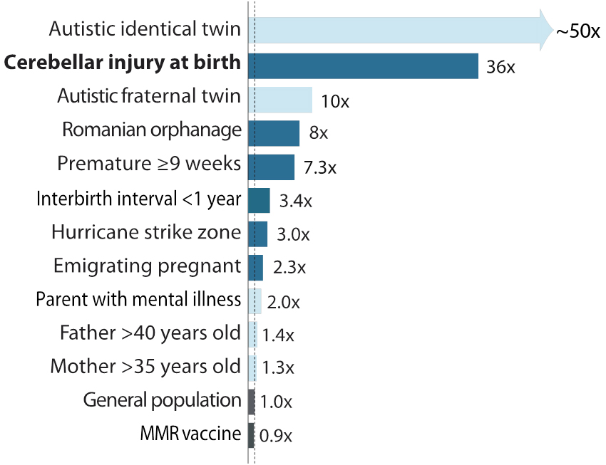
Figure 1: Risk ratios for autism spectrum disorder. Bars indicate heritable (light blue) and environmental (dark blue) factors.
These clinical data suggest that the cerebellum is crucial for the development and control of flexible and social behavior, in addition to its well-known role in movement. Functional neuroimaging in healthy subjects also demonstrates cerebellar involvement in nonmotor tasks involving language, working memory, affect, and reward (Seymour 2004). The cerebellum sends disynaptic projections throughout the neocortex, which are thought to guide the maturation of remote neural circuitry (Seymour 2004). Motor areas of the cerebellum perform adaptive control to compensate for errors during movement; recent anatomical evidence suggests that nonmotor areas may function similarly, helping to smooth “movements” through state space. Thus we suggest that the cerebellum processes sensory and internal information to influence neocortical circuit activity in adult life, and that these circuits are refined in development. These observations lead to our overall hypothesis that genes that increase risk for ASD act by influencing the development of the cerebellum in ways that impair its ability to shape adaptive flexible behavior.
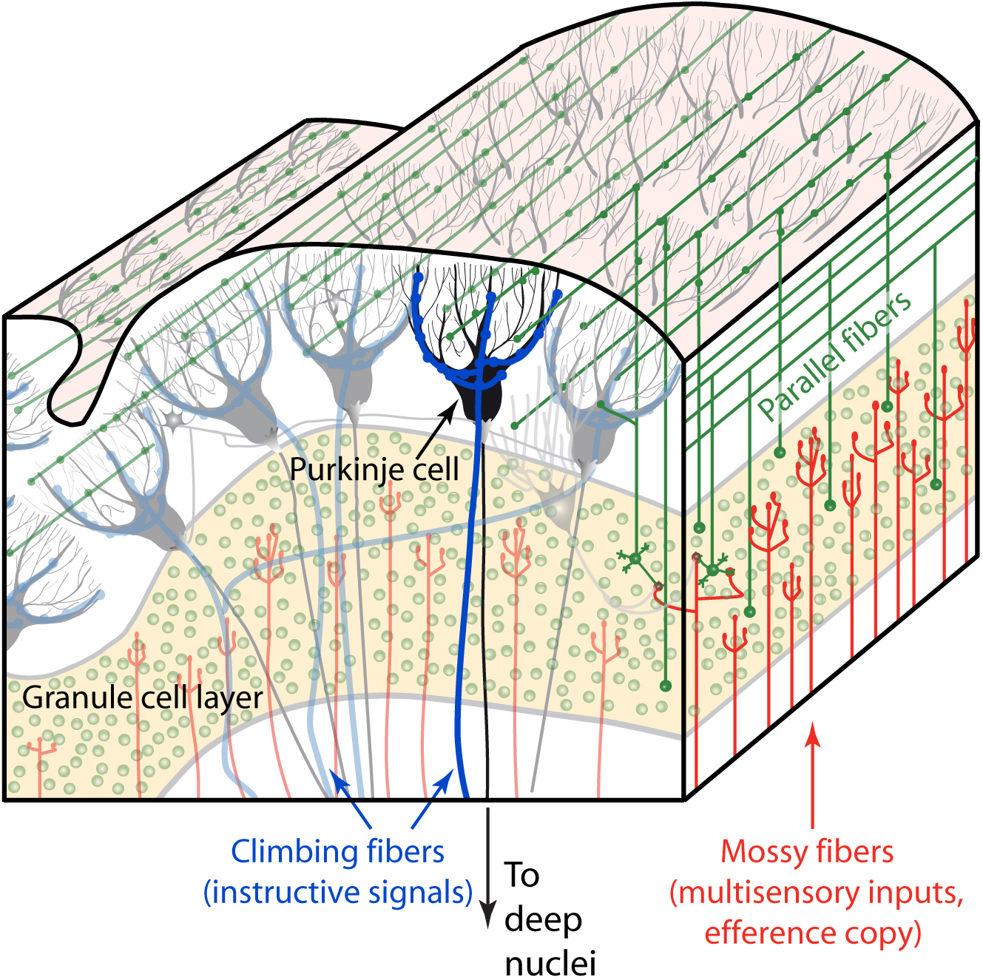
Figure 2: The cerebellar microcircuit, parasagittal view.
We have proposed (Wang 2014) that the cerebellum acts as coprocessor to other brain regions, and that its distinctive modular local circuit structure (Fig. 2) allows it to perform a common algorithm upon a variety of inputs (Koziol 2013). The mossy-fiber pathway conveys highly convergent information via granule cells onto Purkinje cells, the sole output of the cerebellar cortex. Processing in this pathway is shaped by climbing fibers, an instructive pathway that acts as an interrupt to alter firing on a subsecond time scale and as a teaching input to drive synaptic plasticity. The circuit is thought to make short-timescale predictions that modulate activity elsewhere in the brain moment by moment. This canonical microcircuit has an orderly relationship with the rest of the brain. The cerebellum is divided into microzones and lobules that project in a characteristic fashion to distant midbrain and neocortical targets, forming a map, not only to sensorimotor regions, but also to cognitive, social, and affective areas.
Our previous work suggests that ASD model mice that share cerebellar pathway-specific expression of different risk alleles also share a behavioral phenotype involving this neural common substrate. In five validated mouse models of autism spectrum disorder, the Wang laboratory found recurring patterns of deficit in eyeblink conditioning (Kloth 2015), a form of cerebellar learning in which the underlying circuit function is well understood. ASD-associated alleles that are expressed in the cerebellar mossy fiber pathway lead to deficits in the performance or amplitude of learned cerebellar reflexes (Fig. 3), consistent with models of eyeblink conditioning in which the mossy fiber pathway conveys contextual information from the environment. In contrast, disruption of ASD-related genes in climbing fibers and deep nuclei lead to deficiencies in the learning process itself, again consistent with existing theory. These findings demonstrate how different genes may have specific effects on systems function that are predicted by their cellular effects on cerebellar circuitry.
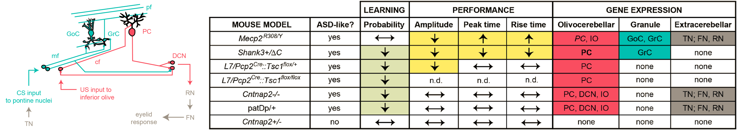
Figure 3: Cerebellar phenotypes of five mouse autism models. Left, major pathways of the cerebellar cortex. Mossy fiber pathway elements are indicated in green. Purkinje cell, climbing fiber, and deep nuclear elements are indicated in red. Right, cerebellar cell types and phenotypes associated with five mouse autism models. Eyeblink conditioning phenotypes are indicated in tan and yellow. Sites of gene expression are indicated in red, green, and brown.
Understanding of the cerebellum’s role has been hampered by two technical obstacles: activity is perturbed across much or all of the cerebellum, often irreversibly, and behavioral consequences are measured crudely. This proposal overcomes these limitations. New techniques will let us monitor and perturb specific cell types on subsecond time scales. To relate rapid cerebellar activity to behavior, we will use new analyses to capture the full temporal complexity of behavior in wild-type and ASD mice. Finally, we will use novel statistical techniques to identify the latent dynamics and plasticity rules governing neural activity, and use these insights to inform computational models of the dynamics and development of cortical–cerebellar interactions.
Significance for human disease. The cerebellum’s critical role in cognitive and affective processing accounts for the otherwise puzzling observation that it is a common site of cytological and gross abnormality in autism, attention deficit/hyperactivity disorder, and other neuropsychiatric disorders (Palmen 2004; Amaral 2008; Durston 2011). In adults, vermal damage can lead to a cognitive-affective syndrome (Stoodley 2010), in which thought becomes disjointed or emotional responses flattened. Pediatric insult can result in a regression in the complexity of spoken language known as cerebellar mutism. Identification of time windows and anatomical subregions of vulnerability in the cerebellum would suggest new targets for intervention in such disorders.

Innovation
We expect that the proposed experiments will reveal innovative mechanisms by which cerebellar circuits contribute to ASD. Our methods are also innovative: multiphoton microscopy, optogenetics, and chemogenetic methods will let us observe and manipulate selected neurons, while sophisticated behavior quantitation via dimensionality reduction will identify rapid and subtle effects of such manipulations in freely moving animals.
In vivo imaging of neural activity. The Wang laboratory pioneered calcium imaging of multiple-neuron activity in the intact cerebellum with multiphoton fluorescence microscopy (Sullivan 2005) in awake mice, along with genetically encoded calcium indicators, fast GCaMPs, with on/off kinetics 3 to 10 times faster than GCaMP6f.
Behavioral analysis in freely moving mice. The Shaevitz laboratory has led the way in automated classification of animal poses using unsupervised methods. These experimental and analytical tools generate a representation of animal movement without loss of spatial or temporal information content. In conjunction with miniscopes, which enable wide-field fluorescence microscopy and optogenetic light delivery in freely moving animals, this approach allows us to explore the fine details of behavior in a more natural setting.
Chemogenetic and optogenetic disruption of neurons. We control neuronal activity chemogenetically by designer receptors activated by designer drugs (DREADDs), G-protein-coupled receptors that are activated only by a non-natural agonist, clozapine N-oxide (CNO). After multiple experimental sessions, the location and cell-type specificity of these perturbations can be seen precisely. On subsecond time scales, we use genetically encoded light-sensitive opsins: channelrhodopsin activates or halorhodopsin inhibits specific cells.

Approach
Overview. The overall hypothesis of this project is that genes that increase risk for ASD act by influencing the development of the cerebellum in ways that impair its ability to shape adaptive flexible behavior. We will use quantitative and theoretical methods to identify causal mechanisms linking cerebellar circuits to behavior in wild-type and ASD genetic model mice. Aim 1 establishes unbiased pose classification as a way to quantify free behavior, compares it with eyeblink conditioning, and uses two-photon microscopy to probe neural activity with high temporal resolution in the same individuals in both behavioral contexts. Aim 2 causally relates ASD-like behavior to cerebellar subregions in pose classification and an evidence-accumulation task, using imaging, optogenetics, and computational modeling. Aim 3 uses chemogenetics and modeling to identify cerebellar contributions to pose classification and traditional behavioral tasks in development and adulthood.
Investigators. All three investigators on this U01 bring unique technical and scientific expertise to bear on the project, yet the approach is integrated and synergistic. Cerebellar neuroscientist Wang is an expert in two-photon optical recording, chemogenetic manipulation, and data-analysis methods. Shaevitz pioneered techniques for monitoring natural movements in Drosophila, nematodes, and mice while probing and perturbing the brain. Pillow, a leader in computational and statistical neuroscience, has extensive experience analyzing high-dimensional datasets and investigating large-scale information processing. Their shared vocabulary in biophysics and distinctive capabilities will provide a sound foundation for intellectual partnership.

Aim 1: Determine how autism risk genes influence spontaneous behavior and cerebellar activity
Physiological and optogenetic methods allow us to monitor and perturb neural function with subsecond precision, but the behavioral measures in common use do not approach this temporal resolution. In this Aim, we will use unbiased methods for automated pose classification to obtain a rich representation of behavior that can be used to characterize the detailed consequences of autism-inducing genetic variation. Such automated observations of mouse behavior have revealed genotype-specific differences, including some in autism models (Hong 2015) and some that were not identifiable by conventional behavioral testing (Wiltschko 2015). These methods have even revealed strain-specific differences (Carola 2011; Goto 2015; Okayama 2015). To validate the pose-classification technique, we will compare it to classical tasks with a known role for the cerebellum.
We will use pose classification to discover novel dynamics that emerge in unrestrained animals and to determine the effects of ASD risk alleles on natural behavior (Aim 1a). The interplay between free movement and control behaviors will lead to a deeper understanding of the neural basis of both types. In freely moving and head-fixed mice, we will use two-photon microscopy and quantitative monitoring of free behavior to determine how autism risk genes affect the mossy-fiber (Aim 1b) and climbing-fiber (Aim 1c) pathways. By imaging and recording cerebellar granule cells, molecular-layer interneurons, and Purkinje cells in behaving animals, we will map gene products to principles of sensory encoding and synaptic learning rules.
Aim 1a: Evaluate the dynamic relationship between cerebellar activity and spontaneous behavior. Recent advances in imaging and machine vision allow us to analyze sequences of naturalistic poses to form a low-dimensional representation of animal movement. A leader in this new area of research is co-PI Joshua Shaevitz. Briefly, we will start with movies of behaving animals at high spatiotemporal resolution and decompose the dynamics of the pixel values into a low-dimensional basis set describing the animal’s posture (Fig. 4). Time series will be produced by projecting the original pixel values onto this basis set, and the local spectrogram of these trajectories will then be embedded into two dimensions (Berman 2014). Each position in this behavioral map corresponds to a unique set of postural dynamics, with nearby points representing similar motions, i.e., related body parts executing similar temporal patterns. We have used this automated approach to measure the full behavioral repertoire of Drosophila melanogaster and resolve subtle differences between animals and lines, including the effects of sex, age, context, and genetic background, while perturbing neural activity with optogenetics (Berman 2014, 2016; Wang 2016; Klibaite 2017).
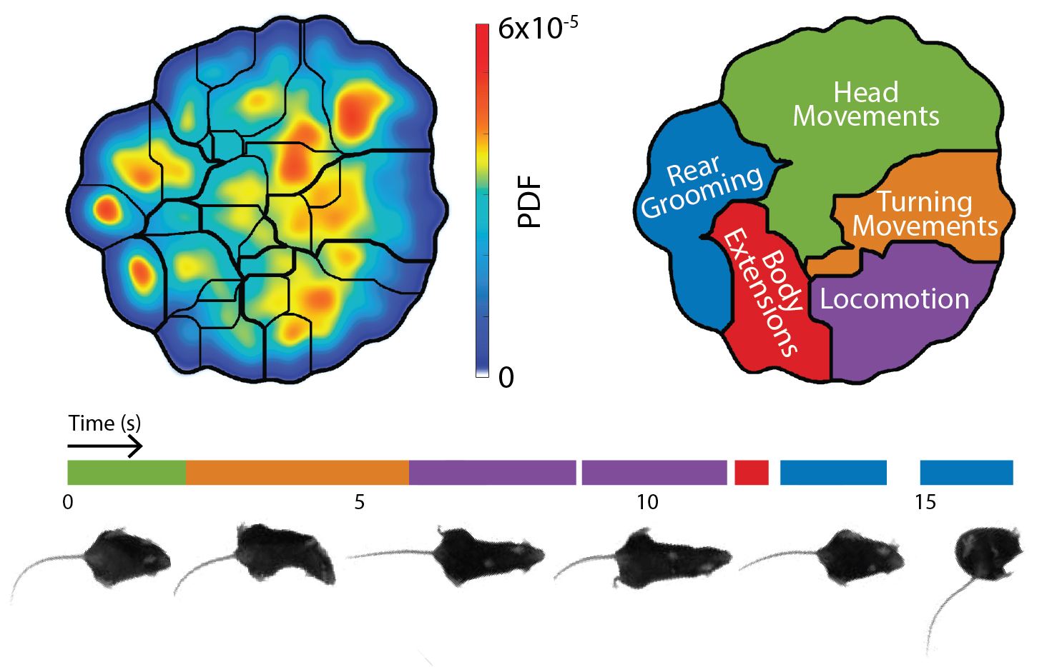
Figure 4: Unbiased classification of poses in a freely-moving mouse. Top left, probability density function of mouse behavioral space. Thin black lines show automatically-classified poses defined by watershed criterion; thicker black lines show manual clustering into behavior types. Top right, names of behavior types. Bottom, Sample ethogram and images showing a mouse turning, walking, and then rear grooming. White spaces indicate periods of rapid movement among multiple watershed regions.

We have adapted pose classification for mouse behavior (Fig. 4). By combining a low-resolution, depth-sensitive, 3D camera and high-resolution, 2D camera, we will segment the body image, accurately capturing the tail, head, and paws, while the mouse bears a Doric head-mounted fiberscope. Our postural decomposition can capture the full mouse pose in as few as 25 dimensions. Embedding the postural dynamics into a 2D behavioral map, in preliminary data we found ~30 discrete behaviors organized into 5 categories (locomotion, turning, body extension, rear grooming, head movements). Our preliminary data also show that we can combine fluorescence microscopy of neural activity with such analysis (Fig. 5; see below).
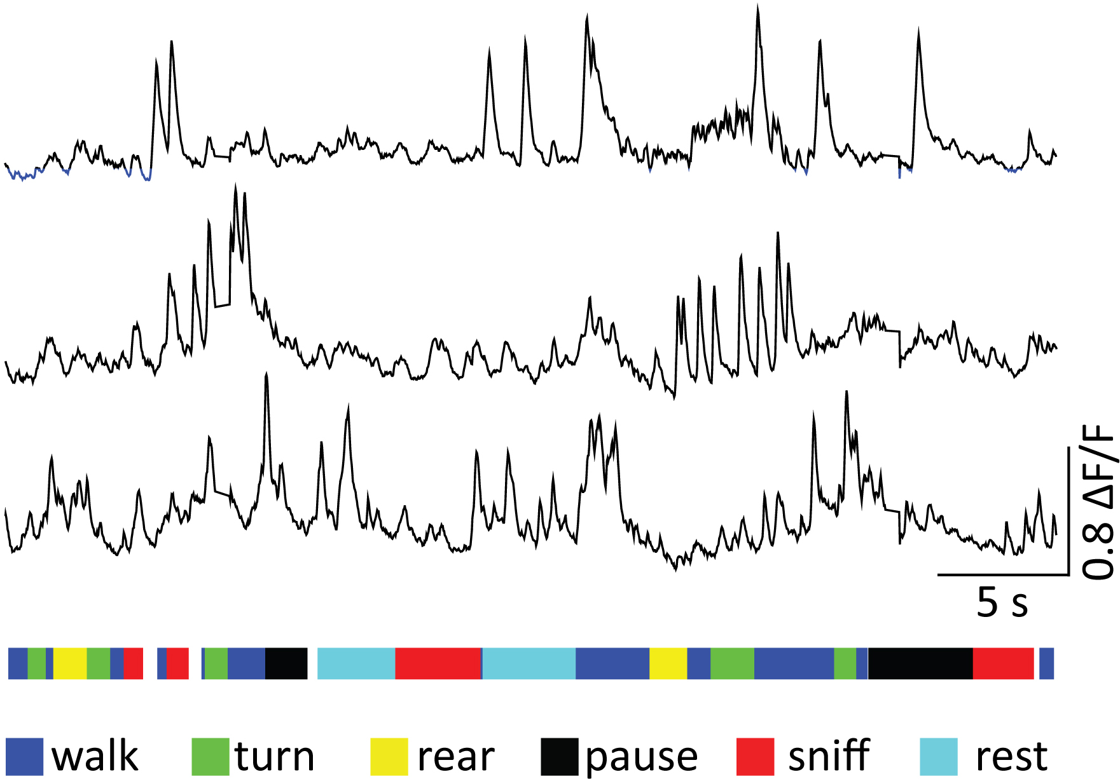
Figure 5: Purkinje cell dendritic signals in a freely moving mouse. Top, GCaMP6f signals from three Purkinje cell dendrites in lateral lobule VI of a Pcp2-Cre mouse injected with AAV-CAG-DIO-GCaMP6f. Bottom, sample ethogram of six identified features of behavioral activity.
We have developed an open-field foraging task to test flexible behavior in a free-moving context. Mice will find buried food rewards scattered at different locations in an arena. We will move these locations and monitor changes in postural dynamics and x-y trajectory as mice learn the new ones. In this task, we will test if spontaneous behavior exhibits long time-scale patterns of transition that echo the findings of classical tests. These temporally rich measurements will identify subtle gene-specific behavioral differences in our six ASD mouse models (Fig. 3). We will also disambiguate motor deficits on short time scales, a classical role of the cerebellum, from changes in flexible behavior.
Pitfalls and alternatives. Because pose classification has identified positive results in mice that did not show a behavioral phenotype by older methods (Wiltschko 2015), our behavioral findings may be difficult to interpret. Thus, we will compare these findings with conventional tasks (see below). Because these ASD model mice have phenotypes in conventional behavioral tests, we have confidence in observing pose-classification effects.
Aim 1b: Determine how ASD risk genes influence climbing-fiber pathway function. The powerful climbing fiber-Purkinje cell synapse triggers a massive dendritic action potential, providing an instructive signal that drives synaptic plasticity in the mossy-fiber pathway. Climbing fibers convey the occurrence of unexpected events and teach the mossy fiber-Purkinje pathway to predict sensations, and corrections of action, in the immediate future. Climbing fibers encode events contextually, in that a sensory stimulus to a limb evokes a diminished neural signal if the animal is moving, a phenomenon termed gating (Apps 1999; Ozden 2012).
However, it is not known how gating might occur in freely moving animals. This question is critical in understanding the etiology of ASD, because early-life learning, including the acquisition of cognitive and social capacities, may depend on how teaching events are represented in climbing fibers. Cerebellar misprocessing of sensory information in early postnatal development might be a step in the etiology of the behavioral signs of ASD.
First, we will use the unbiased-classifier method to test freely moving animals’ responsiveness to cutaneous stimuli. We will use wild-type animals as a baseline for evaluating ASD models. Our team has demonstrated expertise in monitoring cell-type-specific activity in both mossy and climbing fiber pathways in vivo. To probe for functional disruption in circuits, we will image the climbing fiber pathway using GCaMP6f and measure the amplitude of climbing fiber-evoked calcium spikes in Purkinje cell dendrites. These dendrites will be monitored using AAV-driven GCaMP6f expression (Najafi 2014a, 2014b). Puffs of air will be delivered through jets inserted at various points in the floor of the arena, and stimuli will be delivered as the mouse’s hind limb moves over them, detected by the camera system. Sensory responses will be correlated with movements of the limb as well as other limbs, and analyzed as a function of pose and kinematic state.
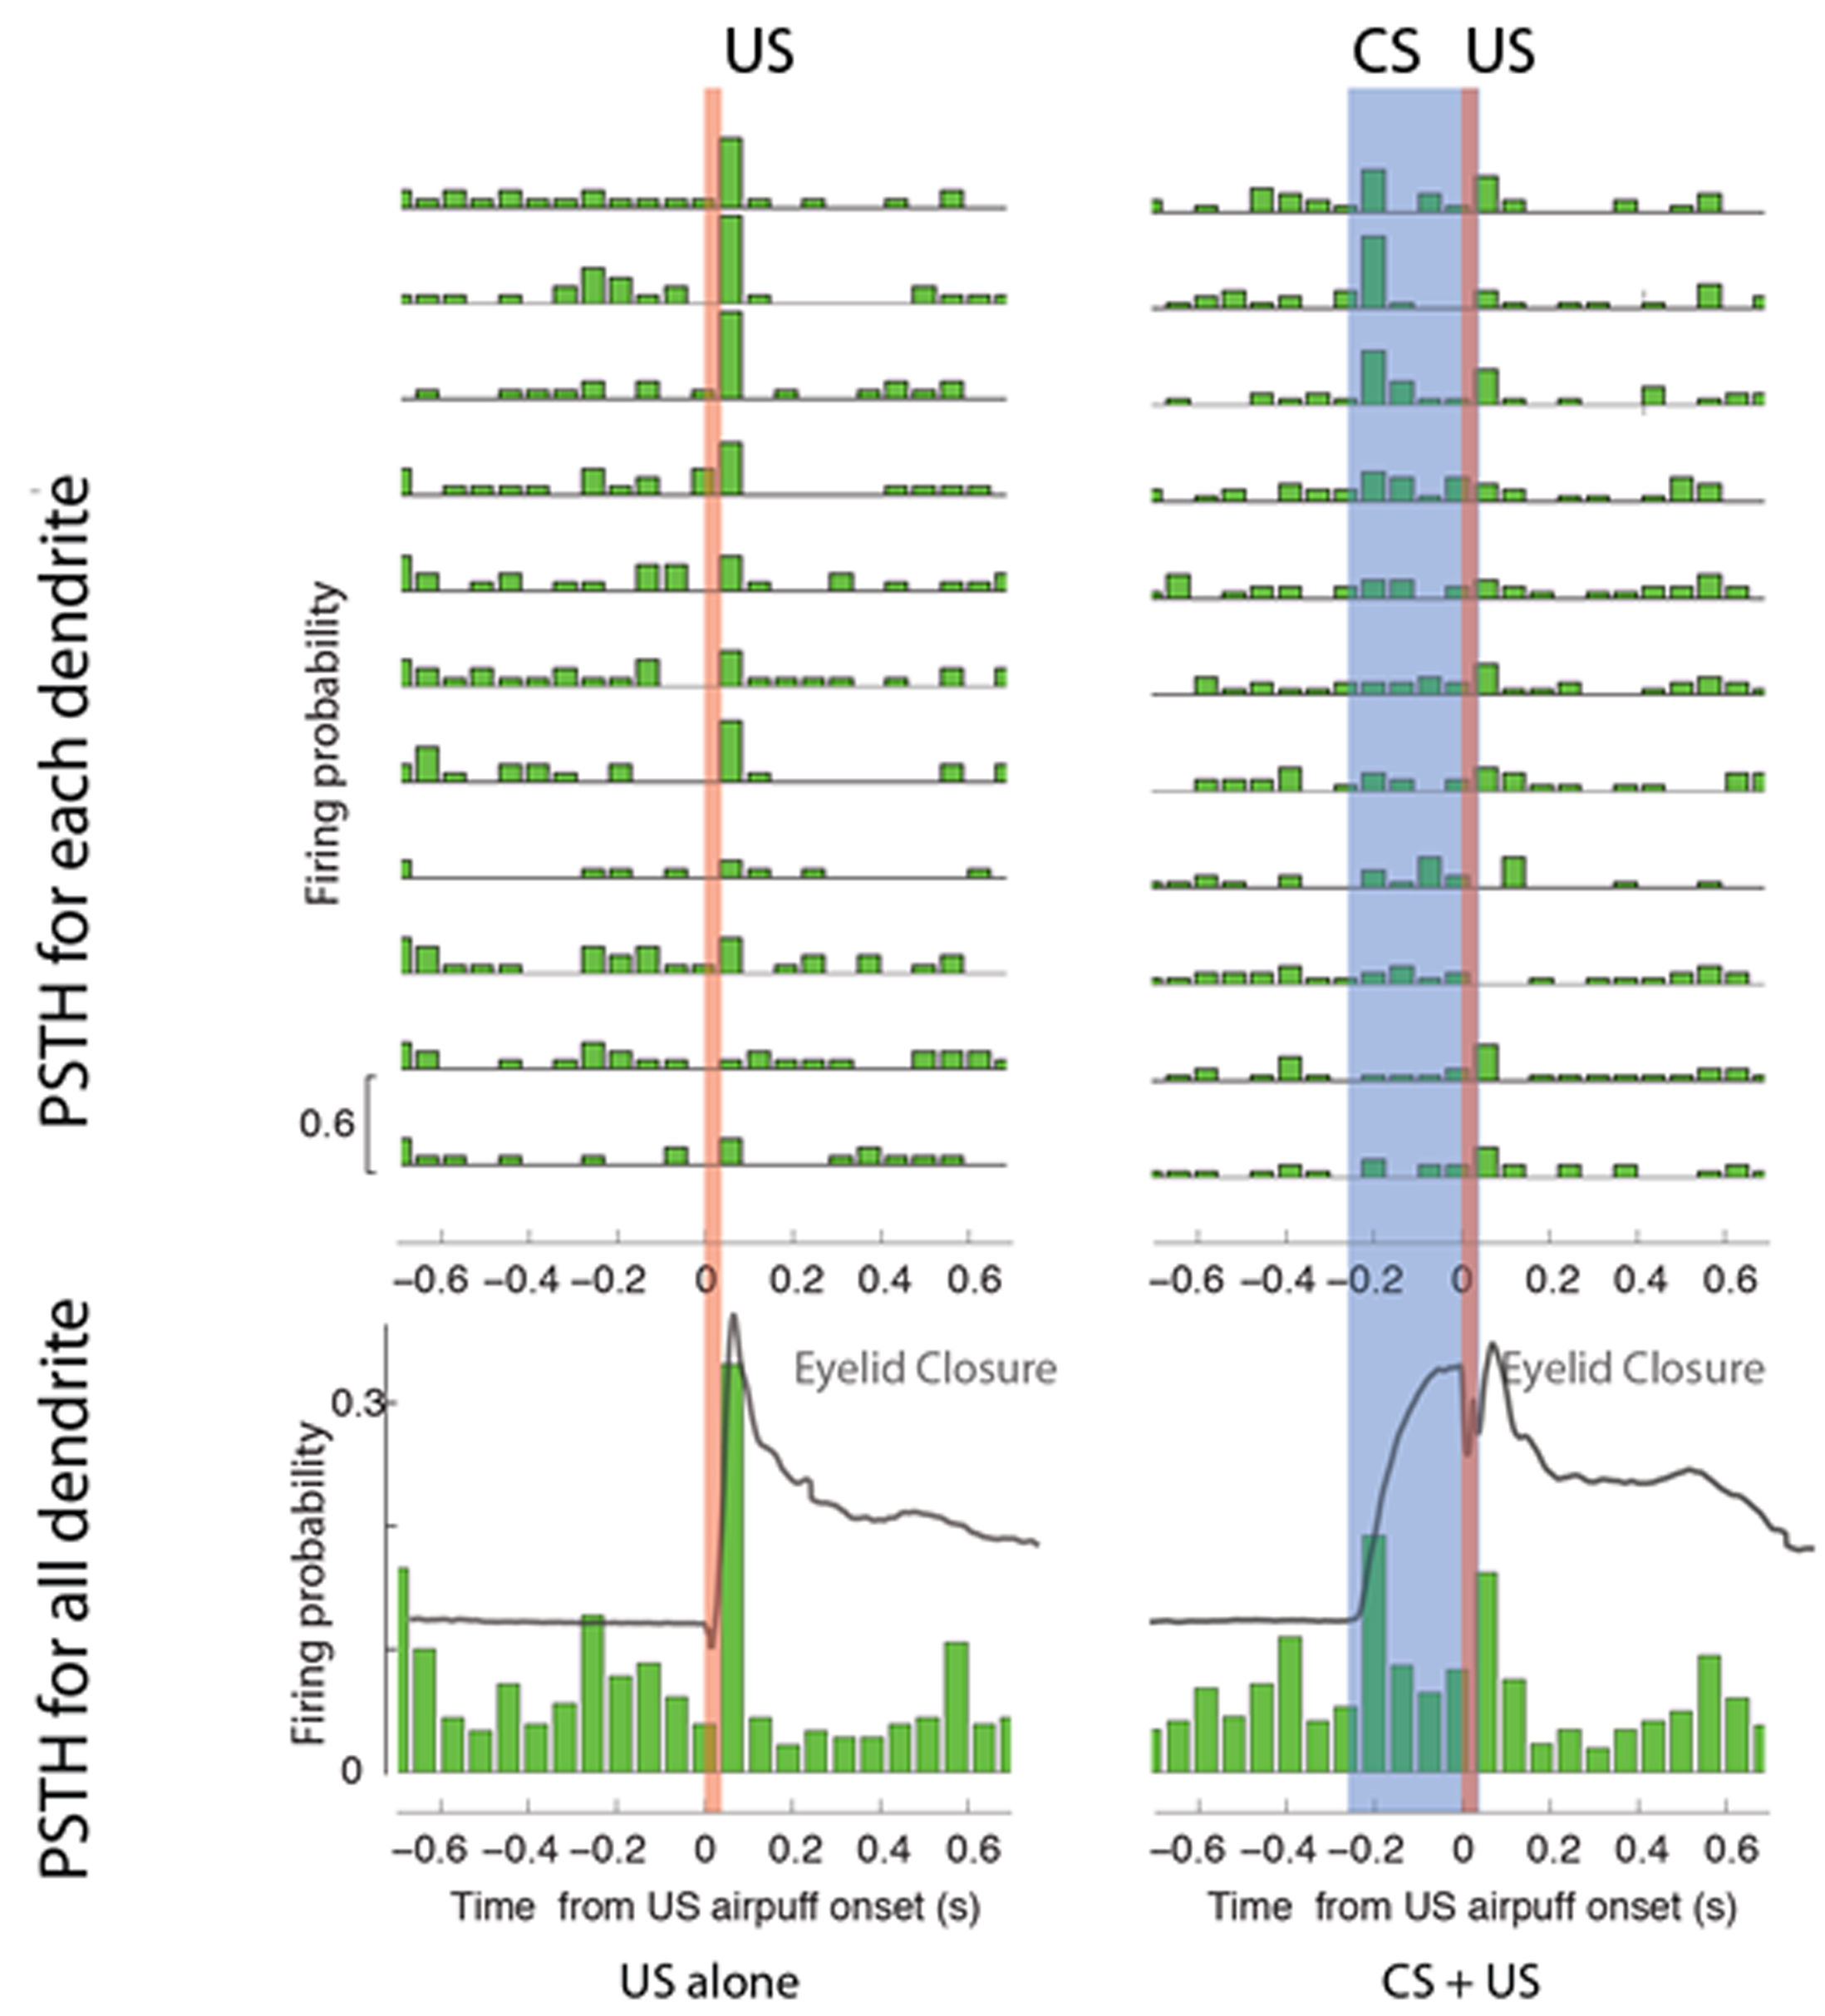
Figure 6: Change in dendritic response to air puffs after eyeblink conditioning. Left, Peristimulus time histogram of dendritic firing events in lobule VI in response to an airpuff stimulus (US) given alone. Top, individual dendrites. Bottom, group average. Right, responses to a tone stimulus (CS) paired with airpuff (US). Note the reduction in US responses.

Second, we will measure context-dependent sensory processing under more controlled conditions. In classical eyeblink conditioning, near-simultaneous sensory inputs from two modalities converge on common targets in cerebellar cortex and nuclei, and an association is formed: a neutral stimulus such as a tone becomes associated with a unconditional blink-evoking stimulus, an airpuff to the cornea. Instructive signals arising in the inferior olive pass via climbing fibers to Purkinje cells to shape cerebellar properties as a feedback controller to the rest of the brain. The climbing-fiber input acts as a teaching signal to drive synaptic plasticity in the mossy-fiber pathway. We have found that a conditioned stimulus (CS) such as a tone reduces the airpuff-induced climbing-fiber signal (Fig. 6), consistent with a prediction error (Ohmae 2015) and with gating. We will explore the specific deficits of the ASD mouse models of Aim 1a. In Cntnap2^{−/−}, patDp(15q11-13)/+, and L7/Pcp2^{Cre}::Tsc1^{flox/+} mice, which have Purkinje cell/deep nuclear expression patterns, we expect smaller calcium signals and reductions in the response probability, consistent with behavioral findings (Kloth et al., 2015). We will further test if CS-gated responses are reduced in model mice, as they are in wild-type animals.
Pitfalls and alternatives. GCaMP6f kinetics may be insufficient to resolve calcium spikes that occur in rapid succession. The Wang lab has developed Fast-GCaMPs, calcium indicator proteins with 3 to 10 times faster kinetics than GCaMP6f. If needed, we will use them to resolve climbing fiber signals occurring in close succession. Complex spikes will also be monitored by extracellular recording.
Aim 1c: Determine how ASD risk genes affect encoding in the mossy-fiber pathway. Some autism risk alleles are expressed in the mossy-fiber pathway, where they may also influence cerebellar development, as discussed in Aim 1b. Here we will test the hypothesis that high-penetrance autism risk alleles cause deficiencies in granule-cell encoding of sensory and learned information. The Wang laboratory is one of the few groups that can extract firing events at >10 Hz from cerebellar granule cells and even parallel fiber boutons (Giovannucci 2017) (Fig. 7). In ASD models with disruptions in the mossy-fiber pathway, we found that learned blinks are attenuated and have a distorted time course (Kloth 2015). This is consistent with a framework in which mossy fibers and granule cells encode the CS to drive Purkinje cell spiking output, which modulates the blink response. We also found, using multiphoton imaging of the calcium indicator protein GCaMP6f, that granule cells have a rich and dense representation of both sensory events and the learned response (Giovannucci 2017), the latter being a form of efference copy.
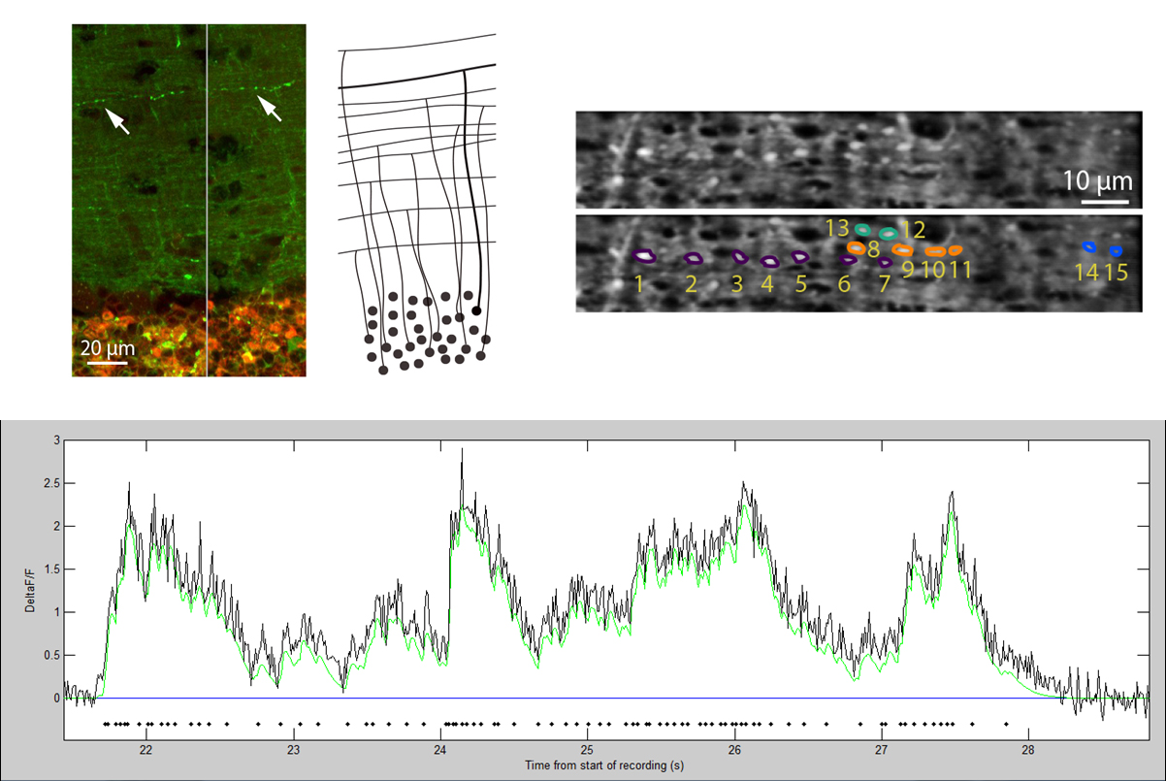
Figure 7: Imaging parallel fibers. Parallel fibers expressing GCaMP6f in brain slices (upper left) or in awake animals (upper right). Bottom, GCaMP signal from one parallel fiber (black) and fitted signal (green). Inferred spike times are indicated by the dot raster.
Our learning experiments lead to two predictions in mutant animals: that sensory responses will be attenuated, and that the signal associated with learned responses will be attenuated and altered in time course, consistent with temporal distortions in information processing of the mossy fiber-granule cell pathway. To test these predictions, we will analyze the amplitude and time course of granule cell signals, as we have done in wild-type animals. We will examine Shank3∆C and Mecp2^{R308/Y}, which carry mutations of genes expressed in granule cells, show aberrant response timing, and have reduced Purkinje-cell dendritic spine density. Because of the difficulty of monitoring granule cells in vivo, these experiments must be done in head-fixed animals.
Pitfalls and alternatives: Granule cells are challenging to image due to their close packing, which raises the risk that single-cell signals will not be entirely independent. If neighboring signals are strongly correlated, we will reduce the titer of AAV injection to generate sparser expression. In parallel fiber boutons, excessively high expression may add calcium buffering, thus attenuating and slowing signals. In this case, we will coexpress GCaMP with CyRFP to identify weakly expressing parallel fibers. To disambiguate CS-associated activity from conditioned response (CR)-associated activity, trials will be compared as a function of CR occurrence and size.
Aim 2: Identify specific cerebellar pathways that shape flexible behavior
In addition to modulating sensation and movement, the cerebellum influences flexible behavior via specific anatomical pathways that influence the entire forebrain. These pathways are organized into projections from lobules through the deep nuclei to the rest of the brain. This organization can potentially explain the diversity of expression of ASD, which combines endophenotypes whose severity can vary dramatically across individuals. Using optogenetics to target specific regions, we will combine behavioral observations with dimensionality-reduction methods to identify causal relationships between specific cerebellar lobules, brain-wide function, and complex behavior.
The cerebellum is implicated in neurodevelopmental disorders, but a circuit-based model has been lacking to explain how it would affect flexible behavior. We will use an evidence-accumulation and decision-making task, in which we have found clear circuit-based correlates of specific components of the task, to probe deficiencies induced by ASD risk alleles using these neural correlates. This work will allow ASD-related genetic defects to be related to specific cerebellar and behavioral defects.
Aim 2a: Determine how ASD risk genes affect nonmotor predictive learning mechanisms. As discussed in Aim 1, difficulty in learning from sensory evidence may be an developmental step leading to autism (Wang 2014). Defects in prediction provide a possible neural substrate for such early-life dysfunction. Here we will test the working hypothesis that Cntnap2, patDp, and PC-specific Tsc1 mice show learning defects, accompanied by alterations in error signals. We will determine if these signals are attenuated in the ASD model mice, and whether their amplitude is modulated differently by behavioral parameters than it is in wild-type mice.
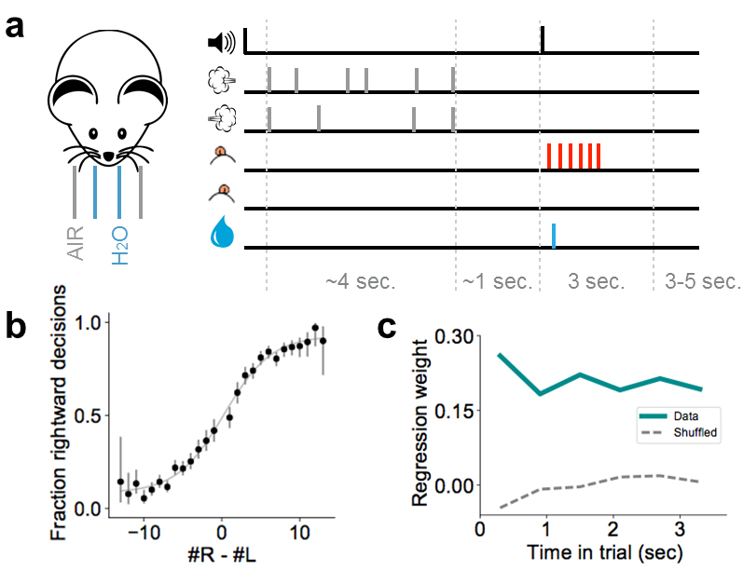
Figure 8: Head-fixed evidence accumulation task. A, experimental paradigm showing tone prompt for the mouse’s choice, air puffs to right and left whiskers, left and right licks, and water reward. B, psychometric curve showing correct response probability as a function of the predominance of left or right puffs. C, contributions from different times of the trial, demonstrating that mice integrate evidence from all times of the trial.
To do so, we have developed a head-fixed task for evidence accumulation (a form of working memory) and reward-driven decision-making. In this task, mice receive somatosensory stimuli to left and right whiskers for 3.8 seconds, and then choose to lick to the left or right to indicate which side received more stimuli (Fig. 8). Correct choices lead to a water reward. In preliminary data, evidence-accumulation and decision errors seem to be represented in Purkinje cell activity of crus I, which communicates with prefrontal cortex, an area central to working memory and decision making.
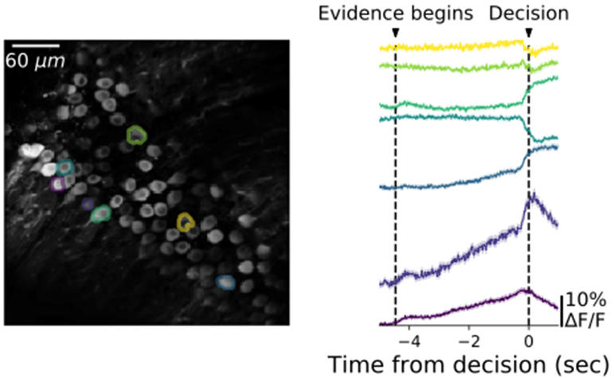
Figure 9: Neural correlates of evidence integration. Fluorescence of Purkinje cell somata in crus I demonstrates ramps of activity, consistent with integration of evidence.

We will monitor simple-spike firing in Purkinje cells, the ultimate output arising from granule-cell signaling impinging on Purkinje cells, via somatic calcium signals (Ramirez 2016). Our preliminary data reveal ramp-like signals (Fig. 9), a type of dynamics commonly associated with evidence accumulation. In Shank3 and Mecp2^{R308/Y} mice, compared to wild-type mice, we will determine whether these ramp-like signals, a sensitive assay of mossy-fiber pathway effectiveness, are influenced by autism risk.
We will also evaluate prediction errors in wild-type and ASD model mice. Our preliminary evidence indicates that left/right errors are accompanied by a dendritic spike in some crus I Purkinje cell dendrites (Fig. 10). These error signals are larger on the side with fewer errors, suggesting that the signals encode saliency. We will evaluate how well the prevalence and magnitude of these signals track the cognitive state of the animals. For instance, we will determine the timescale at which the error response correlates with the animal’s decision bias and response latency. These variables, metrics of the animal’s confidence and thus expectation of reward, can be used to characterize the neuronal signal in terms of internal cognitive variables.
Pitfalls and alternatives: Purkinje cell somatic calcium signals may not precisely reflect firing rate because of nonlinearities such as calcium-induced calcium release; thus, we will do extracellular recordings to confirm the time course of activity ramps. The slow somatic calcium responses may conceal important dynamics of firing. To improve temporal resolution, we will use Fast-GCaMPs and scan the axon initial segment.
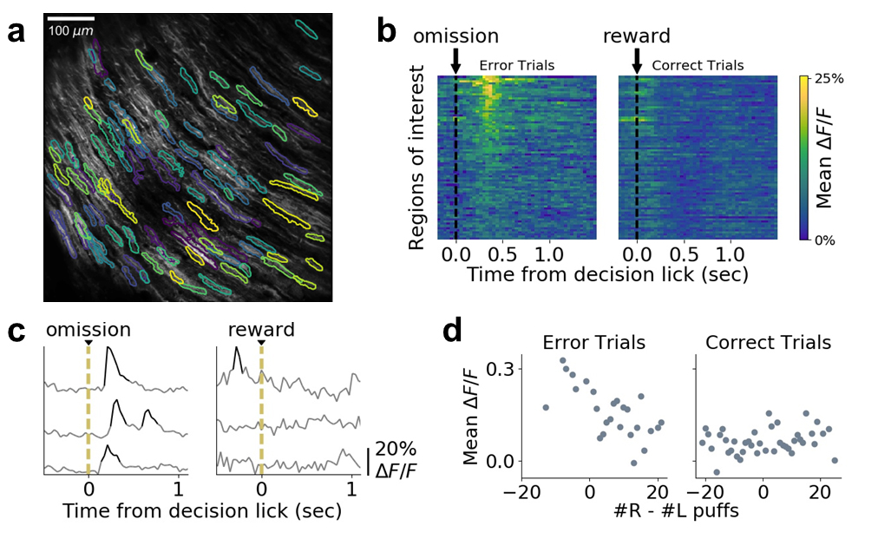 Figure 10: Error signals following incorrect decisions. A, Purkinje cell dendrites in crus I. Regions of interest (ROI) are outlined. B, in a single trial, signals across many ROIs after an incorrect lick ("omission") or a correct trial ("reward"). C, single-ROI signals. D, error signals are larger in the direction of less-frequent errors, which in this case occurred for left-side evidence (#R-#L<0).
Aim 2b: Optogenetic perturbation of flexible behavior. Damage to the cerebellum produces deficits in cognition, which can include impairments in working memory and reward learning (Schmahmann 2004). Purkinje cell-specific perturbation in animal models can induce defects in flexible and social behavior (Tsai 2012), suggesting that Purkinje cells strongly influence non-motor function. In our preliminary experiments, disruption of activity lobule VI or crus I led to difficulties in reversal learning (see Aim 3).
We will apply optogenetic technology in lobule VI and crus I to freely moving mice to characterize changes in their flexible behavior (see Aim 1). We will test the hypothesis that perturbations that lead to perseveration or impair reversal learning will also lead to repetitive motifs in movement sequences. For reversal learning, we will use a foraging task in which food rewards are initially buried in one location, then moved to another location. Changes will be quantified using the frequency of sequential motifs of behavior as well as the probability of repeatedly searching for food at the original location. To inactivate the cerebellum, we will inject Pcp2-Cre mice with AAV-Flex-ArchT in crus I, crus II, or lobule VI, then deliver light through a fiber routed through the head-mounted microscope.
The evidence-accumulation task in Aim 2a offers a perceptually salient and quantitatively rigorous alternative way to to probe flexible behavior. Its cognitive demands occur at separate points in time and include dynamic manipulation of working memory and reward learning. To interrogate the role of cerebellar circuitry in this process, we will optogenetically perturb Purkinje cells to assess their causal influence on behavior. In 1-hour behavioral sessions, 15% of trials will be randomly selected as inactivation trials, during which the onset and duration of activation will be randomly assigned to one of five phases: whole trial, evidence-presentation, decision, delay, or reward phase. These alternatives will enable us to separately evaluate roles in evidence accumulation, memory maintenance, motor activity, and reward or error signals. We will compare experimental conditions (the 5 phases plus no inactivation) with psychometric functions and logistic regressions (Fig. 8), response latencies, lick rates, trial-completion rates, and a drift-diffusion model of evidence accumulation that quantifies parameters by which individuals accumulate evidence (Brunton 2013). This approach has successfully revealed neuronal-coding principles of evidence accumulation in rodent models (Erlich 2015).
Pitfalls and Alternatives. The site of light delivery may be difficult to adjust with the head-mounted microscope. A more flexible approach to robustly inactivating Purkinje cells in head-fixed mice is to implant an optogenetic ferrule at the brain surface with a 300 µm fiber optic for light transmission to tissue (Lee 2015).
Aim 2c: Develop a model of cerebellar-neocortical interactions. From a computational standpoint, the putative advantage of cerebellar-neocortical closed loops is the joining of radically different circuit architectures to support hybrid forms of information processing and learning. The cerebellar cortex is widely believed to facilitate a form of discriminative learning, in which a high-dimensional representation in the granule layer converges on Purkinje cell outputs, allowing subtle differences in sensory input patterns to be learned easily. In contrast, the neocortex has a highly recurrent architecture, enabling forms of association useful for learning sequences. Joined together, these two architectures should provide a powerful hybrid architecture that is well suited to efficiently learn and stabilize neural activity patterns that support dynamic behaviors.
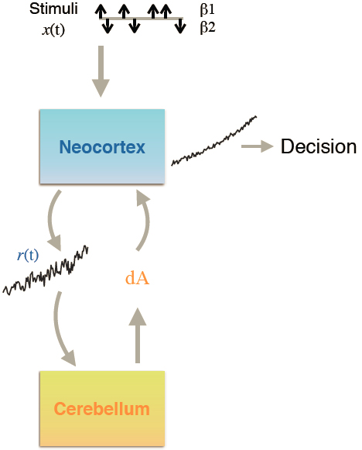
Figure 11: Neocortical-cerebellar feedback.
We will model the ability of cortico-cerebellar architectures to support evidence accumulation in the decision-making task of Aim 2a. We chose this task because it involves integration of sensory signals over time, a process that requires continual calibration to maintain accuracy (Seung 1996; Aksay 2001; Major 2004; Mensh 2004). The goal of the cortical circuit is to stably integrate sensory evidence, which can be implemented by a population with linear dynamics: dr/dt = A r(t) + β x(t), where r(t) is the vector of population activity, A(t) is a linear weight matrix specifying recurrent connectivity, x(t) represents the time-varying sensory input signal, and β is a set of weights determining what sensory signals the network integrates. Accurate integration requires weight matrix A to have top eigenvalue close to 1, so that population activity along the dominant eigenvector accurately reflects the accumulated evidence. This outcome requires fine tuning of A to prevent decay or runaway excitation (Seung 1996; Aksay 2001; Major 2004; Mensh 2004), which might occur via cortico-cerebellar feedback loops.
We will use in vivo physiological measurements and optogenetic/behavioral observations to constrain a spike-based model of cerebellar-neocortical interactions (Fig. 11). We will construct detailed simulations of a three-layer model: cerebellar cortex, a recurrent model of cortex, and joining nuclei—pons and inferior olive in the descending direction, and cerebellar deep nuclei and thalamus in the ascending direction. We will test whether activity trajectories are more stable and robust when both structures work together. The Pillow lab will apply advanced statistical methods for inferring synaptic plasticity rules and functional connectivity from multi-variate spike train recordings (Stevenson 2011; Linderman 2014, 2016) to ask what learning rule based on simple- and complex-spiking patterns would produce a control signal that corrects performance errors in frontal neocortex. In this model, complex spikes convey the unconditioned teaching signals that we observed in preliminary experiments. The results will combine genes, circuit function, and multi-region interactions to generate a comprehensive model of how cerebellar processing may influence cortical performance.
Future directions: In the long term, we can combine the mouse's poses and positions with optogenetic stimulation of climbing fibers as a teaching signal, to modulate the learning of flexible behavior. This will test the idea that complex sequences of actions can be regulated by an artificially applied teaching signal.

Aim 3: Evaluate how cerebellar pathways shape ASD endophenotypes in development and adulthood
In this Aim, we will perturb the function of cerebellar lobules to determine their effects on behavior. To probe broad patterns of functional change, we will use a battery of behavioral tests (Fig. 12): (a) a Y-maze task, including reversal of the rule, a measure of cognitive flexibility (Tsai 2012), (b) a 3-chamber social preference and investigation assay, (c) an elevated-plus maze, (d) eyeblink conditioning, and (e) a virtual-reality navigation task. These tests, drawn from well-established practices, provide a means of assaying mouse behavior that overlaps with a large body of data from the mouse autism community. They complement the newer tasks in Aims 1 and 2.
To reversibly perturb the function of a cerebellar lobule, we are expressing engineered G-protein coupled receptors (DREADDs). DREADDs do not act unless exposed to the otherwise biologically inactive molecule clozapine-N-oxide (CNO) (Wess 2013). Thus, we can reversibly perturb neural function for minutes to hours and test behavioral outcomes. We are using an adeno-associated virus (AAV) carrying sequence for the inhibitory DREADD hM4Di, fused to mCherry protein under a synapsin-1 promoter, which drives expression in molecular layer interneurons (Kuhn 2012). We will stereotactically inject AAV into lobules VI/VII or crus I/II and begin the CNO treatment 10 days later. To test for developmental impact, we will perturb in the second month of postnatal life, which approximately corresponds to the first several years of human life as defined by neocortical growth and plasticity. We will then test these developmentally perturbed animals as adults, long after CNO was removed.
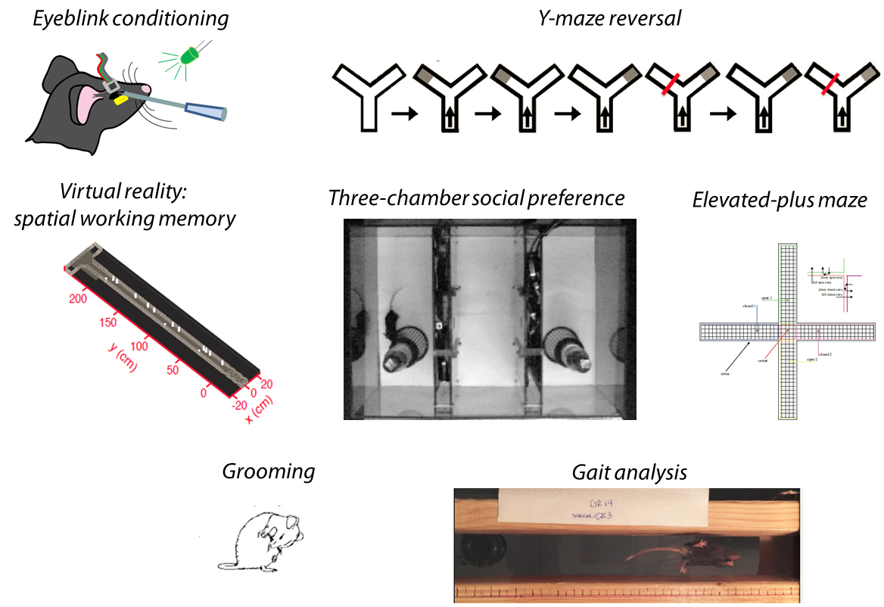Figure 12: Tasks for assessing motor, flexible, and social behaviors.
In preliminary evidence (Fig. 13), we have found that lobules VI and VII and crus I influence perseveration and social recognition, and that these influences are substantial during juvenile development. Locomotion is not affected. We will then use transsynaptic viral tracing to match these regions to forebrain regions. This work will generate an anatomically specific map of cerebellar anatomy to neurodevelopmental endophenotypes. This work constitutes, to our knowledge, the first mouse modeling of individual endophenotypes in ASD.
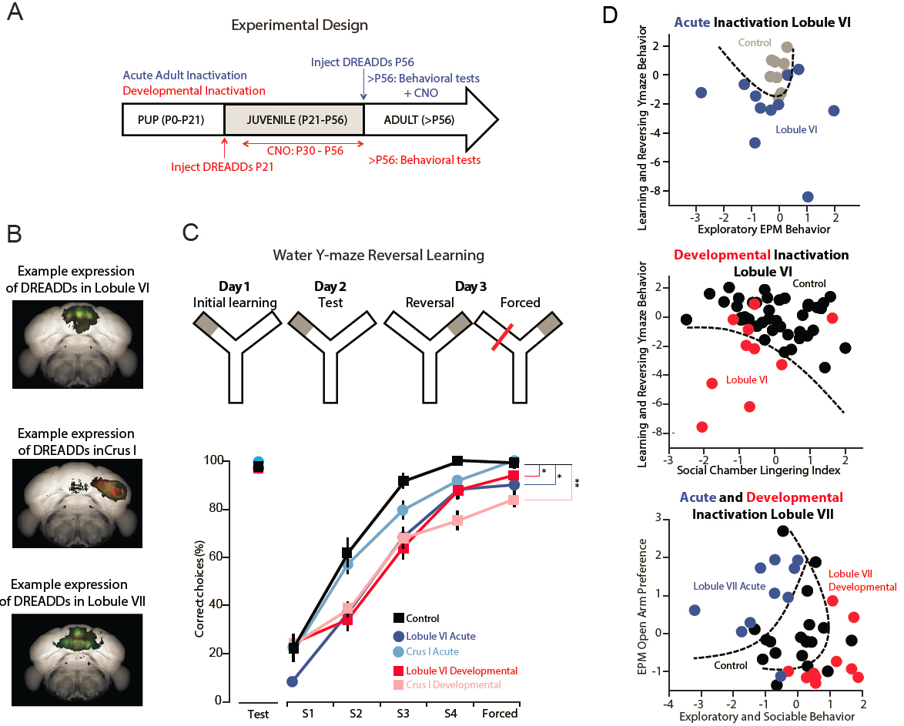
Figure 13: Adult and developmental perturbation of flexible and social behaviors. A, Experimental design for adult (blue) and developmental (red) perturbation of cerebellar function. B, Example expression of DREADDs, reconstructed by two-photon tomography of GFP coexpression. C, Inhibition of reversal learning, but not initial learning, after perturbations in lobule VI and crus I. D, Covariation of traits across tasks after perturbation of single lobules. Each point represents a single animal.The dashed curves indicate an estimated boundary calculated using a random-forests machine learning algorithm.
Aim 3a: Relate ASD-like endophenotypes to lobule-specific perturbations. Preliminary experiments reveal parameters of learning and performance that covary. For example, when lobule VI is activated by inhibitory DREADDs, we see impaired reversal learning and a shift in elevated-plus-maze arm preference. Combinations of task features that covary among individuals may reveal a deeper underlying deficit.
To address this covariation, we will quantify parameters of each task and reduce their dimensionality using principal component analysis (PCA) to identify eigenbehaviors: patterns of phenotypes that span multiple tests, and may co-vary among individuals. We will relate these phenotypes to anatomical location using post hoc two-photon tomography to localize the injection. Multiple injections will be done in each lobule, and a generalized linear model will identify anatomical patterns corresponding to patterns of behavior disruption.
Preliminary experiments show that DREADD-based chemogenetic disruption of specific lobules in early postnatal life leads to more severe phenotypes than in adult life (Fig. 14). In particular, early disruption of crus I leads to lasting deficits in three-chamber social test. Disruption of lobule VII has opposite effects when the disruption occurs in juvenile or adult life. Such age differences are evident in other lobules as well. Using the methods in Aim 2b, we will look for time windows during which lobule-to-endophenotype effects are largest.
These phenotypes, observed under rigidly defined conditions, suggest that in free environments, mice will also show spontaneous behavioral motifs. We will test if difficulties in reversal learning or repeated activities like elevated grooming are accompanied by pose sequences and repetitive motifs that prevent flexible behavior.
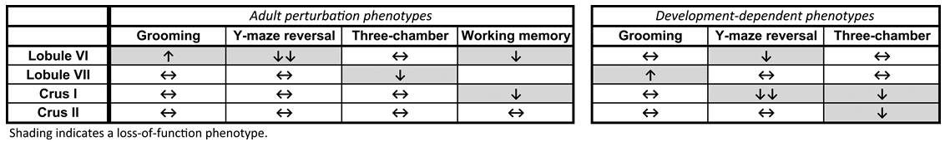
Figure 14: Adult phenotypes arising from DREADD-based perturbations of single cerebellar lobules.
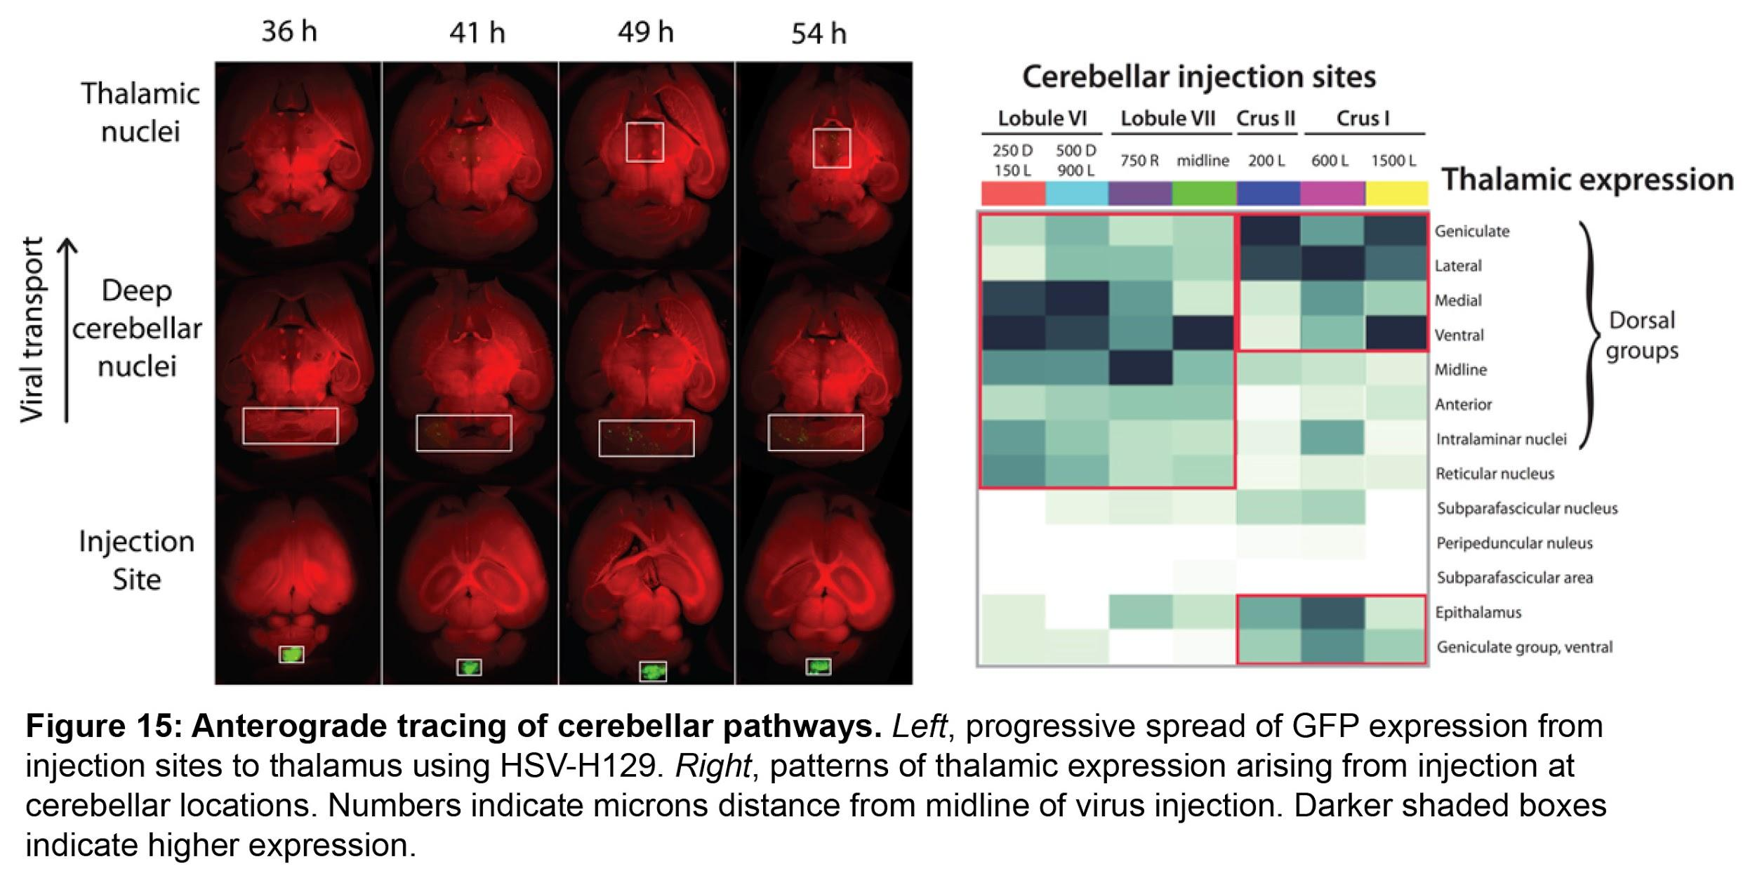
Pitfalls and alternatives. Our first experiments will target molecular-layer interneurons, for which we have an expression strategy and which affect both the pattern and amount of Purkinje cell output. These effects will be confirmed by in vivo extracellular recording or two-photon imaging. To test whether the absolute level of activity is important, we will also use chemogenetic experiments on granule cells or Purkinje cells to affect output directly. If DREADDs are difficult to use, for instance because of differences in the second-messenger transduction machinery in each cell type, we will use PSEM technology to achieve activation or inactivation.
If eigenmode intensity varies across individuals, we will use full reconstructions of injected volumes to identify any relationship between expression extent and intensity and eigenmode amplitude. If repetitive motifs arise in all mice, then we will separate the motifs by length and type, and test for correlations with specific eigenmodes.
Forebrain partner regions. To interpret these experiments and identify the correct regions to image in neocortex, we need to know how the cerebellum maps to the thalamus and neocortex. In an F30- and U01-funded project, the Wang lab is generating the first long-distance map between cerebellum and midbrain and forebrain, using two transsynaptic tracers. The Bartha variant of PRV is used for retrograde tracing (Wang 2014), while the HSV-H129 virus (mainly anterograde; Wang 2014) is used to identify polysynaptic paths from Purkinje neurons to thalamus. Pathways are visualized by fluorescent protein expression, iDISCO (related to CLARITY) tissue clearing, light-sheet microscopy, and a computational pipeline to register and automatically analyze image volumes. These experiments demonstrate exact projection patterns from cerebellar lobules VI and VII, and crus I and II, to nonmotor forebrain targets (Krienen 2009). Preliminary results (Fig. 15) identify thalamic nuclei that project to cognitive regions with high relevance for cognitive function: posterior parietal cortex, prefrontal cortex, ventral tegmental area, and anterior cingulate cortex.
Aim 3b: Establish how cerebellar activity influences neocortical structural plasticity in development. In analogy to classical work by Hubel and Wiesel, we hypothesize that the cerebellum may influence plasticity elsewhere in the young brain. We will test this idea directly using in vivo two-photon microscopy in a thinned-skull preparation in frontal cortex of juvenile Thy-1 mice, which express YFP in neocortical pyramidal neuron dendrites. In collaboration with Wenbiao Gan at NYU Medical Center (see letter of support), we will transiently inactivate cerebellar lobules while imaging neocortical plasticity in YFP mice. We predict that changes in cerebellar output will affect plasticity of dendritic spines in cognate regions of neocortex.
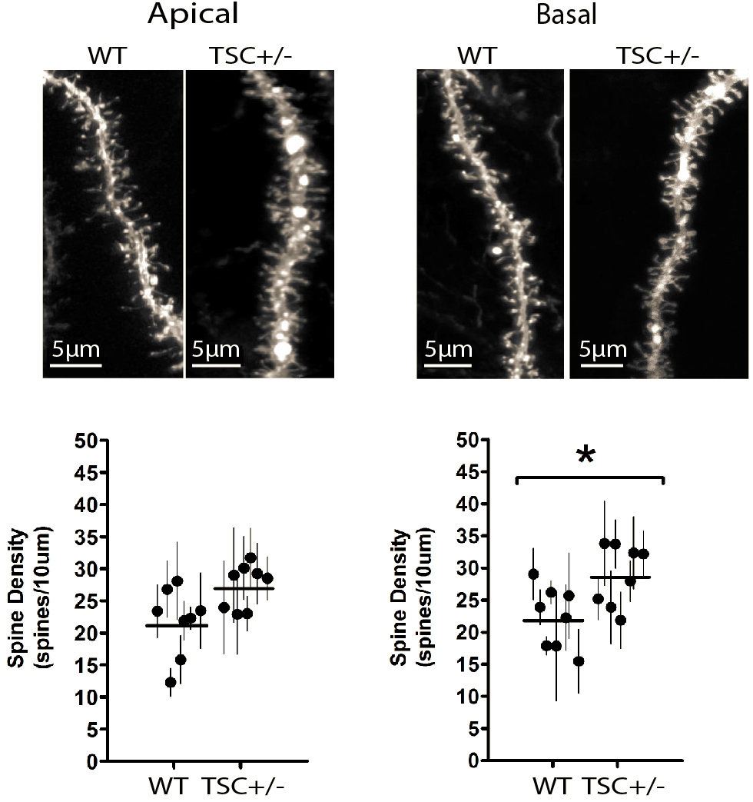
Figure 16: Neocortical structural effects of cerebellar disruption. Spine counts in neocortex show distal consequences of Purkinje cell-specific disruption of TSC1.

We will classify and categorize dendritic spines over time to quantify growth, retraction, and motility, followed by postmortem analysis of whole arbors using Sholl analysis. Our preliminary results in Tsc1-Pcp2 mice, in which Purkinje cell output is disrupted, show increases in spine density in the basal dendrites of prefrontal pyramidal neurons (Fig. 16). We will test whether juvenile DREADD-based disruptions lead to comparable changes.
Adeno-associated virus (AAV) injected at postnatal day (PND) 7 will drive expression of inhibitory DREADD (Gi/o-coupled human muscarinic M4, hemagglutinin-tagged). CNO will be given in water at 10 mg/kg/day until PND 60. In addition to in vivo measures of motility, at PND 60 mice will be perfused with 1% paraformaldehyde and Dil-coated tungsten particles delivered by gene gun, followed by confocal microscopy. Pyramidal forebrain neurons, apical layer II/III and basal layer V, will be quantified by Neurolucida 360 software (MBF Bioscience).
Pitfalls and alternatives. To identify regions for in vivo imaging, we are using anterograde tracing viruses such as herpes simplex virus-H129 (HSV-H129) in conjunction with light sheet microscopy. If changes in dendritic morphology are not apparent on disrupting individual lobules, we will use Cre to express DREADDs cerebellum-wide.
Aim 3c: Model the acquisition of stimulus salience via cerebellar-neocortical interactions. Most computational models of flexible behavior assume the salience of certain sensory events, which then guide behavior. Here we will use statistical and computational analyses to determine whether cerebellar teaching signals can help the developing neocortex to learn the salience of stimuli relevant for behavior. To evaluate how the cerebellum might shape cortical activity, we will analyze the model from Aim 2c. In addition to stable dynamics, the network needs to learn which features of the sensory input stream to integrate. In our model, this is captured by the weight matrix β, which determines a low-dimensional projection of the sensory input x(t). Here x(t) can be considered a high-dimensional vector containing many kinds of sensory information, most of which are irrelevant to the task. The deep cerebellar nuclei fire continuously, punctuated with bursts, providing an output stream that is believed to predict sensory events. We will treat cerebellar output as a guidance signal that, by integrating sensory prediction errors and reward information, drives neocortical plasticity governing β. We will use statistical and simulation analyses to study which spike timing-dependent plasticity rules, in concert with prediction error signals from the cerebellum, can account for the learning of salient sensory inputs in association cortex. This model will provide a simplified mechanistic description of biological function by including generalized-linear-model neurons with stochastic spiking as well as a biophysically realistic model of deep nuclear neurons that reproduce bursting phenomena. As more experimental constraints become available, we expect that these simulations will contribute to a transformative view of neurodevelopmental disorders leading from genes all the way to theoretical causative principles. Although our starting framework will be the evidence-accumulation task, this model can be generalized to other behaviors that require the selection of salient sensory events relevant for the prediction of loss or reward.

Bibliography
Aksay, E., Gamkrelidze, G., Seung, H.S., Baker, R., and Tank, D.W. (2001). In vivo intracellular recording and perturbation of persistent activity in a neural integrator. Nat. Neurosci. 4, 184–193 PMID: 11175880.
Akshoomoff, N., Lord, C., Lincoln, A.J., Courchesne, R.Y., Carper, R.A., Townsend, J., and Courchesne, E. (2004). Outcome classification of preschool children with autism spectrum disorders using MRI brain measures. J. Am. Acad. Child Adolesc. Psychiatry 43, 349–357 PMID: 15076269.
Amaral, D.G., Schumann, C.M., and Nordahl, C.W. (2008). Neuroanatomy of autism. Trends Neurosci. 31, 137–145.
Apps, R. (1999). Movement-related gating of climbing fibre input to cerebellar cortical zones. Prog. Neurobiol. 57, 537–562 PMID: 10215101.
Berman, G.J., Choi, D.M., Bialek, W., and Shaevitz, J.W. (2014). Mapping the stereotyped behaviour of freely moving fruit flies. J. R. Soc. Interface 11 PMCID: PMC4233753.
Berman, G.J., Bialek, W., and Shaevitz, J.W. (2016). Predictability and hierarchy in Drosophila behavior. Proc. Natl. Acad. Sci. U. S. A. 113, 11943–11948 PMCID: PMC5081631.
Brunton, B.W., Botvinick, M.M., and Brody, C.D. (2013). Rats and humans can optimally accumulate evidence for decision-making. Science 340, 95–98 PMID: 23559254.
Carola, V., Mirabeau, O., and Gross, C.T. (2011). Hidden Markov model analysis of maternal behavior patterns in inbred and reciprocal hybrid mice. PLoS One 6, e14753 PMCID: PMC3050935.
Courchesne, E., Yeung-Courchesne, R., Press, G.A., Hesselink, J.R., and Jernigan, T.L. (1988). Hypoplasia of cerebellar vermal lobules VI and VII in autism. N. Engl. J. Med. 318, 1349–1354 PMID: 3367935.
Durston, S., van Belle, J., and de Zeeuw, P. (2011). Differentiating frontostriatal and fronto-cerebellar circuits in attention-deficit/hyperactivity disorder. Biol. Psychiatry 69, 1178–1184 PMID: 20965496.
Erlich, J.C., Brunton, B.W., Duan, C.A., Hanks, T.D., and Brody, C.D. (2015). Distinct effects of prefrontal and parietal cortex inactivations on an accumulation of evidence task in the rat. Elife 4 PMCID: PMC4392479.
Giovannucci, A., Badura, A., Deverett, B., Najafi, F., Pereira, T.D., Gao, Z., Ozden, I., Kloth, A.D., Pnevmatikakis, E., Paninski, L., et al. (2017). Cerebellar granule cells acquire a widespread predictive feedback signal during motor learning. Nat. Neurosci. PMID: 28319608.
Goto, T., Okayama, T., and Toyoda, A. (2015). Strain differences in temporal changes of nesting behaviors in C57BL/6N, DBA/2N, and their F1 hybrid mice assessed by a three-dimensional monitoring system. Behav. Processes 119, 86–92 PMID: 26220275.
Hong, W., Kennedy, A., Burgos-Artizzu, X.P., Zelikowsky, M., Navonne, S.G., Perona, P., and Anderson, D.J. (2015). Automated measurement of mouse social behaviors using depth sensing, video tracking, and machine learning. Proc. Natl. Acad. Sci. U. S. A. 112, E5351–E5360 PMCID: PMC4586844.
Johnson, M.R., Behmoaras, J., Bottolo, L., Krishnan, M.L., Pernhorst, K., Santoscoy, P.L.M., Rossetti, T., Speed, D., Srivastava, P.K., Chadeau-Hyam, M., et al. (2015). Systems genetics identifies Sestrin 3 as a regulator of a proconvulsant gene network in human epileptic hippocampus. Nat. Commun. 6, 6031 PMCID: PMC4627576.
Kates, W.R., Burnette, C.P., Eliez, S., Strunge, L.A., Kaplan, D., Landa, R., Reiss, A.L., and Pearlson, G.D. (2004). Neuroanatomic variation in monozygotic twin pairs discordant for the narrow phenotype for autism. Am. J. Psychiatry 161, 539–546 PMID: 14992981.
Klibaite, U., Berman, G.J., Cande, J., Stern, D.L., and Shaevitz, J.W. (2017). An unsupervised method for quantifying the behavior of paired animals. Phys. Biol. 14, 015006 PMID: 28140374.
Kloth, A.D., Badura, A., Li, A., Cherskov, A., Connolly, S.G., Giovannucci, A., Bangash, M.A., Grasselli, G., Peñagarikano, O., Piochon, C., et al. (2015). Cerebellar associative sensory learning defects in five mouse autism models. Elife 4, e06085 PMCID: PMC4512177.
Koziol, L.F., Budding, D., Andreasen, N., D’Arrigo, S., Bulgheroni, S., Imamizu, H., Ito, M., Manto, M., Marvel, C., Parker, K., et al. (2013). Consensus Paper: The Cerebellum’s Role in Movement and Cognition. Cerebellum 13, 151–177.
Krienen, F.M., and Buckner, R.L. (2009). Segregated fronto-cerebellar circuits revealed by intrinsic functional connectivity. Cereb. Cortex 19, 2485–2497 PMCID: PMC2742600.
Kuhn, B., Ozden, I., Lampi, Y., Hasan, M.T., and Wang, S.S.-H. (2012). An amplified promoter system for targeted expression of calcium indicator proteins in the cerebellar cortex. Front. Neural Circuits 6, 49 PMCID: PMC3408591.
Lee, K.H., Mathews, P.J., Reeves, A.M.B., Choe, K.Y., Jami, S.A., Serrano, R.E., and Otis, T.S. (2015). Circuit mechanisms underlying motor memory formation in the cerebellum. Neuron 86, 529–540 PMCID: PMC4417109.
Limperopoulos, C., Chilingaryan, G., Guizard, N., Robertson, R.L., and Du Plessis, A.J. (2010). Cerebellar injury in the premature infant is associated with impaired growth of specific cerebral regions. Pediatr. Res. 68, 145–150 PMID: 20389260.
Limperopoulos, C., Chilingaryan, G., Sullivan, N., Guizard, N., Robertson, R.L., and du Plessis, A.J. (2014). Injury to the premature cerebellum: outcome is related to remote cortical development. Cereb. Cortex 24, 728–736 PMCID: PMC3920767.
Linderman, S., Stock, C.H., and Adams, R.P. (2014). A framework for studying synaptic plasticity with neural spike train data. In Advances in Neural Information Processing Systems 27, Z. Ghahramani, M. Welling, C. Cortes, N.D. Lawrence, and K.Q. Weinberger, eds. (Curran Associates, Inc.), pp. 2330–2338.
Linderman, S., Adams, R.P., and Pillow, J.W. (2016). Bayesian latent structure discovery from multi-neuron recordings. In Advances in Neural Information Processing Systems 29, D.D. Lee, M. Sugiyama, U.V. Luxburg, I. Guyon, and R. Garnett, eds. (Curran Associates, Inc.), pp. 2002–2010.
Major, G., Baker, R., Aksay, E., Mensh, B., Seung, H.S., and Tank, D.W. (2004). Plasticity and tuning by visual feedback of the stability of a neural integrator. Proc. Natl. Acad. Sci. U. S. A. 101, 7739–7744 PMCID: PMC419676.
Menashe, I., Grange, P., Larsen, E.C., Banerjee-Basu, S., and Mitra, P.P. (2013). Co-expression profiling of autism genes in the mouse brain. PLoS Comput. Biol. 9, e1003128 PMCID: PMC3723491.
Mensh, B.D., Aksay, E., Lee, D.D., Seung, H.S., and Tank, D.W. (2004). Spontaneous eye movements in goldfish: oculomotor integrator performance, plasticity, and dependence on visual feedback. Vision Res. 44, 711–726 PMID: 14751555.
Najafi, F., Giovannucci, A., Wang, S.S.-H., and Medina, J.F. (2014a). Sensory-driven enhancement of calcium signals in individual Purkinje cell dendrites of awake mice. Cell Rep. 6, 792–798 PMCID: PMC3996650.
Najafi, F., Giovannucci, A., Wang, S.S.-H., and Medina, J.F. (2014b). Coding of stimulus strength via analog calcium signals in Purkinje cell dendrites of awake mice. Elife 3, e03663 PMCID: PMC4158287.
Ohmae, S., and Medina, J.F. (2015). Climbing fibers encode a temporal-difference prediction error during cerebellar learning in mice. Nat. Neurosci. 18, 1798–1803 PMCID: PMC4754078.
Okayama, T., Goto, T., and Toyoda, A. (2015). Assessing nest-building behavior of mice using a 3D depth camera. J. Neurosci. Methods 251, 151–157 PMID: 26051553.
Ozden, I., Dombeck, D.A., Hoogland, T.M., Tank, D.W., and Wang, S.S.-H. (2012). Widespread state-dependent shifts in cerebellar activity in locomoting mice. PLoS One 7, e42650 PMCID: PMC3411825.
Palmen, S.J.M.C., and S J M (2004). Neuropathological findings in autism. Brain 127, 2572–2583.
Parikshak, N.N., Luo, R., Zhang, A., Won, H., Lowe, J.K., Chandran, V., Horvath, S., and Geschwind, D.H. (2013). Integrative functional genomic analyses implicate specific molecular pathways and circuits in autism. Cell 155, 1008–1021 PMCID: PMC3934107.
Ramirez, J.E., and Stell, B.M. (2016). Calcium Imaging Reveals Coordinated Simple Spike Pauses in Populations of Cerebellar Purkinje Cells. Cell Rep. 17, 3125–3132 PMID: 28009283.
Schmahmann, J.D. (2004). Disorders of the Cerebellum: Ataxia, Dysmetria of Thought, and the Cerebellar Cognitive Affective Syndrome. J. Neuropsychiatr. 16, 367–378.
Schumann, C.M., and Nordahl, C.W. (2011). Bridging the gap between MRI and postmortem research in autism. Brain Res. 1380, 175–186 PMCID: PMC3050078.
Seung, H.S. (1996). How the brain keeps the eyes still. Proc. Natl. Acad. Sci. U. S. A. 93, 13339–13344 PMCID: PMC24094.
Seymour, B., O’Doherty, J.P., Dayan, P., Koltzenburg, M., Jones, A.K., Dolan, R.J., Friston, K.J., and Frackowiak, R.S. (2004). Temporal difference models describe higher-order learning in humans. Nature 429, 664–667 PMID: 15190354.
Stevenson, I., and Koerding, K. (2011). Inferring spike-timing-dependent plasticity from spike train data. In Advances in Neural Information Processing Systems 24, J. Shawe-Taylor, R.S. Zemel, P.L. Bartlett, F. Pereira, and K.Q. Weinberger, eds. (Curran Associates, Inc.), pp. 2582–2590.
Stoodley, C.J., and Schmahmann, J.D. (2010). Evidence for topographic organization in the cerebellum of motor control versus cognitive and affective processing. Cortex 46, 831–844 PMCID: PMC2873095.
Sullivan, M.R., Nimmerjahn, A., Sarkisov, D.V., Helmchen, F., and Wang, S.S.-H. (2005). In vivo calcium imaging of circuit activity in cerebellar cortex. J. Neurophysiol. 94, 1636–1644 PMID: 16079125.
Tsai, P.T., Hull, C., Chu, Y., Greene-Colozzi, E., Sadowski, A.R., Leech, J.M., Steinberg, J., Crawley, J.N., Regehr, W.G., and Sahin, M. (2012). Autistic-like behaviour and cerebellar dysfunction in Purkinje cell Tsc1 mutant mice. Nature 488, 647–651 PMCID: PMC3615424.
Wang, Q., Taliaferro, J.M., Klibaite, U., Hilgers, V., Shaevitz, J.W., and Rio, D.C. (2016). The PSI-U1 snRNP interaction regulates male mating behavior in Drosophila. Proc. Natl. Acad. Sci. U. S. A. 113, 5269–5274 PMCID: PMC4868454.
Wang, S.S.-H., Kloth, A.D., and Badura, A. (2014). The cerebellum, sensitive periods, and autism. Neuron 83, 518–532 PMCID: PMC4135479.
Wess, J., Nakajima, K., and Jain, S. (2013). Novel designer receptors to probe GPCR signaling and physiology. Trends Pharmacol. Sci. 34, 385–392 PMCID: PMC3758874.
Willsey, A.J., Sanders, S.J., Li, M., Dong, S., Tebbenkamp, A.T., Muhle, R.A., Reilly, S.K., Lin, L., Fertuzinhos, S., Miller, J.A., et al. (2013). Coexpression networks implicate human midfetal deep cortical projection neurons in the pathogenesis of autism. Cell 155, 997–1007 PMCID: PMC3995413.
Wiltschko, A.B., Johnson, M.J., Iurilli, G., Peterson, R.E., Katon, J.M., Pashkovski, S.L., Abraira, V.E., Adams, R.P., and Datta, S.R. (2015). Mapping Sub-Second Structure in Mouse Behavior. Neuron 88, 1121–1135 PMCID: PMC4708087.

