Chapter 5: Autism, Race, and Socioeconomic Factors in the United States
________________________________________________________________

While racial and ethnic differences in child mental health measures have been well documented, the association between race, ethnicity, and autism diagnosis in the United States is tenuous (6, 140, 174, 178, 557). Smaller studies demonstrate that non-white children, includes African Americans and Hispanics, are less likely to receive an autism diagnosis (312, 375). A Texan study notes that increased school district resources and decreased percentage of economically disadvantaged children are associated with increased autism prevalence (374). A study controlling for race found that autistic diagnosis increases with increased maternal education, male gender, and low IQ (312). Such evidence suggests that both race and socioeconomic factors may influence autism diagnosis and prevalence. In this chapter, I use the National Health Interview Survey (NHIS) to assess whether racial and socioeconomic factors, such as household income and parental education, are associated with higher autism diagnosis in the United States.
Researchers observe racial and ethnic variation in the timing of autism diagnosis and in autism misdiagnosis. While several studies report an association between race, ethnicity, and the age of autism diagnosis, these studies do not report consistent findings on which races are diagnosed at an earlier time period (310, 456). Autism severity, male gender, low IQ, older maternal age, and higher maternal education were other associated factors that may explain lower autism identification ages (456). Researchers also not increased autism misdiagnosis in ethnic minorities, with African Americans 2.6 less likely to received an autism diagnosis on their first specialty care visit than white children, instead receiving diagnoses of attention-deficit hyperactivity disorder (ADHD) and conduct disorder (309). These racial differences in autism misdiagnosis could be due to differences in autism symptoms, patient access to care, clinician responses to patients, or socioeconomic status (309). Increased autism misdiagnosis of ethnic minorities explains previous findings that black children require more health care visits to obtain an autism diagnosis (310). If the NHIS suggests decreased autism in minority ethnic groups, further research on these hypotheses should be considered.
Cultural differences in perception of autism may lead to racial and ethnic differences in the autism diagnosis and its timing. Culture, defined as the values, beliefs, and behaviors shared by a particular group of individuals, is often measured by race, ethnicity, or country of origin (311). Cultural difference can cause parents to interpret autistic symptoms normal and non-health related (311). For example white parents are more likely to believe that autistic symptoms are due to an underlying health condition than Asian and African American parents (310, 311). Additionally, cultural differences may explain why Indian parents first notice cultural difficulties in their autistic children whereas American parents are more likely to note language delays (130, 147, 311). Culture differences in perception of autistic symptoms may lead to variation in autism diagnosis (142, 310, 311). Researchers have observed racial differences in attributing mental health conditions to relational and familial problems and physical causes (311, 558). Cultural differences in beliefs of autism’s etiology could lead to cultural treatment variation and may account for increased non-traditional therapies in Latino autistic children (290). Although many individuals of the same racial and ethnic group share a similar culture, culture is not synonymous with race. Although findings from the NHIS regarding the relationship between race and autism may give some information about the role of culture in determine autism treatment, additional research identifying specific cultural beliefs through directed surveys is needed to best assess culture’s importance.
Socioeconomic factors such as income and parental education may explain observed differences in autism diagnosis. A Texan study that found autism prevalence was associated with increased school district resources and decreased prevalence of economically disadvantaged students suggested that schools and parents with more resources can provide better autism screening tools and treatment for their children (374). Evidence suggests that physicians associate autism with higher socioeconomic classes, leading to diagnostic biasing (142, 283). Studies finding an association between increased maternal education and autism suggest that increased education may lead to higher awareness of crucial developmental points or of how an autism diagnosis may lead to increased services (308). As these income and maternal education also very with race, these variables are potential confounders for studying the relationship between race, ethnicity, and autism (308).
Regional variation in autism diagnosis and prevalence may be due to varying racial and socioeconomic factors. The morbidity and mortality weekly report (MMWR) findings on autism prevalence have reported regional differences in the U.S. in 2000, 2002, and 2006 (6-8). As the included sites also demonstrate differences in racial and ethnic composition, race as well as associated socioeconomic factors may influence these regional differences. Analysis of autism by region using the NHIS survey in this analysis may thus reflect underlying racial and socioeconomic variation.
Using the NHIS, I will examine how autism varies by race, socioeconomic factors such as household income and parental education, and region in the United States. Understanding the relative importance of these factors on autism diagnosis and prevalence will shed light on whether these factors need to be controlled for in studies seeking to determine autism’s etiology.
Methods

Administered by the Center for Disease Control and Prevention’s National Center for Health Statistics, the National Health Interview Survey (NHIS) is an annual health questionnaire given in person to a subset of civilian, non-institutionalized households in the United States (3). Although the survey has been conducted since 1957, only available data from 1997 to 2005 used consistent weighting and sampling methods (3). Included data was pooled from 1999 to 2005 as data from 1998 and 1999 contained incomparable racial information regarding Asians and Pacific Islanders (3). In included households, an adult was interviewed about the health of one randomly selected child in the household (3). To achieve cost-effectiveness, the NHIS oversamples ethnic minorities and organizes the U.S. population into several primary sampling units and strata; these aspects of study design were accounted for in the data analysis.
This study sought to determine whether race, household income, parental education, and region were associated with autism in the United States. Adults were asked whether a doctor or health professional diagnosed the sample child with a list of disorders including autism, Down syndrome, and others (3). Children lacking a response to the autism question were excluded, giving a study population of 81,062, with 299 autistic individuals. Separate questions inquired whether a doctor or health professional diagnosed the child with mental retardation or “any other developmental delay” (3). Separate variables measuring mental retardation and developmental delay under age 1 and from age 2 to 17 were combined to give one mental retardation and one developmental delay variable for all children. A racial bridge variable, accounting for White, African American/Black, American Indian, Chinese, Filipino, Asian Indian, Other Race, and Multiple races, was used to allow cross-year data pooling (3). Race was collapsed into White, African American/Black, and other due to the small autistic population. Household income and maternal education variables were collapsed for similar reasons with income in 4 categories ($0 - $34,999; $35,000-$74,000; $75,000 and above; missing) and maternal education in 5 categories (some middle and/or high school; high school degree/GED; Associate’s or Bachelor’s degree; graduate degree; missing). All sample children were classified by region of the country in which they lived (Northeast, Midwest, South, or West)(3).
I performed basic descriptive statistics and a binomial logistic regression using Stata 10 software (Stata Corp, College Station, TX). The NHIS provided sample child sample weights to estimate whole population variance. For the logistic regression and descriptive statistical analyses of the entire population by race and autism status, I accounted for weights and study design using the pweight and svyset commands in Stata with stratum and psu variables. For descriptive statistical analyses of the autistic population, I applied weights using Stata’s aweight command due to difficulty performing the Fischer’s exact test for significance using the pweight command. Significant tests were performed using Pearson’s Chi Square test and the Fischer’s exact test for all categorical variables. The ANOVA and student’s t-test were used when analyzing quantitative variables. I performed a binomial logistic regression for autism status accounting for age, sex, race, household income, maternal education, and region.
Results

Descriptive statistics confirm previous findings regarding sex and associated disorders in autistic populations (Table 5.1). While the higher percentage of males in the autistic population confirms previous findings of autism’s high male prevalence (84.12% compared to 51.03%), the study population may be slightly male biased as the accepted average is 3 or 4 to 1 (178, 300). The increased percentage of mental retardation in the autistic population (17.81% compared to 0.58%) confirms the comorbidiity of autism and mental retardation (403). As researchers report that generally 75% of autistic individuals are retarded, this population represents a higher mentally functioning autistic population (403). Parents reporting autism as “other developmental delays” may account for the large numbers of developmentally delayed children in the autistic population.
Descriptive statistics suggest significant differences in maternal education and region in the autistic population (Table 5.1). No significant differences were observed in any racial or income category. Previous associations of high maternal education with autism were confirmed as mothers of autistic children were significantly less likely to receive only some middle and/or high school education and significantly more likely to receive higher college and graduate education (308). Autistic children were significantly more likely to live in the Midwest and less likely to live the South; this confirmed previous findings of low autism prevalence in Southern states such as Alabama and Florida and high autism prevalence in Midwestern states such as Minnesota (8, 48, 205).
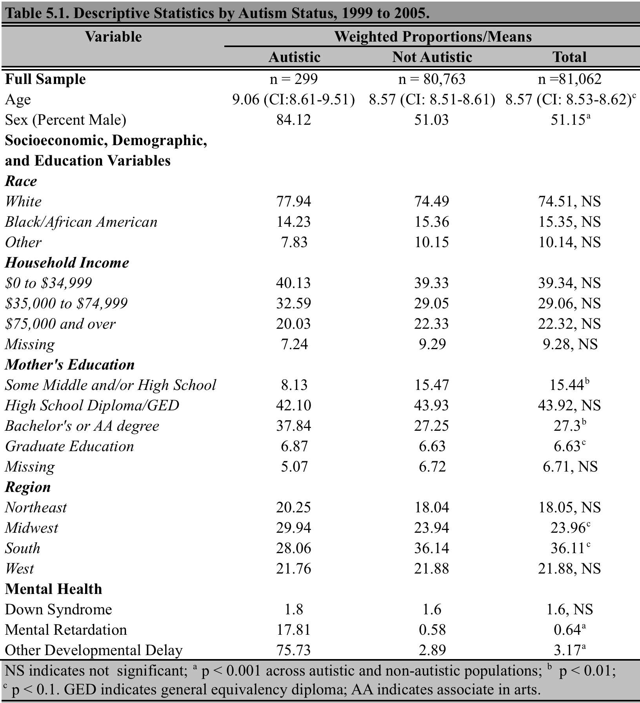

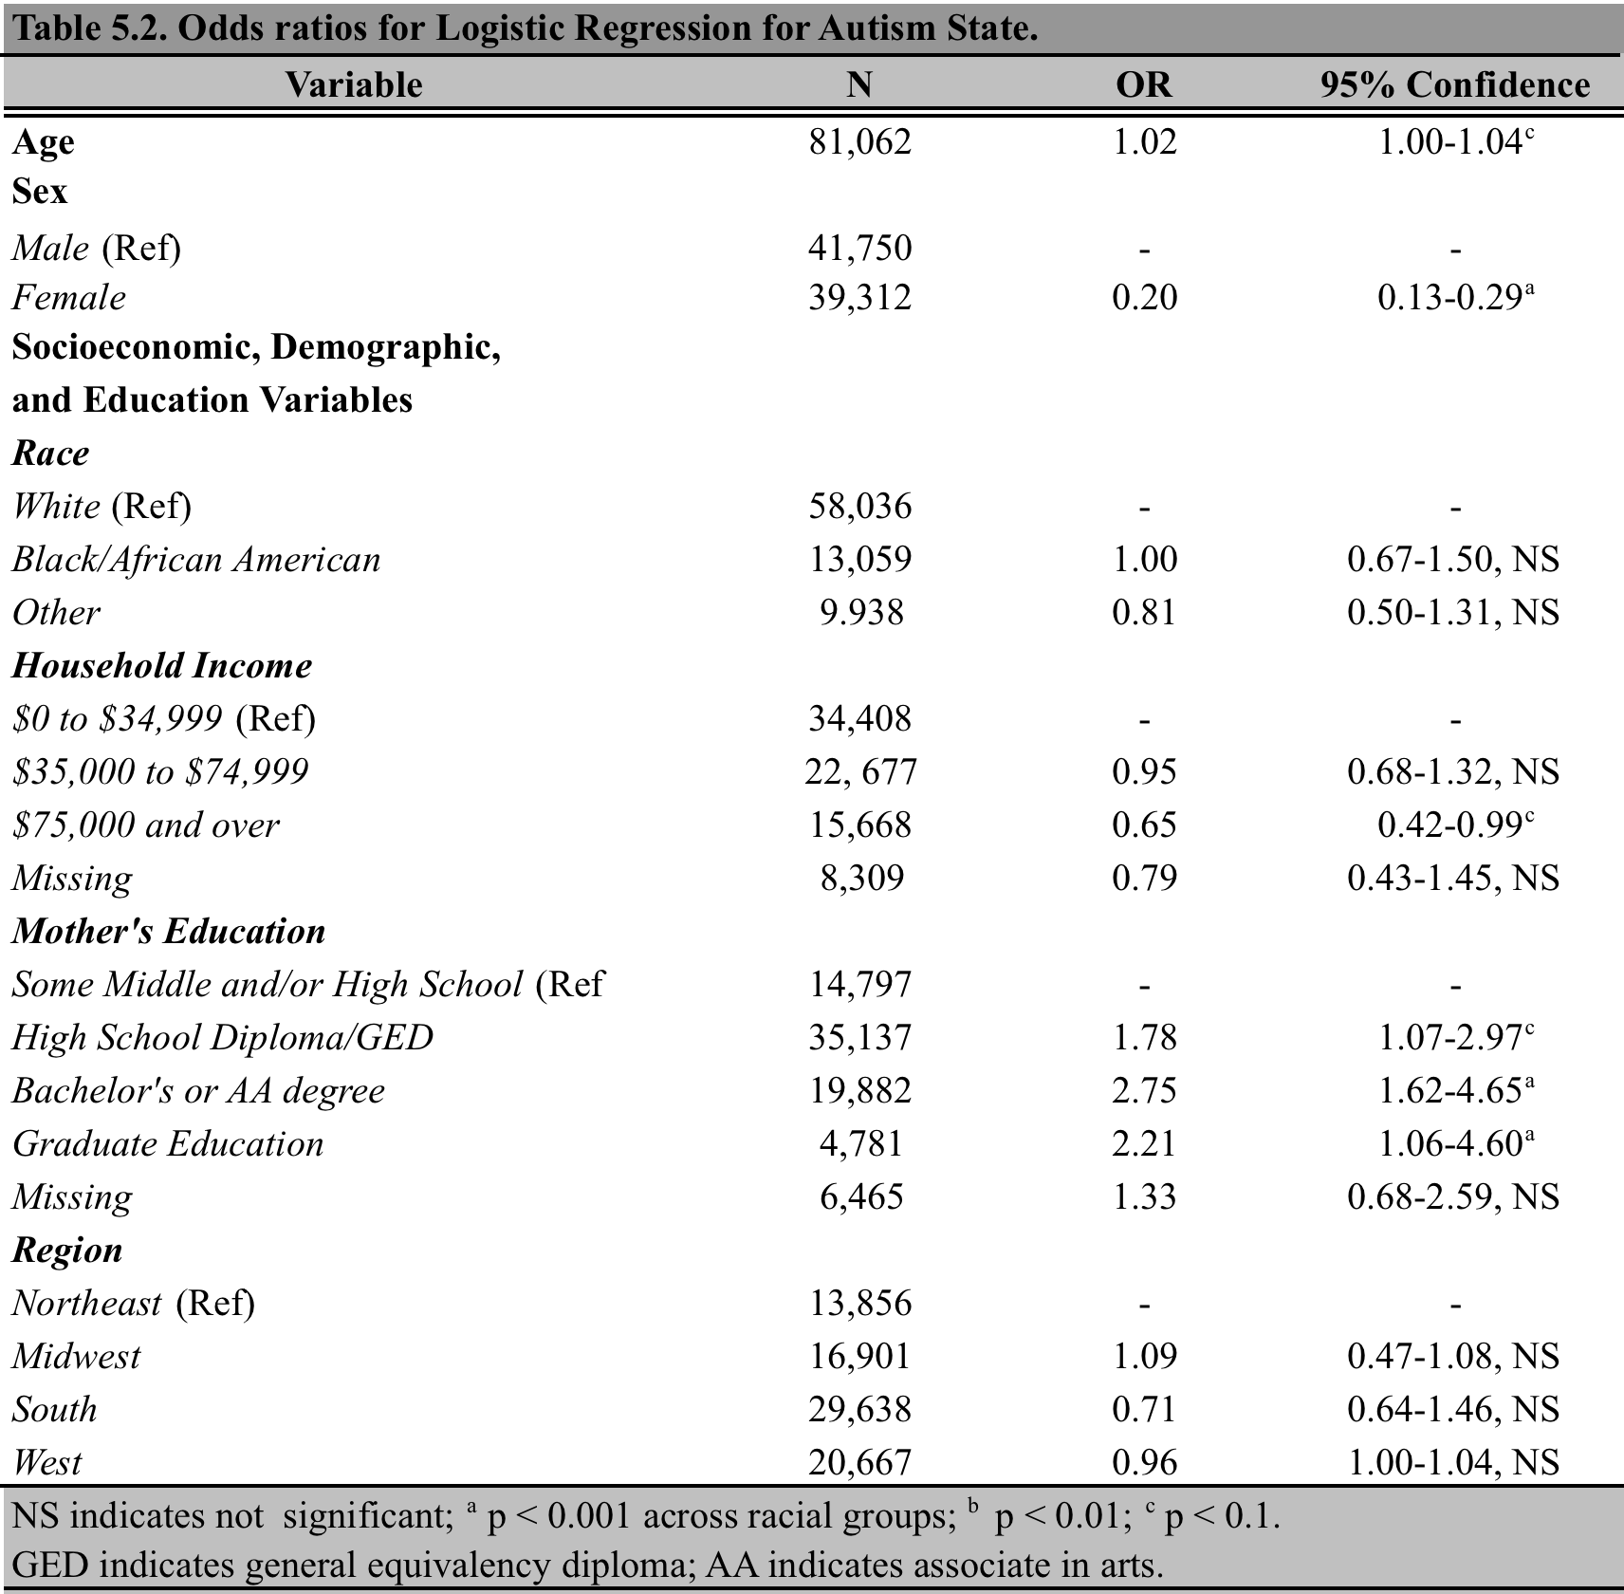
Binomial logistic regression confirms the impact of male sex and maternal education on likelihood of having an autistic status (Table 5.2). When separately accounting for age, sex, race, household income, maternal education, and region through logistic regression, only age, sex, household income over $75,000, and maternal education are significant variables. In this analyses odds ratios represent the odds that the characteristic will be present in the autistic group but not the non-autistic group (200). Odds ratios less than one suggest that individual with that characteristic are more less likely to be autistic than those with the reference characteristic while values greater than one suggest the reverse (200). Income above $75,000 and age had borderline significant values, and thus are not likely to substantially influence autistic status. The low odds ratio associated with being female suggests that compared to males, females have a lower odds of being autistic. The high maternal education odds confirms that children with more educated mothers have an increased odds of being when accounting for other influential variables. The insignificance of region suggests that region differences in maternal education and other confounding variables account for previously observed differences.

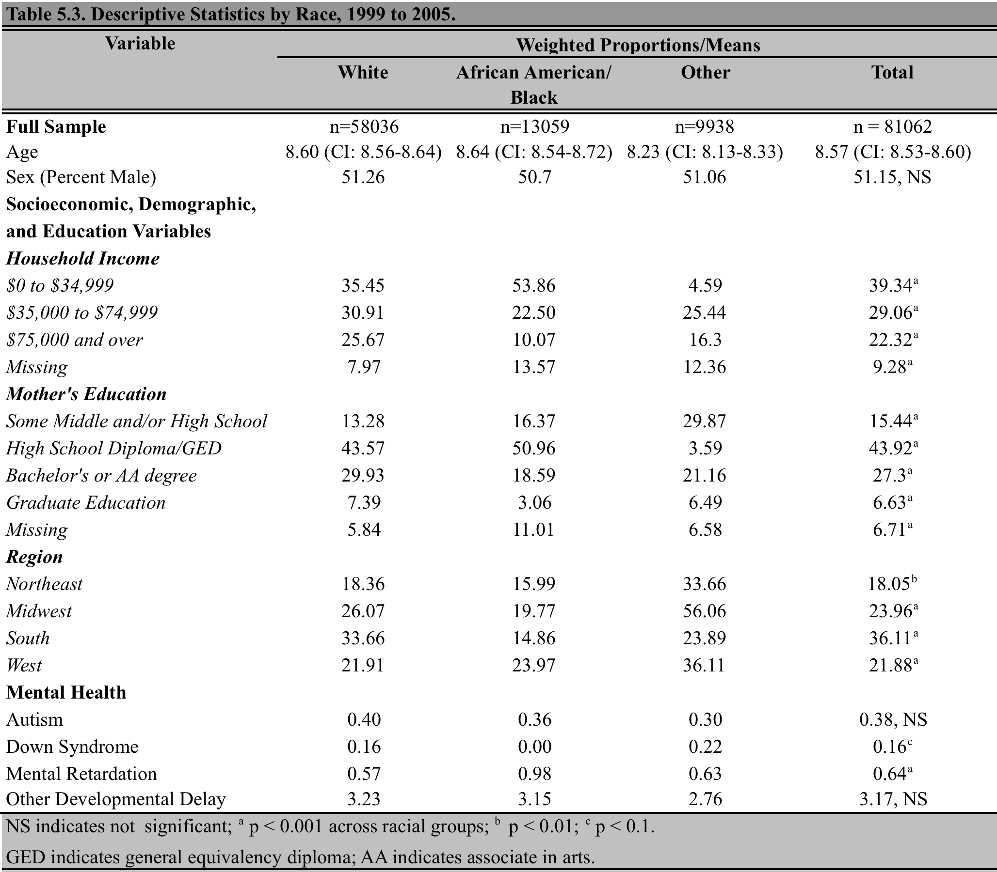

Descriptive statistics by racial status suggest that racial differences in maternal education may account for observed racial variation in autism prevalence in previous studies. White, Black/African American, and other racial groups displayed significant differences in household income, maternal education, region of the country, as well as in the prevalence of Down syndrome and mental retardation (Table 5.3). As maternal education was most associated with autism status in the previous findings, it is possible that racial differences in maternal education lead to racial and ethnic differences in autism prevalence in other populations. While the small values in the autistic population made it difficult to estimate differences in household income, maternal education, and region with certainty, it appears that white mothers of autistic children have higher levels of education as well as higher household incomes (Table 5.4). These confounding socioeconomic factors may make it difficult to determine racial and ethnic variation in autism prevalence in practice.
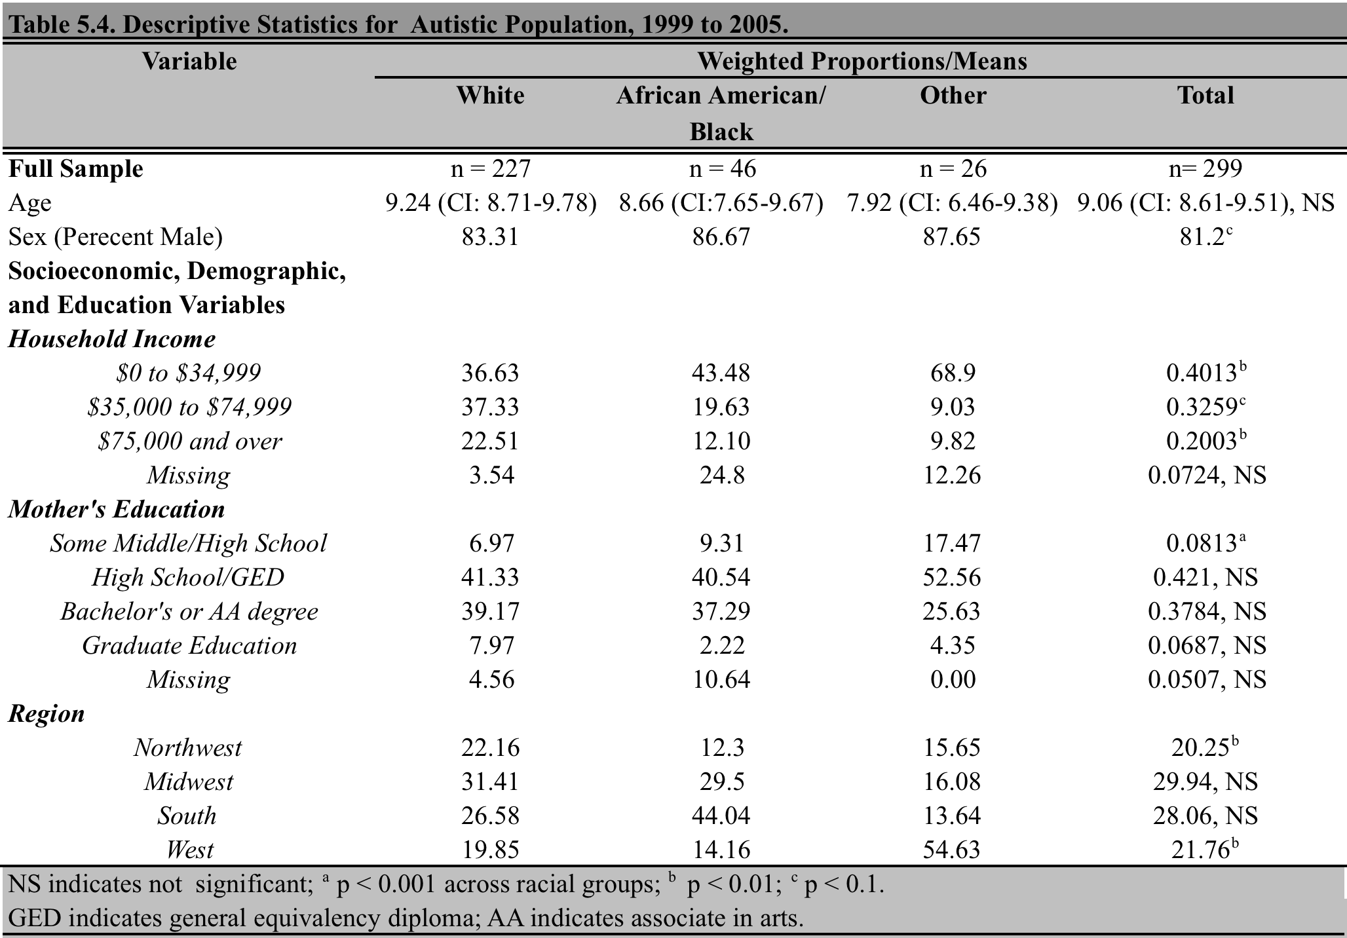
Discussion
Higher maternal education could contribute to increased autism diagnosis by increasing awareness of autistic symptoms. Previous studies have shown that maternal education varies by race and than children with autistic disorder are more likely to have mothers with a higher degree of education (308). Women with higher education may be more familiar with autism and its symptoms, and thus more likely to seek appropriate help for their child when potential symptoms are identified (308). Additional women of higher education may be more aware of the services available for autistic children and thus advocate for an autism diagnosis for the child (308). These analyses suggest that maternal education should be controlled for in future studies attempting to determine autism prevalence in various racial and ethnic groups as maternal education varies by race. Controlling for maternal education in regional studies is similarly important as racial and ethnic composition varies nationally.
Although racial and ethnic differences were not observed in between autistic and non-autistic populations, culture may still play a substantial role in determining report autism levels. As culture does not perfectly coincide with race, cultural differences in autism prevalence undetected in this study may still exist. Additionally, there is room for the influence of culture within maternal education as highly education women of different races and ethnicities may identify different autistic symptoms. Further research exploring whether highly educated women are more exposed to information about autism and how culturally differences affect identification of autistic symptoms among highly education women should be conducted.
Significant limitations to this analysis include the small size of the autistic population, reliability of parental answers to the questionnaire, representative sample selection, and lack of income adjustments for inflation. The autistic population’s small sample size may make significance levels difficult to achieve and prevent the detection of important autism-associated socioeconomic variables. As information on autism and other mental health status was based on parental information, it is not as reliable as data based on educational or clinical records where a trained professional assesses the child in question. While the population in question was designed to be representative of the U.S. as a whole, it may not best represent the U.S. autistic population. The reported prevalence of autism from these analyses (0.38%) is lower that values identified in recent studies (0.90%), confirming that these sampling methods are not ideal for determine autism prevalence (8). Additionally, the lack of adjustment of income measurements for inflation will give greater weight to income data from later years, potentially biasing results. To correct for these errors, race and socioeconomic variables should be studied in a larger autistic population with clinically confirmed cases of autism by selection methods that are more widespread to assure accurate prevalence estimates.
Despite these limitations, these findings suggest that race alone does not significantly contribute to autism status in the U.S. and that other confounding socioeconomic variables may play a significant role. The significance of such socioeconomic variables suggests that measures such as maternal education and income should be taken into account before considering racial and ethnic differences in autism-associated genes. As socioeconomic variables such as maternal education are associated with reported autism diagnoses, such socioeconomic variables could have significant impact on autism prevalence.

